‘They’re like cool librarians’: investigating the information behaviour of pop music fans

INSTG099 MA Library and Information Studies

2018

Amy McMullen

This dissertation is submitted in partial fulfilment of the requirements for the Master’s degree in Library and Information Studies, University College London.

Vancouver referencing style used.

ABSTRACT

This dissertation aims to examine and characterize the information behaviour of popular music fans. The literature studied demonstrated that fans, both individually and as a group, have been the focus of an increasing amount of study in recent years, and that they exhibit a range of common behaviours and practices that place a high value on information. The topic of music in information science, and information behaviour in a LIS context were also examined to contextualise the research and provided a rationale for studying music fans information behaviour as a unique topic rarely observed before.

In order to achieve its aims, this research was primarily based around Hektor’s information activities model (2001), with eight information behaviour aspects. Out of this model, an online survey was structured and published, with a mixture of quantitative and qualitative data gathered. The results of this survey were processed and analysed in a number of ways, primarily through thematic coding and quotation analysis.

The results supported the Hektor model as an appropriate model to characterize the information behaviour of the pop music fans surveyed, with sufficient evidence to demonstrate the presence of each of the eight information activities. The research suggests that an ‘evaluate’ aspect may be added, encompassing the entire model, due to the prevalence of this behaviour throughout the data covering all eight activities.

The results of this research may have an impact on how information behaviour is observed in a leisure context, and how music information may be treated by music artists and related occupations in order to maximise engagement with fans. Further research is suggested on a more granular level, to observe specific information activities by fans such as communication via social media, and to gain a larger and more varied sample group, and to bring out peripheral themes that will strengthen the conclusions drawn here.

Declaration

I have read and understood the College and Departmental statements and guidelines concerning plagiarism. I declare that:

- This submission is entirely my own work.
- Wherever published, unpublished, printed, electronic or other information sources have been used as a contribution or component of this work, these are explicitly, clearly, and individually acknowledged by appropriate use of quotation marks, citations, references and statements in the text. It is 12000 words in length.

Table of contents

 | Page
Abstract | 2
Declaration | 3
Acknowledgements | 5
List of figures | 6
Introduction | 7
Literature review | 9
Fan studies  Music in information science  Information behaviour in LIS | 10  14  19
Methodology | 26
Results | 35
Discussion | 50
Limitations and further research | 66
Conclusion | 67
Bibliography | 70
Appendix 1: Approved research ethics form | 76
Appendix 2: Screenshot of consent notice at start of survey | 79
Appendix 3: Screenshots of online survey created via Opinio | 80

List of figures
 | Page
Figure 1: Model of the structure of this dissertation | 26
Figure 2: Hektor’s information activities model | 27
Figure 3: Screenshot of post on Tumblr blog appealing for survey participants, taken from www.seriousfans.tumblr.com [Accessed 19 August 2018] | 34
Figure 4: Edited representation of Hektor’s model of information behaviour | 35
Figure 5: 4. Which resource do you consider most valuable if you are seeking information about a particular musician you are interested in? | 36
Figure 6: 7. What motivates you to find information about your favourite music? Choose up to 3 reasons. | 38
Figure 7: Word cloud made on wordclouds.com, showing relative popularity of online locations mentioned by respondents in Question 8 via tally chart. | 39
Figure 8: 13. Is your preferred area of fandom mostly online or offline? | 41
Figure 9: 14. What is the most important aspect of music to you as a fan, and what do you want to find out more information about – the artist or the music itself? | 42
Figure 10: 15. Do you like to communicate with other fans in the fandom to exchange information, either online or in person eg. via private messaging or a forum? If so, how often do you do this? | 43
Figure 11: 16. Which is the most common reason you exchange information with other fans? | 44
Figure 12: 20. Are you involved in a community where you discuss information about your chosen artist, such as a group online or offline, or via social media? If so, please specify which. | 47
Figure 13: 21. Which of these statements do you most relate to regarding ‘collective’ areas of fan information/knowledge? Please choose 3. | 48
Figure 14: The music fan lens on Hektor’s model | 69

List of abbreviations

LIS – Library and Information Science/Studies

Acknowledgements

This dissertation would not exist without the guidance of my supervisor, Dr Charles Inskip, whose LIS expertise, personal interest in music, and encouragement has been invaluable in developing my work, and as a result I think this research has been interesting for the both of us to observe.

I would also like to acknowledge Ludovica Price, recent LIS PhD graduate for her help and encouragement via email in the early part of this research. The personalized reading list she provided, based on her own work on fan information behaviour, was very useful in initiating my research, and her completed thesis was also extremely helpful.

It is also important to acknowledge and appreciate the numerous fans who both took part in and promoted my survey, most of whom I did not know personally. They were extremely generous with their time and contributions, and this work would not be possible without them.

Introduction
The inspiration for the topic of my Master’s thesis was initially personal. I have considered myself a fan of many things throughout my life, to different extents of dedication. A fan, in my view, is anyone with an enthusiasm or deep interest in a particular object of fandom; in this instance, media. Although this is often simply watching and enjoying a film or a television series, as I grew up, I accessed other resources to feed my desire as a fan to gain more knowledge. I have frequently read non-fiction books about my interests, watching fan videos, reading fan sites and commenting on forums and message boards, and latterly using social media. Although this activity has waxed and waned, it has always been important in my life in some form. Additionally, it has been an inherently social activity for me, having met many long-term close friends through shared fandom.

It was during the taught part of my MA Library and Information Studies (LIS) course that I learnt about concepts such as information behaviour, information literacy and information resources such as databases and wikis. I recognized the similarities between the concepts being taught, and what I had observed and taken part in as a fan for years. Information forms a vital part of any fandom, whether it be plot details of a fantasy series, or metadata of audio-visual material, fans were always organizing and evaluating it, in a constant cycle. Rather than the usual academic or work-oriented context of LIS theory, most of the information ‘work’ fans were doing took place in their own free time and was nearly always unpaid – they did it because they enjoyed it and did not consider it ‘work’ at all. All this ‘work’ can be classed under the topic of information behaviour.
My interest was piqued regarding the crossover of these two areas. Initially, I expected it to be a popular area of study, but upon some preliminary research pre-proposal, it seemed to be a little-explored area of LIS study. I was curious to learn about this topic; to relate it to my own field, to see what the consensus regarding information behaviour of fans was, and to see how understanding of it could be enhanced by further research, and be used to benefit those involved, such as music artists themselves.

The possibilities of exploring fandom were numerous. A fandom (in this case meaning a community of fan users based around a media object of interest) exists around almost anything imaginable, from a local radio show to multinational sports teams. It would be unwise, and impossible, to attempt to study all of them in this comparatively brief study. Therefore, it was important to set the scope for my research early on. Although I have experienced and observed multiple fandoms, I decided upon closely investigating popular (‘pop’) music fans, as a group, rather than individuals. This is a topic familiar to me, as a passionate music fan for much of my life, and so again this study had a personal motivation.

The first step in my research involved a literature review, breaking down the topic of music fan information behaviour to cover the LIS perspective of information behaviour, music information behaviour/retrieval, and fan studies in general, to contextualize. This literature review would lead to deciding upon a LIS-based model to base my own primary research around, from which I could then examine music fan information behaviour.

Literature review
The purpose of this chapter is to present a review of the literature available on the information behaviour of music fans. As an abstract question that has received little attention and crosses disciplines, for ease this has been split into three sections to cover the entirety of the research focus; the discipline of library and information studies (LIS), specific aspects of music information studies, and fan studies itself. These are, of course, large topics, and as a result, only the most relevant research has been focused on, and mostly from the past thirty years.

The review of fan studies sets the context for the research for a reader who may only be familiar with LIS. The study of music in information science is reviewed, in order to extract aspects that may be useful to the study of fans. Finally, information behaviour studies in LIS is evaluated, focusing on the most relevant aspects to this research; the serious leisure perspective, existing studies into fan information behaviour, and information behaviour models.

Fan studies
Fan studies is a relatively new discipline that became active in the late 1980s and early 1990s. Discourse dedicated to fans was led by cultural and media scholars who wanted to examine the variation within media audiences, and also to challenge the previously pejorative view of popular culture fans as either dangerous loners or mindless and obsessed teenage girls. Fan studies has aimed to establish a more nuanced and academic interpretation of fan identity and activity.

Henry Jenkins is the trailblazer of fan studies, and his seminal text ‘Textual Poachers’, published in 1992, set a precedent in the field. By undertaking an ethnographic study of various groups of what he called ‘media fans’ (fans of television series), Jenkins defined five primary ideas of what defines a ‘fandom’; a relationship to a particular mode of reception; a function as an interpretive community; a role in encouraging viewer activism; particular traditions of cultural production, and its status as an alternative social community. Jenkins expanded on these points in his later works, ‘Fans, Bloggers and Gamers’ and ‘Convergence Culture’, where he developed the idea of participatory culture and the idea of fans connecting different parts of culture into a unified space online through Pierre Levy’s theory of collective intelligence. Jenkins recognizes limitations; most of his work focuses on media fans of television and film, and it is entirely likely that fans of other cultural objects (such as the music fans investigated here) may behave differently.
John Fiske’s work on fan studies should be considered alongside Jenkins, as it emerged around a similar time. Fiske focused mainly on the activity of fans (1989 study of Madonna fans) and concluded that such activity manifests in three ‘producerly’ ways; semiotic productivity (making meaning through interacting with the object of fandom); enunciative productivity (when the semiotic meanings are expressed verbally or non-verbally); and textual productivity (fans producing texts, music, videos, or attending events).
Jenkins and Fiske emphasized the importance of viewing fans compared with other media consumers and producers, and this was expanded by Abercrombie and Longhurst in 1998, who established a spectrum in their book Audiences. The spectrum of a media audience ranges from consumer – fan – cultist – enthusiast – petty producer. Abercrombie and Longhurst defined the audience members as having three different sets of skills; technical (knowledge about how the media is made); analytical (considering the details of the media); and interpretive (placing a value or opinion on the thing). The extent of these skills varies across the continuum, and there are different types of productivity along this scale, based on Fiske’s ideas – for example, the extent of textual productivity increases along the scale, as enthusiasts often move into careers based on their interests.

As fan studies developed, focus moved onto specific fan activities such as the mechanics of fan fiction writing. Busse and Gray assessed this shift in focus from fan identity to fan activity in 2011, and made the important distinction that although fan identities can be examined in isolation (i.e. there is only one single fan involved), it is often more productive to examine fan communities (a networked group of fans, more commonly known as ‘fandom’) ‘where its members are characterized not only by engagement with the source text but also by their engagement with one another’. This point will be important to recognise in this research where fan behaviour will be examined across a group rather than individually, as this is where information behaviour is most noticeable.

Music fans have been periodically used for examples in the aforementioned research, but there have been studies where they are the sole focus. Time is the key factor in Ruth Deller’s longitudinal study of two online fan communities (the indie band Belle & Sebastian and Cliff Richard) over ten years found some interesting patterns into the development of fan behaviour over time, such as fans dispersing across social media networks as certain websites’ popularity increases and declines. Deller concludes that the changes could be down to a number of factors such as age of fans and activity of the music artist, all factors worth considering in this research.

Mark Duffett has been the leading critic investigating popular music fans since the Millennium and has published a number of works. Duffett defines his work in the light of Fiske’s focus on fan practices and divides these practices into those motivated by pleasures of connection (with famous musicians and others), of appropriation (of musician’s work or images), and of performance (displaying one's own music skill or knowledge). These practical divisions offer another useful scale on which to possibly classify fan information behaviour.

Music in information science
Music information retrieval is an area within information science that studies the ‘processing, searching, organising and accessing [of] music-related data’. The discipline frequently focuses on the systematic and technical aspects of the discipline, such as classifying audio content (Bainbridge, Downie, 2014), metadata (Bogdanov, Serra, 2017) and digital signal processing (Park, 2009), in order to develop music technology. However, in recent years there has been a recognition that studying user behaviour involving music information as equally useful in developing specialist information resources. In the study of a specialist folk music library located in London, Inskip et al. found that defining the relevance of music-related information can be difficult, and that browsing is an important activity for users of a physical and digital library.

Lee’s large-scale research into natural language queries in the music section of Google Answers is an interesting study into the function of a music-information retrieval system, where users can publicly post queries. Upon content analysis, Lee found that most queries were known-item searches, searching for a specific artist or track, and that the existing music information retrieval systems (e.g. a search engine) were not properly equipped to deal with users that often wanted to describe music outside typical bibliographic data points, such as describing its ‘feel’ eg. its beat or pace.

Lee and Downie’s 2004 quantitative study of the music information behaviour of participants across a university established a number of findings that would go on to be explored. These findings included the importance of social interaction in music information retrieval; the study found that most participants rely on music recommendations and information from others in their search. Lee and Downie established the importance of collective knowledge for those using music information. This social aspect was further developed by Laplante in 2012 in a study into the music tastes of young people, which found that specific knowledgeable ‘opinion leaders’ often serve as a starting point for music information searches within a social group.

Laplante and Downie developed these findings in their 2006 and 2011 studies into what they call ‘everyday life music-information seeking’ of young people. Their work predominantly focused on the outcomes of information behaviour, i.e. what is a satisfied music information need. Laplante and Downie divided the outcomes into two categories; utilitarian and hedonic. The study found that music-information seeking from a utilitarian perspective is linear; it involves the acquisition of music and music-related information in a form that the user judges satisfactory; they found ‘good’ music, and the search ends. However, the hedonic outcomes of music-information retrieval are less tangible; they involve a less easily defined information search, one that is vague and without discrete start and end. This outcome is hedonic in that its participants find it pleasurable and fun. Laplante and Downie’s study suggests a non-goal orientated information behaviour model is most appropriate for investigating those using music for leisure, as fans do.

Later ethnographic studies aimed to apply the findings of Lee, Downie and Laplante to specific information behaviour models and groups of music information users. Margree et al. studied the information behaviour of record collectors in situ, within the perspective of the Savolainen everyday life information practices theory (2008). Like in fandom, record collecting was identified as an information activity borne out of an enthusiasm and passion for music. The study found that record collecting involves information behaviour established over a long period of time with continuous and semi-directed browsing of information sources on a regular basis, which fits Savolainen’s theory. However, the effectiveness of this study may be limited in its small scale and is disappointing given the apparent social network surrounding record collecting; although the interviews with participants were in-depth, only seven record collectors were studied, and all were male.

Kostagiolas et al. used Wilson’s information behaviour model (1999) to study the activities of a community concert band located in Greece. This model aimed to examine the human aspects of information behaviour; needs and motives, resources used, and the barriers to information seeking. The most commonly used information resources by the community band were the internet and inter-personal information exchange with friends and colleagues. Kostagiolas points out that this is in line with the studies of Lee and Downie, which found that survey respondents most often prefer informal sources when it comes to music information, rather than formal sources such as a physical library. Also referenced is the utilitarian and hedonic motives of information seeking of Laplante and Downie. This study asserts that both motives ‘coexist’ in the case of the community concert band, as they seek to improve their performance in the group (a utilitarian process), but to also develop their own music collection (hedonic). Although the scale of the study was larger than that of Margree et al, Kostagiolas et al propose that the majority of the general population fit the hedonic motive of seeking music information for recreational use. This outcome is likely to be the case for the popular music fans being studied in this project.

The studies led by Kostagiolas and Magree both recognize the concept of music as an ongoing and continuous pleasurable leisure activity, showing a recognition by researchers that an interest in music, whether as a practitioner or a listener, can be considered from the serious leisure perspective mentioned next.

Information behaviour in LIS
Information behaviour is the umbrella term for the aspect of library and information science which studies ‘how people need, seek, manage, give and use information in different contexts’, and sets the broadest context for this research. Human information behaviour has typically been conceptualized through models, each formed from the examination of a specific information context.

The 1980s and 1990s saw a growth in the study of information behaviour. Models such as Kuhlthau’s Information Search Process and Ellis’ chaining model gained traction, both following thoughts and feelings throughout a search process. Others leaned on sociological theory, such as Savolainen’s everyday life information seeking process, where individual preferences for information seeking are socially conditioned. Models can be useful in identifying elements within a set process, but this can also be their limit; they can often exclude or fail to represent more complex behaviours or events sufficiently.

Some of the most well-known information behaviour models were developed by Tom Wilson. In 1999, the aforementioned weakness was shown when he examined a number of other popular information models, and concluded that a more inclusive type of model was needed to explore the concept of repeated and successive searching, as humans often seek multiple types of information at a time outside of an academic scenario, and therefore it would be inappropriate to try and fit behaviour into a neat process model.

It became clearer to researchers, including Wilson, that upon reflection it is often more useful to examine information behaviour within a grounded theory perspective, rather than view a model in isolation. Through scrutinizing any chosen model, it was seen that information behaviour is context-specific, and therefore should be examined as such. In the context of this research, it is more productive to look at a theory which is broader, more contextual, and in an ongoing timeframe.

There has been some LIS-based research into fan information behaviour, the precise subject of this dissertation, and this is an area of growth in recent years. Abigail De Kosnik’s recent text ‘Rogue Archives’ explored the role of fans as early cataloguers and archivists, whose information behaviour has always been geared towards recording and storing their own works related to their object of fandom. Similarly, there has been some focus on the bibliographic qualities of fan-created information, such as Hart et al. The researchers suggested that the then-newly born internet would be an ideal way for librarians to access and use fan information and includes a case study of popular music fans using the internet to discuss artists. However, as this study was published in 1999, it is undeniable that fan information behaviour has changed a lot, so the theories of Hart et al. are likely to be outdated now.

Paul Booth’s book ‘Digital Fandom: new media studies’ proposed the concept of ‘narractivity’, the idea of fans interacting with information, creating a ‘web commons’ such as a forum or wiki, where information is collected, edited and created. This links to Levy’s theory of collective intelligence mentioned by Jenkins. Information behaviour of fans online has also been linked to information literacy, with Korobkova recently exploring the online mentoring between fans of pop group One Direction as a way of improving the quality of the fandom’s online material.

In 2016, Price and Robinson investigated information behaviour of cult media fans via a Delphi study, and this was expanded upon in Price’s PhD thesis. It was concluded that fans have distinctive information behaviour present in all parts of the information ‘chain’; from creation to dissemination to management, but no model was created, making it difficult to test their findings with another group of fans. Fan creation in particular has been a popular area of study within the LIS community. In 2017, Price and Robinson surveyed a group of LIS students to find out their opinions on the importance of fanfiction in a traditional library environment. Peckosie and Hill studied a large-scale cross section of fanfiction websites in 2017, and using thematic coding, found three main information activities taking place on these websites; collecting, wayfinding and organizing. Both concluded that fanfiction as a popular serious leisure activity.

Serious leisure is the most suitable theoretical perspective for this research. The phrase was first defined by sociologist Robert Stebbins in 1982. Stebbins defined leisure itself as either casual (play, relaxation, passive entertainment) and serious, which requires dedication and concentrated effort. Stebbins went on to progress his theory with a nod towards information activities, divided serious leisure into knowledge acquisition and knowledge expression.

Due to its focus on activity outside of a work environment, and the recognition that serious leisure requires specialist knowledge, the theory was picked up by many information behaviour researchers. This research was spearheaded by Jenna Hartel in the early 2000s. Hartel developed the understanding of information behaviour in the context of serious leisure, calling it ‘an exciting and virtually unexplored frontier for the library and information studies field’. Stebbins and Hartel classified serious leisure as having six key aspects; proactive acquisition of knowledge and skill; the need to persevere; happens in stages over a ‘career’; has durable benefits, personally and socially; involves strong identification with community, and has a unique ethos or culture. Serious leisure has been examined by a number of researchers, including Prigoda and McKenzie, who investigated a public library knitting group in 2007, Lee and Trace’s 2009 study into hobbyist collectors of rubber ducks, and Hartel’s own research into the document management habits of gourmet home cooks in 2010. These studies led to the development of further aspects of the understanding of serious leisure such as ‘embodied knowledge’, investigating how knowledge is transferred between people involving skills in using the body. Due to the lack of a set serious leisure model, researchers have often used the information behaviour models mentioned previously in their serious leisure studies. Most recently, Hartel et al. used Hektor’s information activities models to explore liberal arts hobbyists, runners and amateur musicians.

Hektor’s information behaviour model was borne out of his thesis in 2001, aiming to characterise how people use the Internet. However, the model devised covers all types of information sources; it was created due to a ‘perceived lack of holistic means to describe uses of information systems in the context of non-work everyday life’. Although the previous criticisms of the comparative simplicity of models compared to reality still stand, it is true that Hektor’s model is an attempt to be more inclusive of a multitude of information activities.

This model in particular is notable and useful for this research project, because it is rooted in the study of everyday life information behaviour, outside of the academic context that informs most models. Additionally, the model takes a socio-cognitive view, recognizing the importance of the social world of the information seeker, and how human interaction can play a large part in their behaviour. Having contextual knowledge of the behaviour of fans from the literature, it is clear that fans are social beings that communicate with each other frequently, and of course most fan activity takes place outside of a traditional workplace – it is a leisurely activity done for pleasure. These elements of the model also match well with the serious leisure perspective established by Stebbins.

There is clearly crossover between the three strands of research explored in this brief literature review. Fan activity is information-rich by its very nature of being ‘fanatic’ about a certain ‘object of fandom’. Looking at music information retrieval gives ideas as to the types of information most valued by music fans and suggests what could mark them apart from other fans. Fan behaviour (music fan or otherwise) and related information retrieval is a serious leisure activity, which must be conceptualized by using a chosen information behaviour model, and the myriad activities of fans have often proven difficult to measure.

Despite the topics of the literature covered here, it has been shown that little research directly into the information behaviour of music fans exists. It is still unknown where they fit into the existing perspectives on information behaviour, and so a research question will be defined further in the methodology.

Methodology
Following the literature review, the initial aims and objectives for this part of the research were refined:
Research question: What are the characteristics of the information behaviour of pop music fans?
Aim: To select a theoretical model to examine the information behaviour of popular music fans.

Objectives:
- Identify and analyse an appropriate model for this study.
- Gather primary data directly from fans regarding their information behaviour.
- Analyse the data gathered in the terms of the model.
- Evaluate chosen model in light of the findings from the data gathered.

The data gathered via the study will be linked with an information behaviour model to structure the analysis and address the aforementioned objectives.
What can be observed and concluded (discussion)

This research
What fans have to say about the topic (primary data)
What is already known (literature review + chosen model)

Figure 1: Model of the structure of this dissertation

This research will aim to continue the research structure of examining a group by interpreting their information behaviour around a model; in this case, the Hektor model has been chosen. As indicated in the literature review, the model (2001) provides an ideal structure for analysing information behaviour in a holistic and inclusive way. Much of the reasoning behind choosing this model was drawn from the 2016 article ‘Information activity in serious leisure’ by Hartel, Cox and Griffin. This article contains a conceptual analysis of the Hektor model, demonstrating its suitability for the serious leisure perspective. An important aspect of this model is that it is not goal-orientated; it does not have a discrete start and end or exist as a cycle. The concept of fandom fits this idea – it is an ongoing activity.

The model has four central information behaviours, which grows into eight information activities;
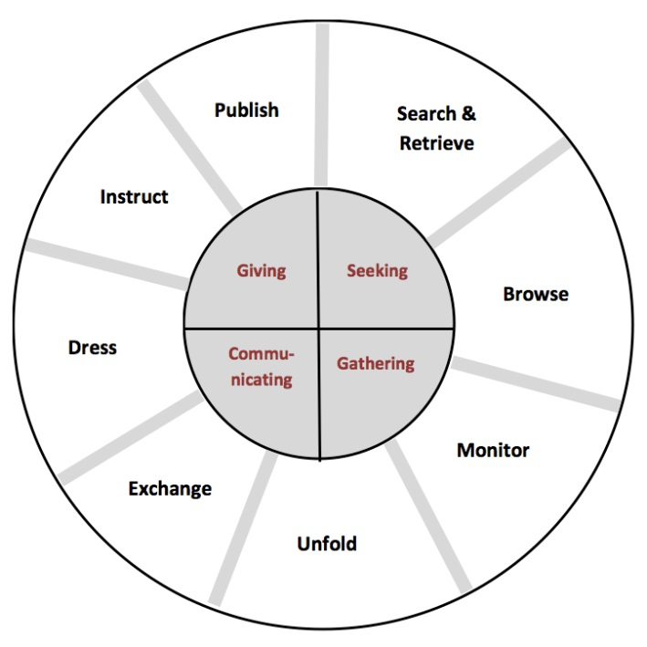
Figure 2: Hektor’s information activities model
- Search and retrieve: describes activities strictly relating to an information-seeking behaviour.
- Browsing: browsing is undertaken as a strategy to find something useful and becoming familiar with the environment.
- Monitoring: monitoring is distinguished from browsing by being directed to a familiar source that is regularly updated, providing stable and valuable information.
- Unfolding: continually directed attention towards an information system e.g. watching and listening.
- Information exchange: the acts of ‘giving’ and ‘getting’ messages in communication.
- Dressing: information activities where information is framed, and a cognitive product is externalized i.e. something is produced.
- Instruct: part of an information-giving behaviour, where the giving is social from an individual to an undistinguished group.
- Publish: activities where an individual gives information by posting it for others to take part in e.g. posting on a website or comment page.
The model will be used to guide the design of the research, and therefore structure the consequent discussion of the results. The discussion will assess whether the data gathered on pop music fan information behaviour can be adequately supported by Hektor’s model.

Research approach
This research is based in the LIS field, however, the influence from other disciplines, predominantly fan studies, cannot be ignored if accurate conclusions can hope to be drawn.
In Price’s PhD thesis on cult fan information behaviour, she draws a strong contrast between the research methods and approach of LIS versus fan studies. Price argues that fan studies has historically been more concerned with the socio-cognitive aspects of research, producing qualitative results, whereas LIS is often more focused on examining processes and producing quantitative results, and that fan studies often focuses on the actions of individuals via case studies or interviews, compared to LIS, which usually studies large groups to gain a consensus. This divide between the two disciplines makes it difficult to consider what would be the best research method to gain an accurate insight into the information behaviour of a specific large group in a relatively short amount of time, with only one round of research being possible.

After some consideration of the objective outlined, and recognizing time and material constraints, it was decided that a questionnaire survey, completed online, would be the method of primary data gathering. In the literature surveyed, this was a common method in both LIS and fan studies. The reasons for this included:

- The survey could be structured around Hektor’s model, and logically lead to a more structured discussion and analysis of results.
- The ability to design the questionnaire to lead to a mixture of quantitative and qualitative results, and thus a more complete picture of the behaviour surveyed.
- The format allows time for consideration when answering the questions, promoting self-reflection, and the ability to get a picture of fan’s general information behaviour, which is likely to have developed over a period of time.
- The possibility of targeting fans across multiple strands of interest e.g. those interested in more than one music group/subgenre.
- The survey is issued online and can therefore reach fans that are often geographically dispersed and diverse in their characteristics. This reduces the chance of local bias and is likely to be more representative of the group as a whole.
- The online format will allow dispersal of the survey across a large number of fans, and to target fans at their sites of congregation online, making it possible to get a large sample size.
- Fans are historically self-reflexive and interested in academic study of fandom, and it is therefore likely that on the whole they will be eager to take part in the survey and give honest and thorough answers.

Research sample group
As the research questions are focused on a specific group, a purposive sample was needed. Participants need to have some level of self-awareness in assessing themselves as a fan; simply surveying the general public, most of which do not partake in typical fan activities to a large extent, would produce results of little use. Furthermore, as stated in the introduction, fans are not a homogenous group. Although the definition of a pop music fan was made clear in the research, it was considered sufficient enough if fans classified themselves – there was purposely no gatekeeping with regards to who counts as a fan or not.

Ethical issues
Undertaking any type of survey involving people requires consideration of ethical issues. Due to the personal investment of many members of fan communities, this was especially important. Many fans use alternative names or pseudonyms to prevent a link being made between their fan activities and ‘real’ lives. To maintain this privacy, all data would be anonymised, with no names being gathered as part of the survey, and any data that may be considered identifiable would be redacted.

It is also worth considering what impact my own experience as a fan has on this work from an ethical perspective. Although it will be advantageous in gaining access to a larger base of possible survey participants, my identity can also be problematic. Freund and Fielding have considered the conflict of holding this dual identity as an ‘acafan’ (academic-fan). Holding a position as a fan myself and also as an academic researcher means I have power over the group of fans being portrayed, and it is important that I do not let my own views or opinions have an impact on the research. Not doing so may impact on the accuracy and extent of data the fans are willing to provide, if they consider I will not be representing them fairly.
In this case, it seems important to follow Busse and Hellekson’s proposal of putting ‘fans first’ by respecting their privacy and identity. The research proposal was approved by the departmental ethics advisor (Appendix 1), and a consent form (Appendix 2) was to be completed by all participants.

Creating the survey
In order to lead to a logical analysis of Hektor’s model, the survey questions were modelled around each of the eight defined information activities (see Appendix 3 for screenshots of the survey live online). Some sections produced more questions than others, and there was a mixture of question formats from open text boxes to scales, in order to produce quantitative and qualitative data. There were 22 questions in total.

Survey distribution
The survey would be issued online via URL link and was created on Opinio. Initially, the link would be posted at common sites of fan congregation, via my own social media accounts, such as Facebook, Twitter and Instagram. However, fans would be encouraged to spread the link to the survey if possible, in order to access and harness currently unknown areas of fan congregation, in public or private.

A blog was produced using Tumblr to advertise the survey (Figure 3). Having used Tumblr in a personal capacity, I was aware of its strengths in creating posts that can be reposted and responded to, and thus spreading across networks of users that may not otherwise be reached. Tumblr is a popular site online, and academic studies have highlighted its ability to gain ethnographic insights due to each Tumblr user tailoring their own content ‘dashboard’. A Tumblr blog is free to use and quick to set up, with a custom URL, which was also attractive. The posts on the blog (www.seriousfans.tumblr.com) no doubt helped gather participants for the research.
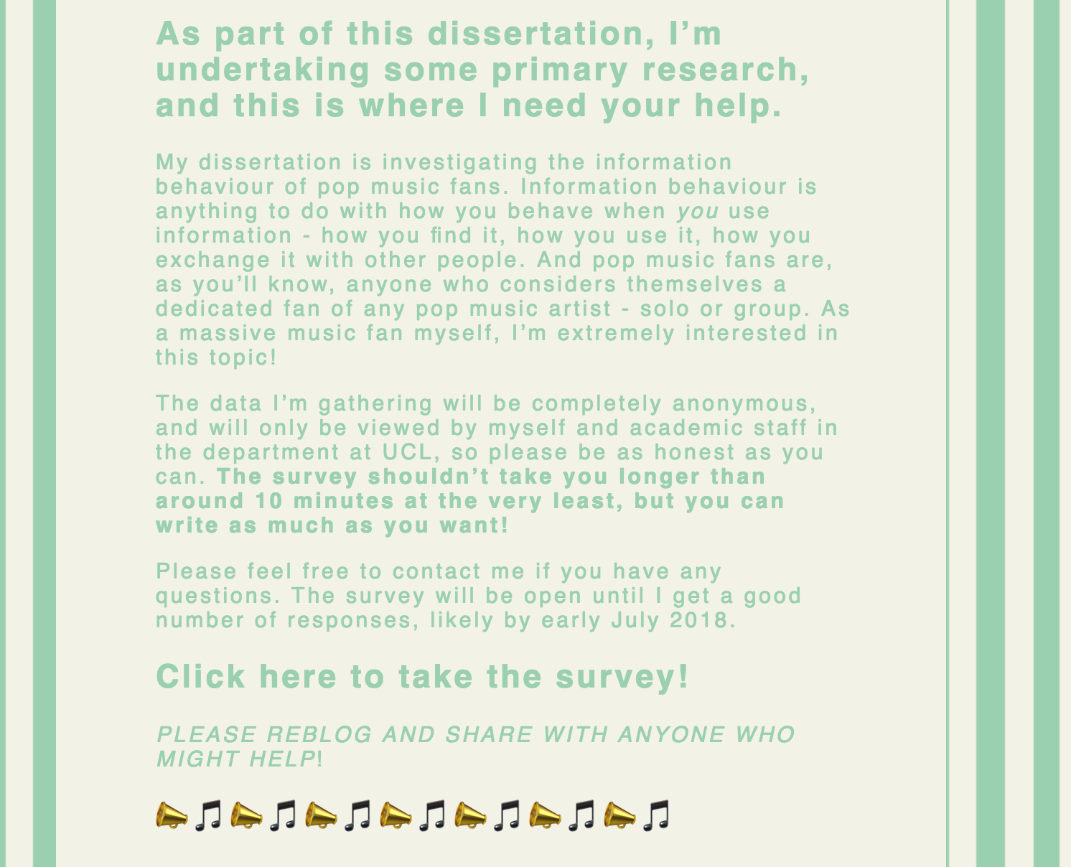
Figure 3: Screenshot of post on Tumblr blog appealing for survey participants, taken from www.seriousfans.tumblr.com [Accessed 19 August 2018].

Results
This section presents a selection of results chosen from the 22 questions asked. The survey received 380 hits, with 135 completed surveys. A selection of the coded data can be seen as an attachment. The results are grouped according to Hektor’s model.

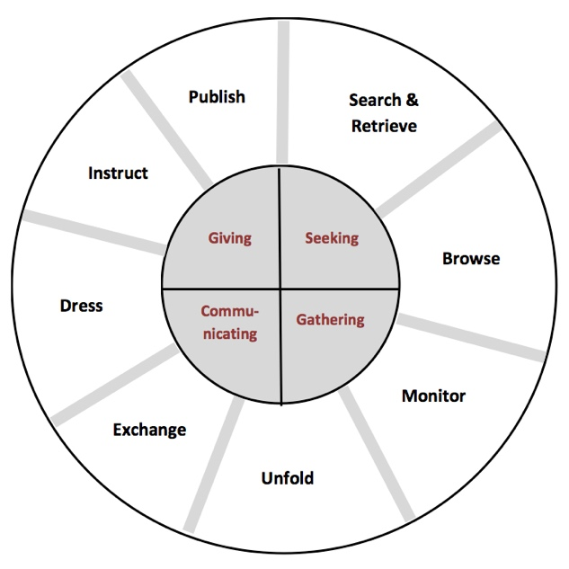
1
8
7
6
3
2
5
4
Figure 4: Edited representation of Hektor’s model of information behaviour

Search and retrieve
‘Search & Retrieve describes activities strictly relating to an information-seeking behaviour. It is very much an active and directed behaviour.’

Figure 5: 4. Which resource do you consider most valuable if you are seeking information about a particular musician you are interested in?

In Question 4 (Figure 5) there was a clear preference for social media accounts run by fans, followed by social media run by official sources, and other fan-run resources such as websites.
The main reasons given for the preferences in Question 5 were:
- Easier/more accessible/quicker to use
‘I don’t have to go out of my way to find information about an artist I like’
- In-depth information synthesized from many sources
‘Fan-created websites and blogs usually collect news from multiple resources and compile them together. It is really nice and convenient, plus very thorough.’

- Most up to date content
‘You can find out about a new release or a tour within minutes’
- Reliable/accurate source
‘Fans tend to collect and share everything, from something published that very day to the most obscure, decades old photos, articles and videos. Official websites or official social media only showcase a smaller proportion of what’s out there to read, listen to, or watch.’

In Question 6, when asked how important it was to meet people face-to-face/read printed materials for information compared being satisfied getting all information regarding music online, 74% (141 of 178 answers) stated that they were happy to get all of their information online;
‘I think now there is so much informative and interesting material online it would be a missed opportunity to disregard it.’

‘I’m fine with getting most of my information online. A lot of print media ends up online anyway…’

26% did express a preference for physical information resources, but were satisfied with getting information online, with most of these respondents commenting on the limitations of print media;
‘I like to read print information like books and magazines if I really love an artist, in addition to online sources. But that’s really only favourites, since print resources cost money and need space to be stored.’

‘Printed material about them becomes a pricey imported indulgence.’

Browse
‘Browsing is undertaken as a strategy to maybe find something of high value, and surely getting familiar with the environment, which is perceived to be a value in itself.’ - Hektor

In Question 7 (Figure 6), the most common reasons for browsing for music information by fans was to understand their favourite music better in a technical way, and to collect information for personal use.

Figure 6: 7. What motivates you to find information about your favourite music? Choose up to 3 reasons.

When asked which specific information resources they used, Tumblr was the most frequently mentioned answer, followed by Twitter and a variety of fan sites, with relative popularity shown in the word cloud in Figure 7.
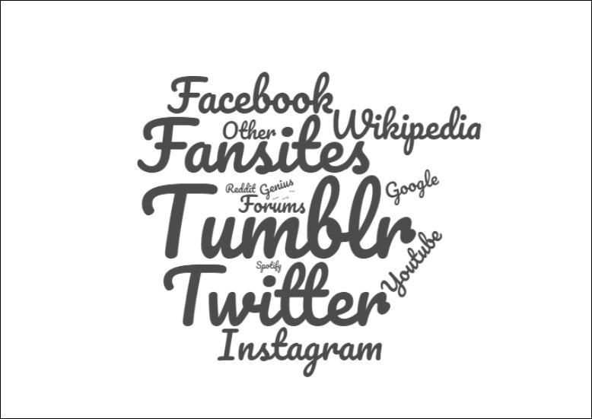
Figure 7: Word cloud made on wordclouds.com, showing relative popularity of online locations mentioned by respondents in Question 8 via tally chart. Word size represents relative frequency.

Monitor
‘Monitoring reaffirms the agent by providing a stable and predictable form and, in part, supplies valued information’ - Hektor

In Question 9, 95% of respondents (139 of 146) stated that they do actively monitor and keep up to date with music information via a variety of sources mentioned previously in Question 8 and highlighted below.
‘I keep up to date with the social media the most, because I follow various accounts and it comes up in my timeline without me having to look for it’

‘If the artist has a tour/record coming up then I subscribe to the newsletter, so I can know things beforehand.’

‘I’ve set it up that I get phone alerts when certain accounts post so I don’t miss anything, and it saves me having to scroll through loads of rubbish!’

‘I have a twitter list focused on my favourite artist which shows me all the latest information from many sources, official and fan pages, and I glance at it several times a day. All the breaking news I get about the artist has reached me via Twitter.’

In Question 12, around 50% (69 of 136) stated that false information is a problem in music fandoms and within the sources they monitor;

‘It’s fairly common, and does create conflict, in that there’s a lot of disagreement about whether specific info is true/false…’
‘False information is common and often ridiculous or mean-spirited…’

Around half of these respondents then said that this false information is detected, evaluated and corrected by fans frequently;

‘Most fan sites and accounts are held to account by the fans so rigorously that if false information is posted, it’s pointed out almost immediately’

‘Fandom self-police hugely.’

‘We’ve learnt to look at everything with a critical eye.’

Around half of respondents said they did not encounter false information as a fan, although a large proportion recognised it was a problem even if it did not affect them personally.

Unfold
‘A term that is suggested to denote activities of continually directed attention towards an information system and the symbolic display it offers.’ - Hektor

Figure 8: 13. Is your preferred area of fandom mostly online or offline?
As supported by responses to earlier questions, online is the main location that fans pay attention to in order to receive information, i.e. the site where they ‘unfold’ information, although a proportion preferred to direct their attention to a mixture of online and offline sources (Figure 8).

In Question 14 (Figure 9), there was an almost 50/50 split between the two options offered, regarding the content of information sought by fans.

Figure 9: 14. What is the most important aspect of music to you as a fan, and what do you want to find out more information about – the artist or the music itself?

This was a closed question, where respondents could only choose one answer, meaning more detailed, open questioning could produce results that are easier to analyse here.

Exchange
‘Exchange is intended to represent the acts of ’giving’ and ’getting’ messages in a communicative behaviour.’ - Hektor

In Question 15 (Figure 10), 70% of respondents stated that they liked to communicate with other fans to exchange information, and this answer was coded further to indicate the frequency with which this communication takes place, which varied widely.

Figure 10: 15. Do you like to communicate with other fans in the fandom to exchange information, either online or in person e.g. via private messaging or a forum? If so, how often do you do this?

The frequency varied between periodic contact between connected fans;
‘You end up with a sort of network of other fans on social media sites’

‘I've gotten to know a couple on twitter and the odd photo is exchanged showing off your haul of vinyl’

To very frequent contact between close fans, often taking place in private online spaces;
‘I get anywhere between 5 and 200 messages from group chats in an hour’

‘Multiple times a day. Some of my dearest friendships have been formed online and are long distance…’

Subsequently, and unsurprisingly, the most popular reason by far for exchanging information with other fans, asked in Question 16, was for social purposes (Figure 11).

Figure 11: 16. Which is the most common reason you exchange information with other fans?

Dress
‘The name for activities where information is framed, and a cognitive product is externalized (consciously or not) by acting individual.’ - Hektor

In Question 17, 60% of respondents said they had used information in a creative way, with a large proportion creating art, fictional and non-fiction writing that was influenced or based on a music artist.
‘I have used songs as inspiration for original pieces of writing, if a song seems interesting and tells a story I love to flesh it out and make it apart [sic] of something bigger’

‘The artists I look up to heavily influence my writing and other artistic endeavours, and I've made zines about artists. I see it as a way to pay tribute, and I can't help but be inspired by their work and have it bleed into my own’

‘I see it as a safe way of practicing my writing skills, and I also use it as a bit of a release’

A smaller proportion were influenced via lifestyle choices such as fashion.

‘I’m constantly inspired my musical heroes’ fashion wise’
‘I was thinking of dressing up […] to demonstrate to other people my interest in music history.’

Those who did not directly use information in a creative way said they often preferred to consume other’s creations instead of creating;
‘I am not a creative person. I prefer to enjoy other people’s work and share my opinion on it with them.’
‘The likes of fanart or fiction were a way to consume more to do with the artists beyond their music’

Instruct
‘The giving [of information] is social but unidirectional from the individual to an anonymous or generalized counterpart.’ - Hektor

In Question 18, 90% of respondents agreed with the idea that certain fans know more information than others, although the majority of those that agreed said that these fans were viewed in a positive way, as they held valuable knowledge that others did not and would often share it;

‘More knowledgeable fans aren’t treated better by others but are appreciated as source of fanlore and perspectives that come from greater knowledge’

‘Yes, a lot of passionate and/or long term fans do, I’ve got a lot of respect for those types but I don’t personally view them as superior or anything, they’re like cool librarians.’

‘They are often treated as a human Citeme for lost interviews and things like that’

Others noted how some fans were more skilled in finding information, or had a job or position that enabled them to gain information not widely known, and so were viewed more positively by other fans because of that;
‘We all have the same access to information online, but some of us are more skilful about searching for it. When another fan is asking for information via social media, I am very quick to respond with that information because I have a database-like memory for original sources and can find it efficiently’

'Yes, access to information or being an 'insider' is highly valued. Information is traded like currency.'

A relatively small proportion of 25% said they had contributed to a shared fan resource, with most stating they had edited Wikipedia or posted on social media fan sources;
‘The only online resources I’ve contributed to is social media, because I always feel like official fan sites and wiki pages are quite formal and I don’t feel like I’ve got the authority to contribute to them, whereas social media feels more open and informal’

The motivation for contributing was most frequently the desire to share their knowledge with others;
‘Yes, I just think if I found information or images or whatever through my own personal interest and it’s not already curated somewhere it can be beneficial to future fans to have access to it without struggling to find it like I might have’
‘I have so because I wanted this information to be public for others interested in learning more about an artist with more of a niche audience’

‘I was trying to find a comprehensive resource related to them, there wasn’t one, so I decided to make my own’

Publish
‘Publishing information is different from instruct-activities by being less administrative, more personal and often more extensive.’ - Hektor

Question 20 (Figure 12) found that the majority of fans surveyed take part in some form of discussion across a range of online spaces, the names of which was counted via tally chart. Nearly half of all respondents communicated very frequently with other fans; 25% said they did not take part in any discussion with other fans.

Figure 12: 20. Are you involved in a community where you discuss information about your chosen artist, such as a group online or offline, or via social media? If so, please specify which.

These varied between;
- Private chat
‘I am part of a Whatsapp group that’s based just on sharing fics [fanfiction] but we talk about a lot of other stuff too’

- Forums
‘The group was created for fans to share information about the general admission line, finding accommodation for those who were travelling, and the like’

- Social media
‘I am a member of a couple of Facebook groups. I am also involved in fan communities on Twitter, Tumblr and Pinterest.’

- Blogs
‘I’m also running two Tumblr pages. I started my first one about Marc Bolan because I had about 2000 photos of him in my laptop, some of them quite rare, and I wanted to share them […] I feel like I'm really helping to keep the Bolan fandom alive, because I've accidentally become one of the biggest Bolan fan sites on Tumblr!’

When asked to consider aspects of sharing information collectively (publishing online and discussing), in Question 21 (Figure 13), the highest proportion of fans agreed that collective knowledge and receiving information from other fans is important, with a large number also agreeing that this concept has had a positive impact on their lives:
Figure 13: 21. Which of these statements do you most relate to regarding ‘collective’ areas of fan information/knowledge? Please choose 3.

In Question 22, which was open to any comments, a number of interesting additional thoughts were shared, which covered a number of topics that are worth highlighting.
- Ownership of information
‘The relationship fans have with "sourcing" content is very strange […] Many people discount sources as unreliable based on allegiance of the source.’

- The value of fan’s work
‘I think the work that fans do to share information about an artist is both misunderstood and undervalued […] Many major fansites and accounts are incredibly organized and professional […] I think it should be acknowledged, especially now that the economics of the artists themselves heavily rely on their work and support.’

- The aspect of choice regarding information
'I feel that now WE can use the (social) media to relay information WE are able to make choices to follow/listen/buy etc. based on information WE feel is relevant to why WE would make these choices. Several years ago, we only got what the news or papers wanted us to know.'

- How availability of information has changed fandom
‘The availability of fan info online has completely changed the way I am as a fan […] I am in my 40s so for much of my time as a music fan, the only information I had about a band was whatever was printed in the cassette or CD booklet […] I was isolated and could only make guesses about what I was listening to. It’s such a different world now.’

Discussion
The results from the previous section can be studied within the Hektor framework used, in order to consider how valuable this framework is in characterizing the participants.

- Search and retrieve

From Question 4 and 5, social media accounts run by fans were clearly the most popular option for the process, followed by fan-created websites such as wikis and forums, showing how most of the fans surveyed undertake the ‘active and directed’ process described by Hektor at any source with a fan influence. The results across echo those of the Kostagiolas et al. and Margree et al. studies of a community concert band and record collectors respectively; in both studies, the groups would most often choose to obtain information from informal, online sources, rather than more formal sources often found offline. There were several reasons for this choice in the results;

- Easier/more accessible/quicker to use
Speed and ease of obtaining information through social media is the format’s main attraction to fans, showing how the easily updated design of social media lends itself to the constantly changing information landscape that exists around many music artists, allowing those who contribute to the source to update as often as needed.
- In-depth information synthesized from many sources
The content of fan-made information sources was also an important element, with many commenting on how these sources often held a wealth of older material that may be otherwise difficult to find. Another frequent comment was how fan sources effectively synthesize information from many different sources, making it quicker and easier to retrieve the desired information, as ‘you only have to go to one place instead of several’, an example of what Thomas Mann called the principle of least effort, where the user chooses the easiest, most accessible information sources, regardless of quality. Mann said this principle exists across all information environments, and so therefore it would fair to describe fan made sources as an online library, containing multiple formats of information in one place. The enthusiasm and dedication of fans means these resources are extensive and well-kept.
- Most up to date content
Many answers drew comparisons between fan made sources and official artist-run sources like websites, and highlighted the shortcomings of these sources, often mentioning them negatively. Some said that fan sources provide a wider range of information not found on official sites, such as videos and images rather than just text, and are updated more frequently than official sources, which tend to focus on formal information such as announcements rather than the minutiae fans often seek. To quote one respondent; ‘fans know what other fans want to know’.

- Reliable/accurate source
Some respondents commented that judgement of reliability impacts their information search, saying how official sources will only detail ‘the specific, curated image of the artist’, showing how fans have a discerning nature between which sources provide them with what they want to know. For example, one respondent stated that they run a blog which details the fashion of boyband One Direction – this information is not found from official sources run by the band, but through independent research initiated by fans themselves, who spot a gap in information that they want. The desired acquisition to search and retrieve information is therefore closely linked to the technical, analytical and interpretive skills that Abercrombie and Longhurst describe fans as practicing. It is evident that fan made resources are filling a gap in terms of what official sources do not, or no longer, offer.

In Question 6, most respondents were happy to search and retrieve using only online sources, although a small proportion would have preferred offline/print resources. There was an acceptance by these respondents that printed sources were not always the best option, listing the common disadvantages of print material in information settings: ‘print resources cost money and need space to be stored’.

- Browse

When asked in Question 7 for the motivation of their information search (i.e. what initiates the browsing behaviour), many fans did identify with the motivations of connection with artists and displaying their own creative skills, as identified by Duffett’s research into the most popular fan practices. The most popular answer was ‘to better understand or interpret the music I love in a technical way’. Anecdotally, there is often a predominant focus on the music artist as a personality, so the popularity of this answer was surprising. The second most popular motivation to browse was ‘to collect information for my own personal use’ which supports the hypothesis that pop music fans are greatly interested in gathering information for themselves. This echoes what was found in Margree’s study of record collectors, regarding the value of building up a personal collection, although in this case, the collection involves information, as well as physical media such as records or merchandise.

In Question 8, the most popular source browsed was Tumblr. Although it would require further research to discover what exactly makes Tumblr such an appealing source for fan browsing, it is clear from variety of the URLs mentioned in the responses that countless different blogs exist for each artist, giving a wide variety of options of sites for browsing. Social media such as Twitter and Facebook were also popular sites for browsing, again admired for their quickly and easily updated format, with 'chains' of links between pages on the site, which encourages browsing. It is clear from both questions that the findings suggest fans will gravitate towards sources that are optimal for browsing, and this supports the hypothesis that fans fit the hedonic motive of music information seeking defined by Laplante and Downie. Their search for music information is for pleasure and not a particular purpose such as learning an instrument. It is most often a non-goal orientated search, one without discrete start or end, as shown by the prevalence of the browsing behaviour. This undefined, vague style of browsing could have implications for future design and structure of music information retrieval sources, as Lee’s study into the shortcomings of existing retrieval systems had similar findings, and suggested considerations in designs such as allowing users to browse their resources without inputting specific queries, allowing indirect and indiscrete browsing behaviour.

- Monitor

Nearly all fans demonstrated the monitoring behaviour, to some extent, in Question 9. The action of monitoring is a mostly passive action, rather than something active. By ‘following’ artists fans are interested in via social media, many different ‘strands’ of information are amalgamated in one place, allowing accumulation of information in a constantly updating feed, which can then be checked whenever desired. This concept of synthesis could be linked to Booth’s ‘narractivity’ theory of a ‘web commons’ being created in an online space, where fans and information congregate virtually. This action enables monitoring to be easily and quickly done, with minimum time and effort to be spent once a reliable source has been located via retrieval and browsing, again showing the principle of least effort. This monitoring corresponds to Hektor’s definition of a ‘stable and predictable form’ of source that is returned to repeatedly; monitoring a source (e.g. by following it on Twitter) is a sign of ‘trusting’ it to meet information needs incidentally.

There were frequent comments from respondents about how their monitoring behaviour would increase around times of increased activity by the music artist, such as around releases or tours. This shows that although monitoring is an ongoing process (see Question 15), there are periods where increased activity occurs, and the passive behaviour becomes more active as users monitor more closely.

An alternative way of examining monitoring would be to focus on the ‘valued information’ part of Hektor’s definition, implying that information found may not always be valid or useful i.e. it is not ‘valued’. This connects to Question 12, regarding how common false information is within music fandom. When false information was present, many respondents commented that information is monitored and validated for authenticity by fans, by actions such as fact-checking or asking for ‘evidence’ such as photos. This practice was referred to more than once as ‘self-policing’, showing that monitoring of information value is a self-reflexive practice for fans; they do it for themselves in order to be assured of valuable information, and could be seen as a form of information literacy according to the CILIP definition. It furthers the idea that monitoring co-exists as passive action but also as an active process - it requires effort on the part of the fan to 'think critically'. Monitoring has a cumulative effect, with many fans noting that reliable sources become clear and more trusted over time, which could be linked back to the browsing behaviour. As a source is monitored and becomes known for valued information, it becomes a notable resource for browsing, as word of reliability spreads.

- Unfold

It is unsurprising that the most popular area to practice ‘unfolding’ (paying attention to something) to information is online. Information online is always in flux as users interact with it via unfolding. The online sources used by fans function as a decentralized and dispersed space for information appropriate to the format the user desires; for example, there are spaces online for fans to watch music videos, download or stream music, discuss music with others, or view related images. This variety of streams of information mean that fans can constantly engage in the unfolding behaviour online. Nonetheless, there was still some preference shown to using a mixture of online and offline sources. Two respondents commented that they would have preferred that ‘offline resources were as readily available and widely used as they once were’, suggesting that although they have accepted online sources, the materiality of offline sources such as books and magazines are still appreciated.

Question 14 offered an interesting result regarding information content, with an almost 50:50 split between those who considered the artist or the music the aspect they wanted to gain more knowledge about i.e. where their unfolding behaviour is most commonly directed at. This is a consequence of the type of media being studied; as music artists exist in real life, they exist as information-rich subjects, which has an effect on the resources preferred. Fans wanting to interpret lyrics will access different sources and use them differently than fans who wish to interact with the music artist personally, who prefer sources that allow what Kehrberg calls parasocial interaction (perceived relationship between fans and famous figures). This variation should have an impact on how music information retrieval systems are designed and used, in order to facilitate the unfolding behaviour for different groups of fans.

- Exchange

In Question 15, the majority of fans undertake some level of information exchange. This is facilitated by the creation of informal networks both online and offline. As mentioned previously, many fans stated that the frequency of information exchange constantly changes along with the rate of activity of the artist they are interested in, with exchange increasing in these networks around special events, making exchange a dynamic and variable process.

The creation of these networks is by repeated exposure; as fans undertake the monitoring and unfolding behaviour repeatedly in the same spaces, connections and relationships develop, which in turn help facilitate other information activities. Many respondents gave the example of establishing a Twitter or Tumblr account, ‘following’ other fans, interacting with them, and gathering and imparting knowledge in a bidirectional exchange, such as interpreting lyrics and swapping media. One fan said they talk to other fans in order to discuss writing fanfiction, an example of the exchange behaviour leading directly to the dress behaviour. This could be said to show the ‘career’ type progression of the serious leisure perspective, as fans develop their information behaviour over time. The process of acquiring knowledge in the exchange behaviour reaffirms social ties.
Interestingly, a proportion of respondents stated that they rarely take part in information exchange. Some said they preferred to receive information rather than impart it, and there was frequent reference to the common concept of ‘lurking’ online. This seems to be simply a personal preference; some fans feel shy about interacting with other fans or find their information needs are satisfied without having to practice reciprocal information exchange.

- Dress

A large proportion of respondents in Question 17 said they had used information in a creative way by 'producing an externalized cognitive product' e.g. writing or producing music, what Jenkins would call ‘cultural production’ and Fiske ‘textual productivity’, therefore showing the fans surveyed engaging in what has been recognised by other researchers as common fan practice. Fandom is used as a cipher to practice and refine producerly hobbies that fans already have, and the dress behaviour has immense personal significance. These fans are acting as both producers and consumers simultaneously, consuming knowledge in order to produce, an example of the increasing practice of fans becoming ‘pro-sumers’, as noted by Korobkova, who says that such behaviour can be used to develop skills outside of fandom.

This behaviour works with the concept of the utilitarian view of music information-seeking defined by Laplante and Downie, where such information is sought and used for a specific purpose i.e. to create something/to improve creative skills. Although fans predominantly fit the hedonic outcome, the utilitarian outcome is undertaken by fans as they practice the ‘dress’ behaviour in the model.

A fairly large proportion of respondents said that although they had not produced any media such as fanfiction or fanart, they were often influenced by the lifestyle of their favourite artist e.g. fashion. This shows an aspect of fan productivity that may not have been considered before, due to the predominant focus of previous fan studies on media fans rather than fans of ‘real life’ celebrities. The knowledge of the artist, such as their iconic appearance, is used in a creative way indirectly, and so can be considered as part of the dress behaviour. Conversely, the ‘real life’ nature of music artists is what many fans attributed to their lack of engaging in this behaviour, stating they felt uncomfortable producing work about real people who they did not personally know.

- Instruct

There was recognition that the instruct behaviour is vital to the structure of a fandom. In Question 18, a large number of respondents recognised a hierarchy within the fan community, with those fans at the top of the hierarchy being more well-known than others. These fans serve as starting points for those wanting to receive ‘instruction’ on music information. This hierarchy has been observed by researchers previously, and echoes what Laplante defined as ‘opinion leaders’ in a music-based information setting. The reasons for this knowledge hierarchy were various. Some said it was dependent on age; older fans, who have been interested in the artist for longer have inevitably built up more knowledge; whereas others believed that some fans had simply put more effort into researching and gathering knowledge, and so their voices had become more amplified and known as reputable and knowledgeable. It would be interesting to consider where different fans within the hierarchy fit into Abercrombie and Longhurst’s spectrum of media audiences – are fans placed higher in the hierarchy more likely to be producers, or have more in-depth technical knowledge? This would require research on a more granular level. Interestingly, these leaders who have more knowledge were described in this question as ‘like cool librarians’ and ‘a human Citeme’, showing how they are seen as sites of reference in LIS-related terms.

The view of these ‘opinion leaders’ was positive, with many saying that these fans were helpful and generous with their instructing behaviour. The attention and prestige given to individual fans who share information suggests that knowledge forms a source of what Fiske calls cultural capital. It is interesting to consider how music artists might use this hierarchy to their advantage. A quote from a manager at a creative agency said in The Independent: ‘Those who demonstrate a deeper level of engagement are hand-picked […] and given access and information that isn’t public’. Here, information is already being capitalised upon as something of value for both fans and artists.

Surprisingly, given the important presence of knowledgeable fans with fandom, that only a small amount of those surveyed said they had contributed to a shared fan resource, such as Booth’s 'web commons', or Jenkin’s concept of an interpretive community in convergence culture. This could be due to the uncontrolled nature of the sample group - those who do frequently share knowledge simply did not take the survey. Those that did contribute to shared resources did so because they felt they had unique content or interpretations to contribute (such as photographs, setlists), and had a desire to share these with other fans. It is a pleasurable activity, done out of generosity, not for profit-motivated reasons, as Jenkins suggested. This demonstrates that fans are generous with the information they ‘instruct’, and the instruct behaviour is one that can only exist via social links.

- Publish

The publish activity is a practice of collective knowledge on a smaller and more personal scale than the instruct behaviour (e.g. running a blog, editing a fansite). There were several spaces mentioned repeatedly as favourite locations to discuss information;
- Private chat
Fans often prefer to talk privately with a small, select number of other fans on apps such as Facebook Messenger, Whatsapp and text messaging. These conversations take place in groups and on a one-on-one basis. Conversations are often formed out of, or lead to, friendships and discussions that are not wholly based on the common interest in music – fans said how they will chat about 'other things', not just the artist. The publish activity is vital to the social aspect of fandom.
- Forums
Forums were mentioned by several fans, although many said they no longer use them frequently. This echoes Deller’s longitudinal study of music fans. Over the 10 years of the study, starting in the early 2000s, the use of early internet-based communities declined, as fans moved the site of discussion elsewhere. Although this research does not cover such a timespan, it is reasonable to assume that a similar thing happened across many music fandoms.
- Social media
Social media is a hotspot for fan interaction. Many respondents mentioned Facebook groups as a popular space, allowing discussions to take place in a more public setting, fitting the publish activity. This public setting allows many to ‘lurk’ and observe, consuming information passively, as mentioned in the exchange section.
- Blogs
Tumblr has emerged as one of the most popular knowledge spaces for fans. Many said they had their own blog which they dedicated to their musical interests. The personalisation of Tumblr, where fans can post and consume content via a self-curated feed, makes it an ideal space to practice many different information activities detailed here.

The use of the word ‘community’ in Question 20 often appeared as an important part of the publish activity. One respondent mentions the phrase ‘micro-communities’ which captures accurately what occurs in spaces such as group messaging. This emphasis on community fits one of the six aspects of serious leisure defined by Hartel. The information behaviour of music fans is characterized not only by fans relationship to the source (music information) but by their engagement with each other.

Leading on from knowledge sharing in this activity, Question 22 showed that fans recognise the characteristics of collective intelligence in their practice, which were explored from a fan perspective by Jenkins, from the initial theory by Levy. The most popular statement in the question was ‘No fan knows everything – but together, we can pool our knowledge to know more’ echoing the theory succinctly. There is consensus amongst fans that their knowledge can be broadened - each fan contributes different knowledge, which can be combined and create a more ‘whole’ picture in terms of information.

There was acknowledgement in this question of the positive effects of collective intelligence, with the third most popular statement being ‘joining in on the community has had a positive and significant contribution to my life emotionally’, reinforcing the idea that being involved in fandom and sharing knowledge works as a bonding activity, affirming identity on a personal and group level. This corresponds with the definition of serious leisure as something that has durable benefits, personally and socially.

The insights of the research provided can lead us to several general conclusions about the information behaviour of music fans, unrelated to the model used. These can be summarised as follows:
Findings

- Fan information behaviour is participatory and collaborative.

- Fans prefer online, informal sources.

- Their information behaviour is often socially motivated.

- There is evidence of hierarchy within groups of fans.

- Collective knowledge is important to fan information behaviour.

- Social media is a key ‘meeting place’ for fans.

- The frequency of communication between fans often matches music artist activity.

In the conclusion, a new version of the Hektor framework will be created, in order to show how the results discussed here fit the chosen model.

Possibilities of future research mentioned previously will be furthered in the next section.

Limitations and further research
The survey format of this research has limits due to sample size; participants were self-selecting. This gives only a snapshot of a comparatively small number of fans. Ideally, the results of this research could be furthered by being compared with investigation into other interest groups. These could be fans of other media or hobbyists such as amateur musicians, who are more likely to use music information for utilitarian purposes. By examining these groups and their information behaviour in the same format as this research i.e. using the Hektor model, similarities and differences will be clear.

More granular research could be undertaken. In order to obtain a wide range of results in the timescale, the questions asked had to be worded in an inclusive way that was not always specific. This limitation has an impact on the clarity of the data gathered. For example, fans were asked what resources they use to browse information, leading to numerous sources being listed, which were grouped into the most commonly mentioned sources by coding. This could be surveyed in a more detailed way e.g. asking if they undertake specific processes such as tagging or tracing specific search paths as they retrieve goal-orientated information.

Exploration of peripheral themes that emerged from the research was limited by the length of this study. This includes how fan taxonomies work (as many said they build personal collections) and more about verifying authenticity of information.
The potential for expanding this study demonstrates that LIS theory and fan studies is an interesting area worthy of further study.

Conclusion
It can be concluded that the Hektor framework is, for the most part, a viable model to characterize music fan information behaviour by. The results found also fit the serious leisure theoretical perspective led by Stebbins and Hartel, with its six defining features listed previously. The most evident aspect of serious leisure in this research is ‘durable benefits, personally and socially’. Across many questions, fans commented about how beneficial being part of a fandom has been for their wellbeing, particularly in relation to building social relationships with other fans. It is clear that there are benefits to the information behaviour demonstrated by fans beyond building knowledge individually and collectively.

Throughout the results, there was a common theme regarding the difficulties for fans to identify what is and is not useful or valuable in their information search. There was recognition that information online can be false, requiring critical thinking by fans to consider which information is accurate. It is clear that fans practice information literacy in a non-work context, as defined by CILIP. An ‘evaluate’ section could easily be added to the Hektor information behaviour model, as the original model lacks such an aspect, and its significance is strongly supported in the results. However, the prevalence of evaluatory behaviour throughout the results would suggest that this is an ongoing and constant process that exists throughout all aspects of the model, rather than a discrete 'activity' that occurs separately.
The results of this research are useful for those managing music information retrieval sites such as information systems architects. It would be advisable to support the 'search/retrieve' and 'browsing' behaviours of fans by for example, providing collections of links in one place. The results would be also be useful in helping music artists and their management in planning their strategy with regards to promotion - as shown, online spaces such as social media are the most popular places for fans to congregate, and these should be targeted by music artists as ideal places to disseminate information and build interest. Additionally, it would be advisable for artists to create relationships with fans directly in terms of information exchange, who in turn have influence over other fans, as shown through the prevalence of hierarchies and networks between fans. Harnessing the power and breadth of fan information behaviour could be vital for music artists in the future.

Finally, what is striking about the results overall is that they show fans undertaking various practices very much aligned to LIS, as was hypothesised initially. The information behaviour on display requires fans to retrieve and evaluate information, using appropriate online and offline sources, just as information professionals do in their work. This will have interesting implications for those considering how to study fan activity in the future, and how non-LIS professionals work with information in different contexts.
Drawing together the results from the study, the Hektor model can now be viewed through the lens of this research (Figure 13). As mentioned, an ‘evaluate’ aspect is added, encompassing all activities and demonstrating its significance that has emerged through this original research.

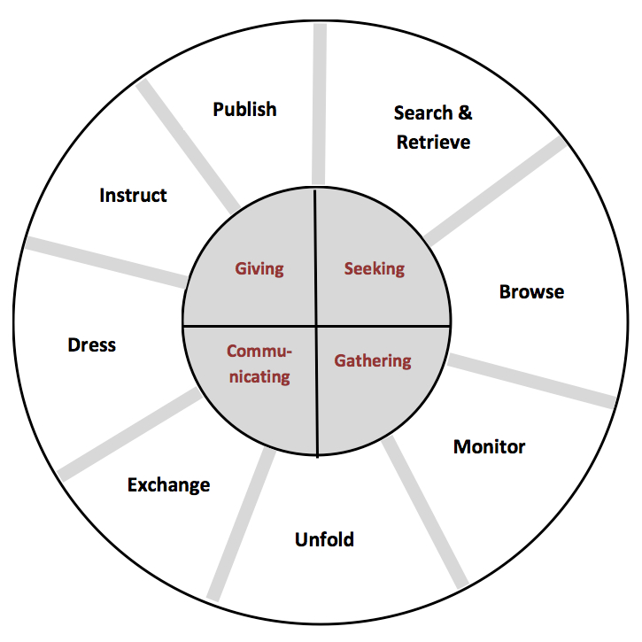
Prefer to use sources made by other fans
Happy to use online sources
Up to date information and accuracy is important

Private conversations are important to fans
Collective intelligence grows from mass publishing
Social interaction has a positive effect on fans
A hierarchy exists within fandom, based on knowledge
Information is valuable and acts as capital in hierarchy
Sharing of knowledge is done out of generosity
‘Following’ sites on social media is key
Frequency of monitoring matches the activity of the music artist
Evaluating and checking validity of information is important
Most fans use online sources for all information needs
Fans are equally interested in the artist and the music
Social networks are created through exchange
Exchange increases around times of increased activity by the music artist

Motivation for browsing is to understand music better
Tumblr a popular site for browsing
Browsing is non-goal orientated, indirect and continuous
Music artists inspire fans to engage in hobbies such as writing and creating music
Lifestyle influences are also common e.g. fashion
Evaluate

Evaluate

Figure 14: The music fan lens on Hektor’s model

Figure 14: The music fan lens on Hektor's model
Bibliography

Abercrombie N, Longhurst B. Audiences. London: Sage; 1998

Anderson T. Still kissing their posters goodnight: lifelong pop music fandom. PhD thesis, University of Sunderland; 2012

Attu R, Terras M. What people study when they study Tumblr: Classifying Tumblr-related academic research. Journal of Documentation [Online]. 2017; Volume 73 (Issue 3), pp.528-554 [Accessed 25 May 2018]. Available at: https://doi.org/10.1108/JD-08-2016-0101

Bainbridge D, Hu X, Downie JS. A Musical Progression with Greenstone: How Music Content Analysis and Linked Data is Helping Redefine the Boundaries to a Music Digital Library. In: Proceedings of the 1st International Workshop for Digital Libraries for Musicology, London, United Kingdom, 12 September, 2014, pp. 1-8

Bamgbade BJ, Akintola BA, Agbenu DO et al. ‘Comparative analysis and benefits of digital library over traditional library’, World Scientific News [Online]. 2015 [Accessed 19 October 2017]. Available at: http://www.worldscientificnews.com/wp-content/uploads/2015/07/WSN-24-2015-1-7.pdf

Bogdanov D, Serra X. Quantifying music trends and facts using editorial metadata from the Discogs database. In: Proceedings of the 18th ISMIR Conference, Suzhou, China, 23-27 October 2017, pp, 89-95

Booth P. Digital fandom; new media studies. New York: Peter Lang Publishing; 2010

Case DO, Given LM. Looking for information: a survey of research on information seeking, needs, and behaviour. Bingley; Emerald Group: 2016

CILIP. What is information literacy? [Online]. CILIP: London; 2018 April 4 [Accessed 10 August 2018]. Available at: https://www.cilip.org.uk/page/informationliteracy

Cox AM, Griffin B, Hartel J. What everybody knows: embodied information in serious leisure. Journal of Documentation. 2017; Volume 73 (Issue 3), pp. 386-406
Dare-Edwards HL. ‘Shipping bullshit’: Twitter rumours, fan/celebrity interaction and questions of authenticity. Celebrity Studies [Online]. 2014; Volume 5 [Accessed 6 July 2018] pp. 521-524. Available at: https://doi-org.libproxy.ucl.ac.uk/10.1080/19392397.2014.981370
De Kosnik A. Rogue Archives: Digital Culture Memory and Media Fandom. Cambridge, MA; MIT Press, 2016

Duffett M. Understanding Fandom: An Introduction to the Study of Media Fan Culture. London: Bloomsbury Academic; 2013

Duffett M. Fan Practices. Popular Music and Society [Online]. 2014; Volume 38 (Issue 1) pp. 1-6 [Accessed 15 April 2018]. Available at: 10.1080/03007766.2014.973764

Duits L, Zwaan K, Reijinders S, editors. The Ashgate Research Companion to Fan Cultures. Farnham; Ashgate: 2014

Ellis D, Modeling the Information-Seeking Patterns of Academic Researchers: A Grounded Theory Approach, The Library Quarterly. 1993; Volume 63 (Issue 4), pp. 469-486

Ewing T, Pop, passion and enemas: how online forums created a new musical culture. The Guardian [Online]. 2018, May 29 [Accessed 29 May 2018]. Available at: https://www.theguardian.com/music/2018/may/29/online-forums-musical-culture-messageboards-social-media-music-essay

Fisher K, Erdelez S, McKechnie L, editors. Theories of Information behaviour. New Jersey; Information Today: 2005

Fiske J. Understanding Popular Culture. London; Routledge: 1992

Freund K, Fielding D. Research ethics in fan studies. Participations: Journal of Audience & Reception Studies [Online]. 2013; Volume 10 (Issue 1) [Accessed 18 May 2018]. Available at: http://www.participations.org/Volume%2010/Issue%201/16%20Freund%20Fielding%2010.1.pdf

Gander K, How Social Media Gave Rise To The ‘Stan’ Superfan. The Independent [Online]. 2016, December 16 [Accessed 25 May 2018]. Available at: https://www.independent.co.uk/life-style/social-media-stan-superfan-twitter-facebook-beyonce-justin-bieber-rihanna-britney-spears-eminen-one-a7477876.html

Gross A, Here’s What It’s Like To Follow Harry Styles Around The World. Noisey [Online]. 2017, November 23 [Accessed 3 June 2018]. Available at: https://noisey.vice.com/en_uk/article/zmzaee/following-harry-styles-fans-around-europe-2017-tour

Hart C, Schoolbred M, Butcher D, Kane D. "The bibliographical structure of fan information", Collection Building [Online]. 1999; Volume 18 (Issue 2) pp.81-89 [Accessed 10 May 2018]. Available at: https://doi.org/10.1108/01604959910265869

Hartel, J. Managing documents at home for serious leisure: a case study of the hobby of gourmet cooking. Journal of Documentation. 2010; Volume 66 (Issue 6), pp. 847–874

Hartel J, Cox AM, Griffin BL. Information activity in serious leisure. Information Research [Online]. 2016; Volume 21 (Issue 4) [Accessed 7 March 2018]. Available at: http://www.informationr.net/ir/21-4/paper728.html

Hasson F, Keeney S, McKenna H. Research guidelines for the Delphi survey technique. Journal of Advanced Nursing [Online]. October 2000; Issue 32 (Issue 4): pp. 1008–1015. [Accessed 18 May 2018]. Available at: http://onlinelibrary.wiley.com/doi/10.1046/j.1365-2648.2000.t01-1-01567.x/full

Hektor A. Information activities on the Internet in everyday life. The New Review of Information Behaviour Research. 2003; Volume 4 (Issue 1), pp. 127-138.

Hektor A. What's the use: Internet and information behavior in everyday life. Linkoping, Sweden: Linkoping University Studies in Arts and Science; 2001 [Accessed 15 May 2018]. Available at: http://liu.diva-portal.org/smash/record.jsf?pid=diva2%3A254863&dswid=6661

Hellekson K, Busse K, editors. The Fan Fiction Studies Reader. Iowa City; University of Iowa Press: 2014
Highfield T, Harrington S, Bruns A. Twitter as a technology for audiencing and fandom: The #Eurovision phenomenon. Information, Communication and Society [Online]. 2013; Volume 16 [Accessed 5 July 2018] pp. 315-339. Available at: https://doi-org.libproxy.ucl.ac.uk/10.1080/1369118X.2012.756053
Hill H, Peckosie JL. Information activities as serious leisure within the fanfiction community. Journal of Documentation. 2017; Volume 73 (Issue 5) pp.843-857

Inskip C, Butterworth R, MacFarlane A. A study of the information needs of the users of a folk music library and the implications for the design of a digital library system. Information Processing & Management [Online]. 2008; Volume 44 (Issue 2) pp. 647-662 [Accessed 7 April 2018]. Available at: https://doi.org/10.1016/j.ipm.2007.05.004

International Society for Music Information Retrieval. ISMIR [Online]. ISMIR: Canada; 2017 [Accessed 7 April 2018] Available at: http://www.ismir.net

Jenkins H. Convergence culture : where old and new media collide. London: New York University Press; 2008

Jenkins H. Fans, bloggers, and gamers : exploring participatory culture. New York: New York University Press; 2006

Jenkins H. Textual poachers : television fans and participatory culture. London: Routledge; 1992

Kehrberg AK. ‘I love you, please notice me’: the hierarchical rhetoric of Twitter fandom. Celebrity Studies [Online]. 2015; Volume 6 (Issue 1) pp 85-99 [Accessed 5 August 2018]. Available at: https://doi-org.libproxy.ucl.ac.uk/10.1080/19392397.2015.995472

Korobkova KA. Schooling the Directioners: Connected Learning and Identity-Making in the One Direction Fandom [Online]. Irvine, CA: Digital Media and Learning Research Hub, 2014
[Accessed 20 April 2018]. Available at: https://dmlhub.net/wp-content/uploads/2015/12/Schooling-the-Directioners_Korobkova.pdf

Kostagiolas PA, et al. Music, musicians and information seeking behaviour: A case study on a community concert band. Journal of Documentation [Online]. 2015; Volume 71 (Issue 1) [Accessed 8 April 2018]. Available at: http://dx.doi.org/10.1108/JD-07-2013-0083

Kuhlthau CC. Developing a model of the library search process: Investigation of cognitive and affective aspects. Reference Quarterly. 1988; Volume 28 (Issue 2), pp. 232-242

Laplante A. 2012. Who influence the music tastes of adolescents?: a study on interpersonal influence in social networks. In: Proceedings of the Second International ACM Workshop on Music Information Retrieval, Nara, Japan, pp. 37-42

Laplante A, Downie JS, 2006. Everyday life music information-seeking behaviour of young adults. In: Proceedings of the 7th International Conference of the Society for Music Information Retrieval (ISMIR’06), ISMIR, Victoria, 8-12 October, pp. 381-382

Laplante A, Downie JS. The utilitarian and hedonic outcomes of music information-seeking in everyday life. Library & Information Science Research [Online]. 2011; Volume 33 (Issue 3) pp. 202-210 [Accessed 8 April 2018]. Available at: https://doi.org/10.1016/j.lisr.2010.11.002

Larsen K, Zubernis L, editors. Fan Culture: Theory/Practice. Newcastle upon Tyne: Cambridge Scholars Publishing; 2012

Lee JH. Analysis of user needs and information features in natural language queries seeking music information. Journal of the American Society for Information Science and Technology [Online]. 2010; Volume 6 (Issue 5) pp. 1025-1045 [Accessed 7 April 2018]. Available at: https://doi.org/10.1002/asi.21302

Lee JH, Downie JS. 2004. Survey of music information needs, uses, and seeking behaviours: preliminary findings. In: Proceedings of the 5th International Conference of the Society for Music Information Retrieval (ISMIR’04), ISMIR, Barcelona, 10-15 October, pp. 441-446

Levy P. Collective intelligence: mankind’s emerging world in cyberspace. Cambridge, MA: Perseus Books; 1997

Lewis LA, editor. The Adoring audience: fan culture and popular media. London: Routledge; 1992

Mann T. Library Research Models. New York: Oxford University Press; 1993

Margree P, et al. Information behaviour of music record collectors. Information Research [Online]. 2014; Volume 19 (Issue 4) [Accessed 8 April 2018]. Available at: http://www.informationr.net/ir/19-4/paper652.html

Meyer MDE, Tucker MHL. Textual Poaching and Beyond: Fan Communities and Fandoms in the Age of the Internet. Review of Communication. 2007; Volume 7 (Issue 1), pp. 103-116

Morimoto L, Stein LE, editors. Tumblr and fandom. Journal of Transformative Works and Culture [Online]. 2018; Number 27 [Accessed 5 August 2018]. Available at: http://journal.transformativeworks.org/index.php/twc/article/view/1580/1826

Nightingale V, editor. The Handbook of Media Audiences. New York: Wiley-Blackwell Publishing; 2003

Nonnecke B, Preece J, Andrews D. The top five reasons for lurking: improving community experiences for everyone. Computers in Human Behavior [Online]. 2004; Volume 20 (Issue 2) pp. 201-223 [Accessed 19 August 2018]. Available at: https://doi.org/10.1016/j.chb.2003.10.015.

Park TH. Introduction to Digital Signal Processing: Computer Musically Speaking. Computer Music Journal [Online]. 2009; Volume 33 (Issue 1) pp. 74-76 [Accessed 7 April 2018]. Available at 10.1162/comj.2009.33.1.74

Pearson R. Fandom in the Digital Era. Popular Communication. 2010; Volume 8 (Issue 1) pp. 84-95

Price L, Serious leisure in the digital world: exploring the information behaviour of fan communities. PhD thesis; City University of London, 2017

Price L, Robinson L. "Being in a knowledge space": information behaviour of cult media fan communities. Journal of Information Science [Online]. 2016; Volume 43 (Issue 5) [Accessed 9 May 2018]. Available at: http://dx.doi.org/10.1177/0165551516658821

Price L, Robinson L. Fan fiction in the library. Transformative Works and Cultures [Online]. 2017; Volume 25 [Accessed 12 May 2018]. Available at: http://dx.doi.org/10.3983/twc.2017.1090

Prigoda E, McKenzie PJ. Purls of wisdom: a collectivist study of human information behaviour in a public library knitting group. Journal of Documentation. 2007; Volume 63 (Issue 1), pp. 90–11

Robinson P, How deep is your love? Fandom in the 21st Century. ID Vice [Online]. 2015, February 19 [Accessed 25 May 2018]. Available at: https://i-d.vice.com/en_uk/article/wj5x89/how-deep-is-your-love-fandom-in-the-21st-century

Romanoff Z, A Journey Into The Dark Heart Of Celebrity Relationship Conspiracy Theories. Buzzfeed [Online]. 2018, June 3 [Accessed 3 July 2018]. Available at: https://www.buzzfeednews.com/article/zanromanoff/celebrity-conspiracy-theories-harry-styles-louis-tomlinson#.gfYwZMLaZ

Savolainen R. Information behavior and information practice: reviewing the ‘umbrella concepts’ of information-seeking studies. The Library Quarterly. 2007; Volume 77 (Issue 2), pp. 109-27

Stebbins RA. Serious Leisure: A Conceptual Statement. The Pacific Sociological Review [Online]. 1982; Volume 25 (Issue 2), 251-272. [Accessed 10 May 2018] Available at: doi:10.2307/1388726

Stebbins RA. (1994). The liberal arts hobbies: a neglected subtype of serious leisure. Society and Leisure. 1994; Volume 17 (Issue 1), pp. 173–186

Westberry S. Reflection on the Principle of Least Effort. Learning Libraries; 2016 June [Accessed 1 August 2018]. Available at: http://learninglibraries.blogspot.com/2016/06/reflection-on-principle-of-least-effort.html

Wheeldon, E. A social society: The positive effects of communicating through social networking sites [Online]. Online Conference on Networks and Communities; 2010 [Accessed 4 August 2018]. Available at: http://networkconference.netstudies.org/2010/04/a-social-society-the-positive-effects-of-communicating-through-social-networking-sites

Wilson T, Exploring models of information behaviour: the ‘uncertainty’ project. Information Processing & Management. 1999; Volume 35 (Issue 6), pp. 839-849

Wilson T, Fifty years of information behavior research. Bulletin of Association of Information Science and Technology [Online]. 2010; Volume 36, pp. 27-34. [Accessed 11 May 2018] Available at: doi:10.1002/bult.2010.1720360308

Appendix 1: Approved research ethics form

DEPARTMENT OF INFORMATION STUDIES
RESEARCH ETHICS APPLICATION FORM

Guidance notes

UCL expects all staff and students to follow its Research Ethics regulations (http://ethics.grad.ucl.ac.uk/).

All staff & students* embarking on research with human participants must complete this form and submit it to the Chair of the DIS Research Ethics Committee (REC), Dr Andrew Flinn (a.flinn@ucl.ac.uk) BEFORE they start their research.

*(MA & MSc students registered for the INSTG099 Dissertation module are generally presumed to be doing research exempt from requirement for full UCL ethical clearance (ie their research does not involve vulnerable subjects and is non-sensitive, anonymised and non-invasive or interactive). However all students whose research involves human subjects must discuss this with their supervisors at their first meeting, completing this short Departmental Research ethics application form (available on Moodle), and submitting this to the Departmental Graduate Tutor (Research) where appropriate.

The REC Chair will review the form and decide whether:
- the proposed research is exempt from the full UCL Research Ethics Committee – the REC Chair will keep your form and no further action is required.
- the proposed research requires further information or full approval by the UCL Research Ethics Committee – the REC Chair will notify you (and if appropriate your supervisor) and advise on how to proceed.

Changes to exempt research project: if you are planning to change your research project or methodology, you MUST contact the DIS REC Chair, Dr Andrew Flinn, as soon as possible and provide relevant details as your project may now no longer be exempt.

DEPARTMENT OF INFORMATION STUDIES
RESEARCH ETHICS APPLICATION FORM

- Personal Details

First Name | Surname | Email
Amy | McMullen | Amy.mcmullen.17@ucl.ac.uk

- For UCL students only

Programme of study | Name of MA/MSc dissertation supervisor (if known) or Principal Supervisor (MPhil/PhD students)
MA Library and Information Studies | Dr Charles Inskip

- All applicants

Brief description of proposed & suggested research methodology (including details of topic, human participants and plans for anonymity, procedures to acquire and document informed consent from participants etc)
The research involves a questionnaire survey, to examine the information behaviour of music fans.

It will be issued online via a web-based survey, accessed by URL by any willing participant who considers themselves as a fan. Fans will be targeted at areas of online congregation such as social media and forums. It is likely that the survey will involve methods to capture both quantitative and qualitative data.

Full disclosure of the research will be made via a starting page of the survey, as well as a consent form to be accepted. All data will be anonymous; no names or contact details will be gathered via the survey, and any personally identifiable information in the results will be redacted.

- Date form submitted to DIS REC Chair

Date: 23 May 2018
FOR OFFICE USE ONLY (to be completed by REC Chair)

- Proposed research is exempt from requiring further approval

- Proposed research requires approval by the UCL Research Ethics Committee

[delete as applicable]

If (2) Applicant notified on: 23/5/2018

Signature: ………………………………………………………………………………

Appendix 2: Screenshot of consent notice at the start of online survey

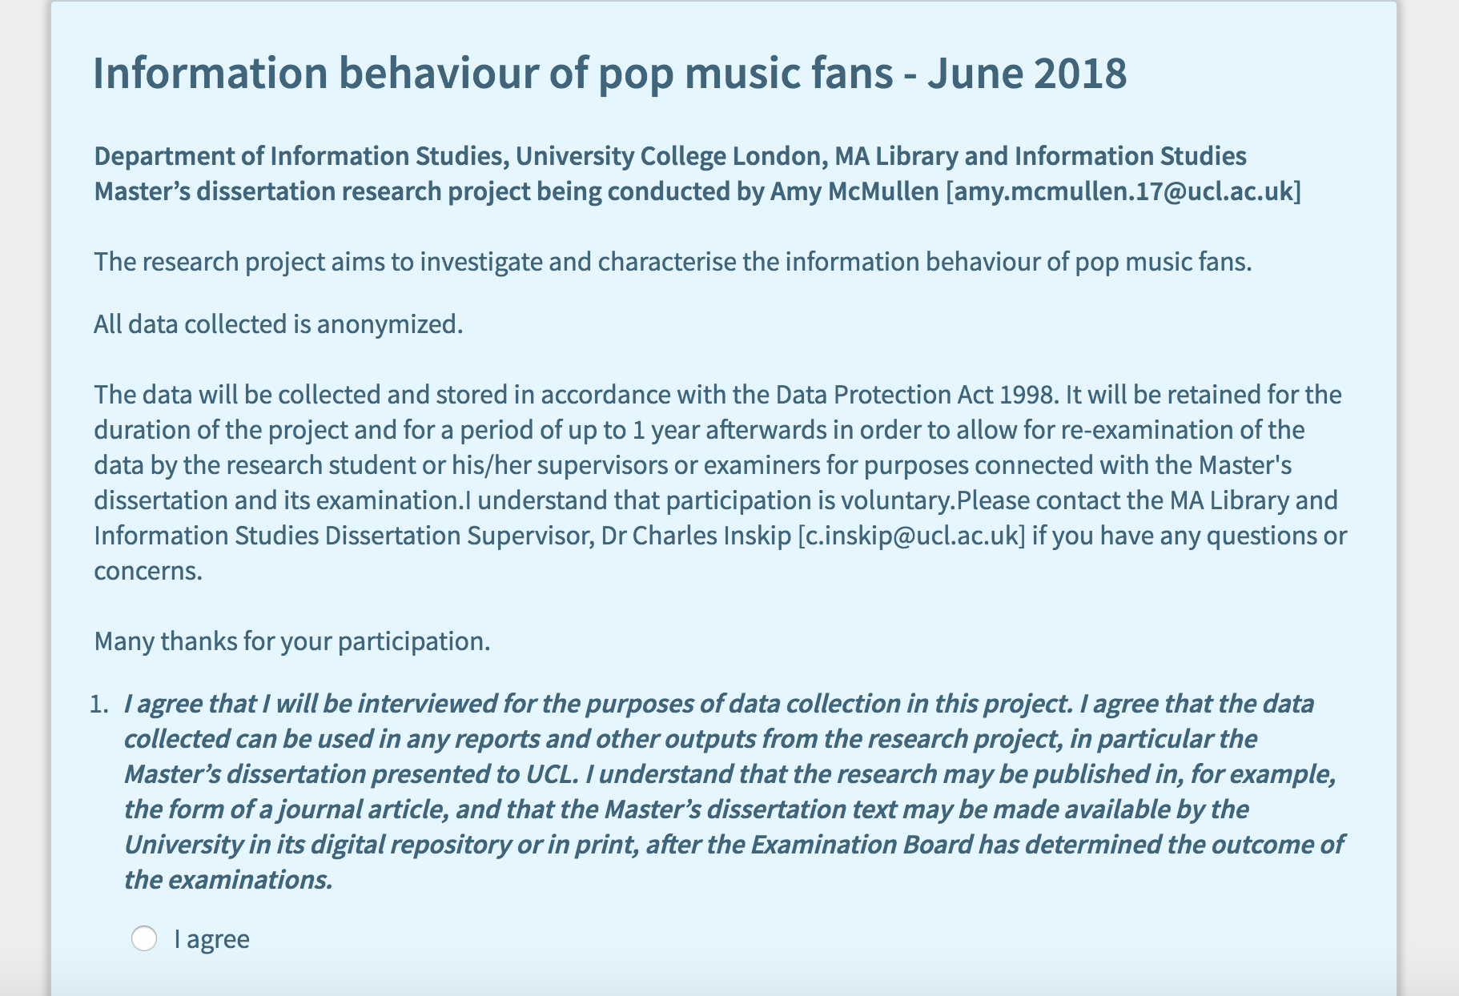

Appendix 3: Screenshots of online survey created via Opinio

URL: https://opinio.ucl.ac.uk/s?s=56302
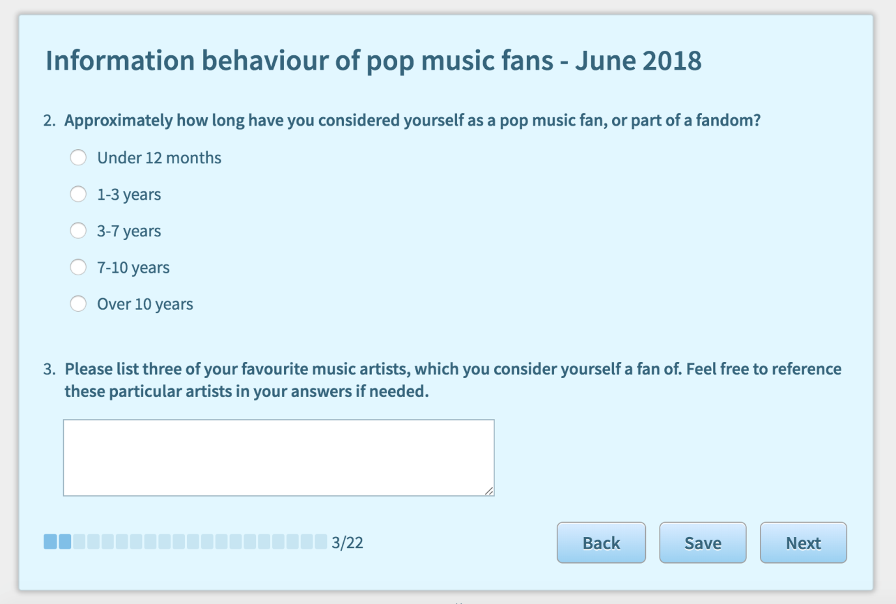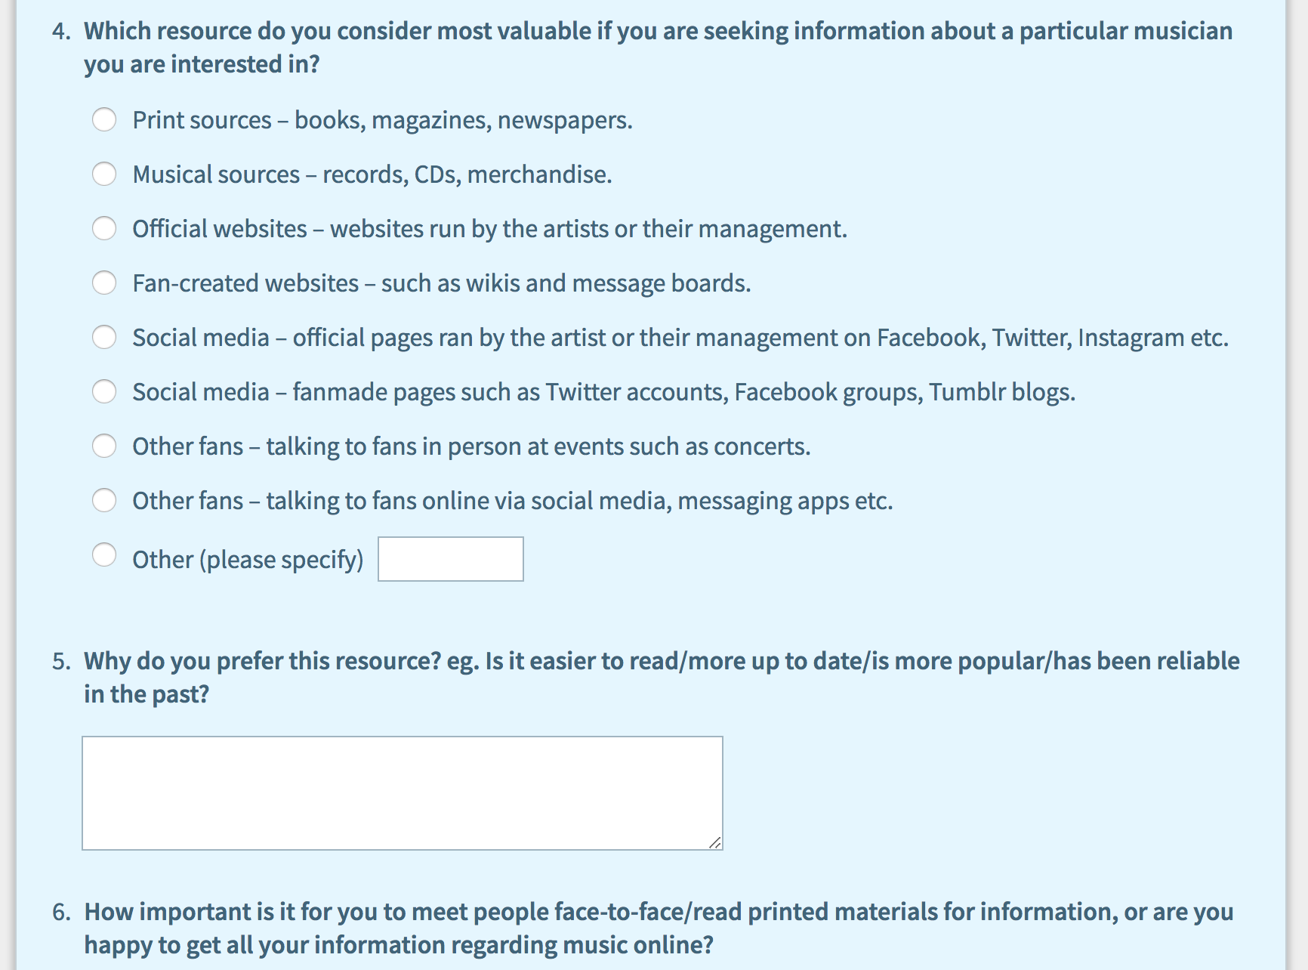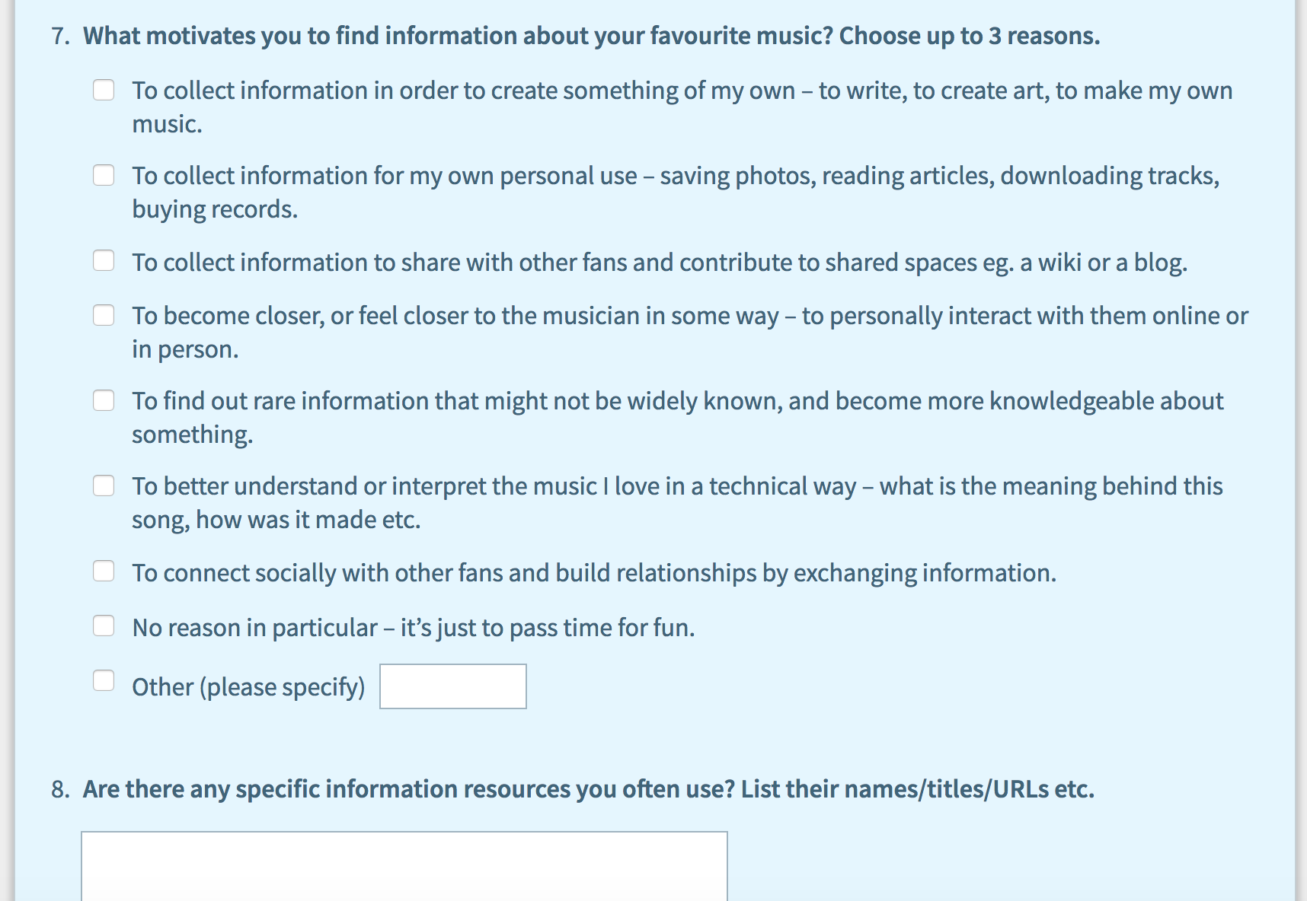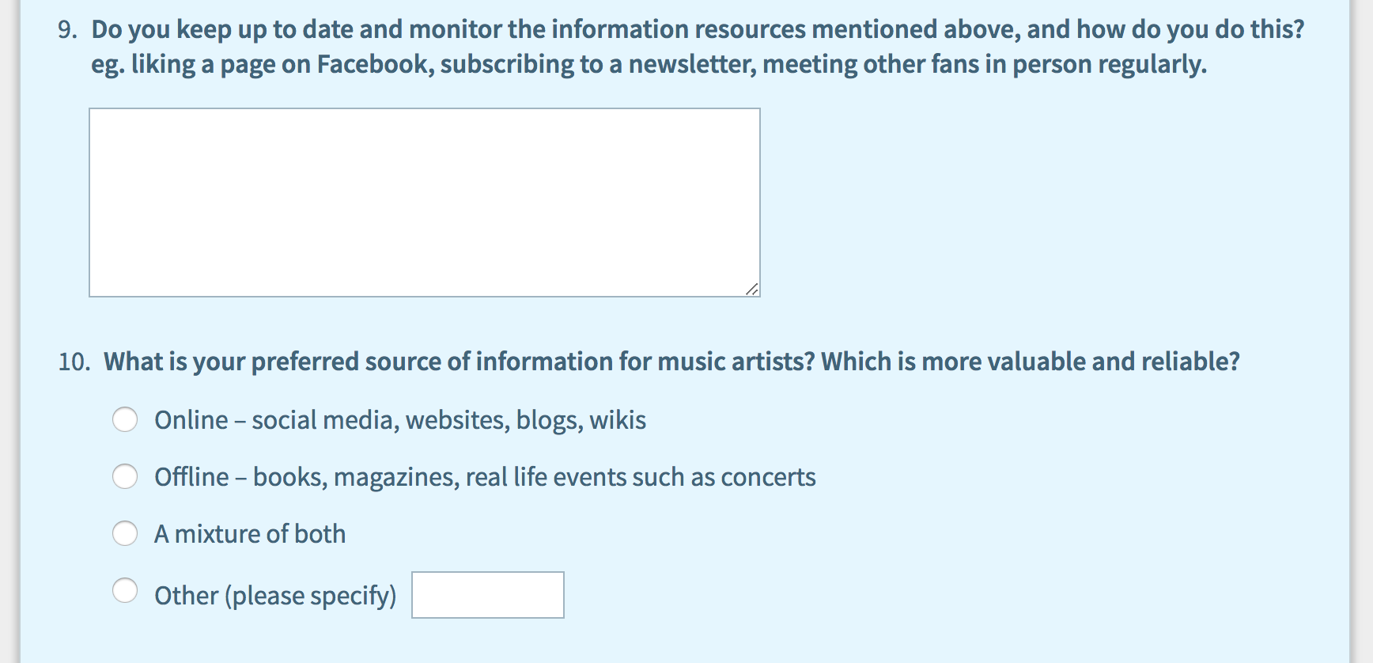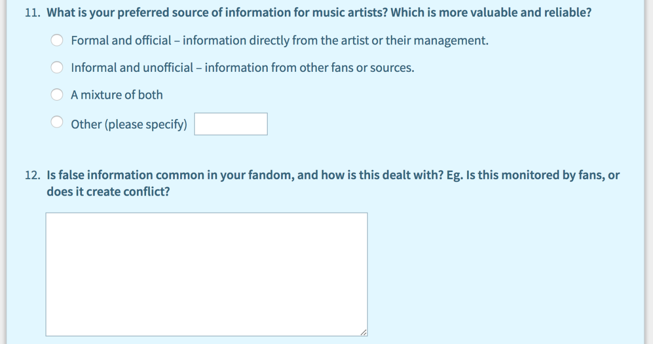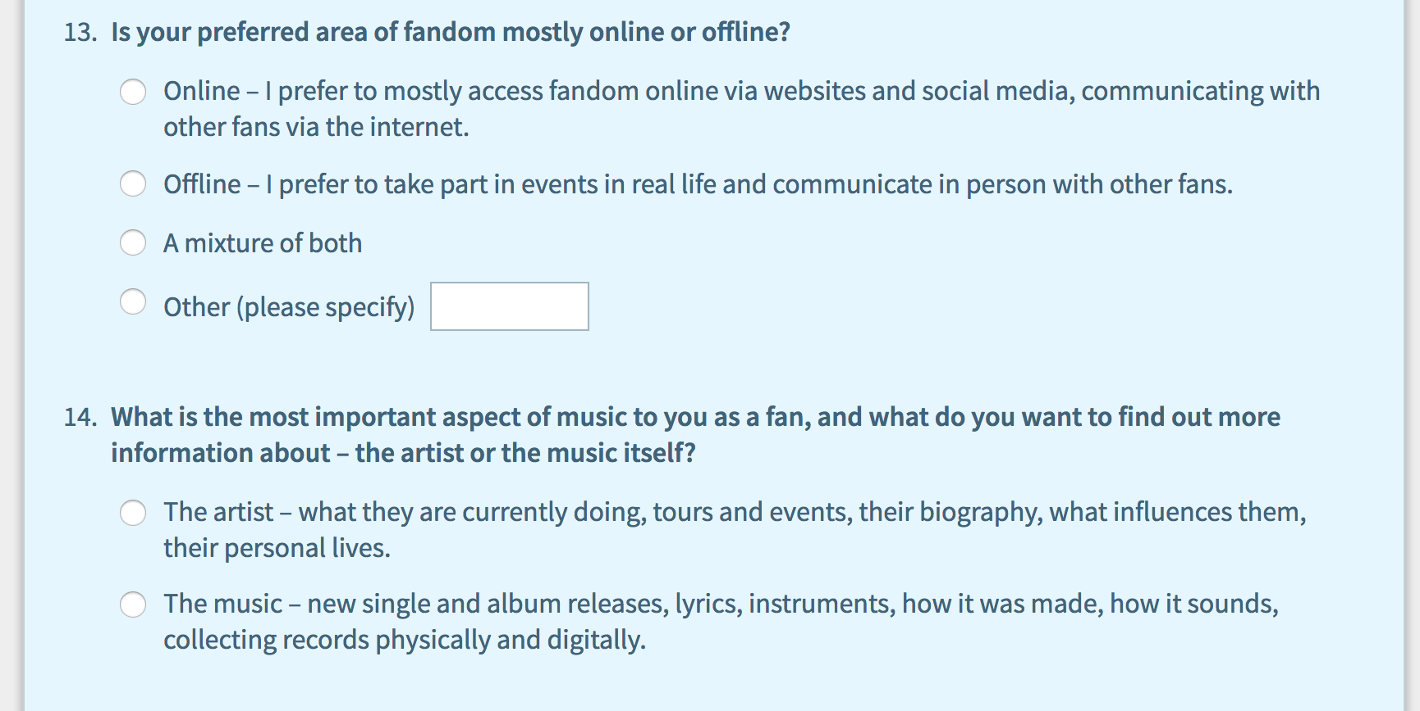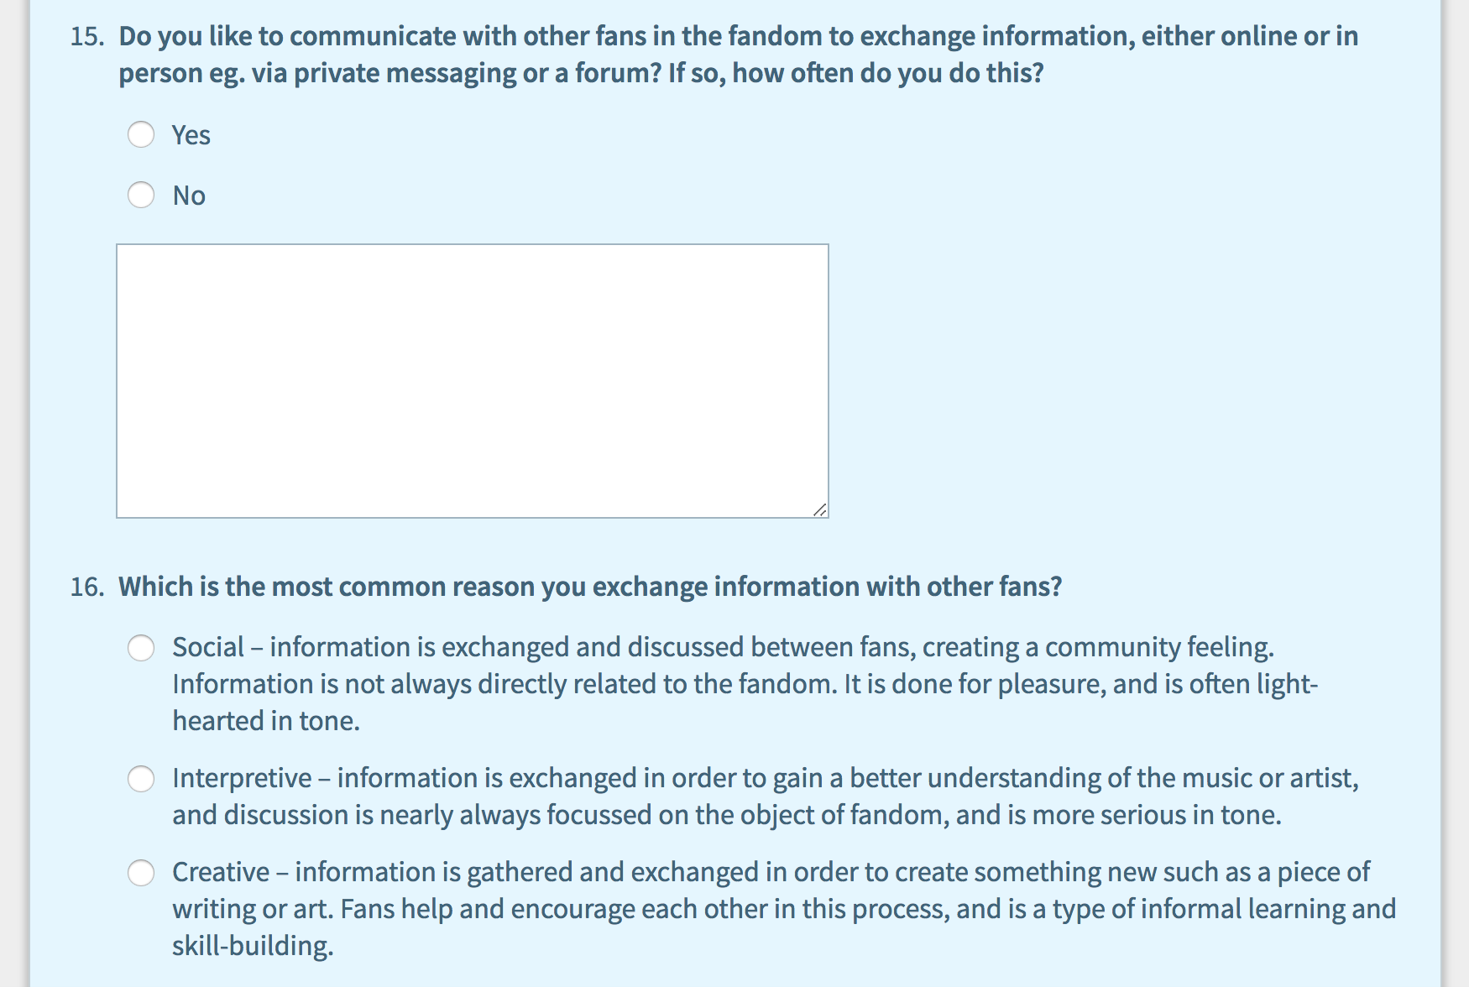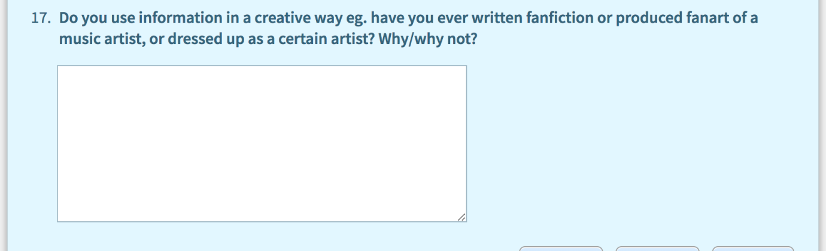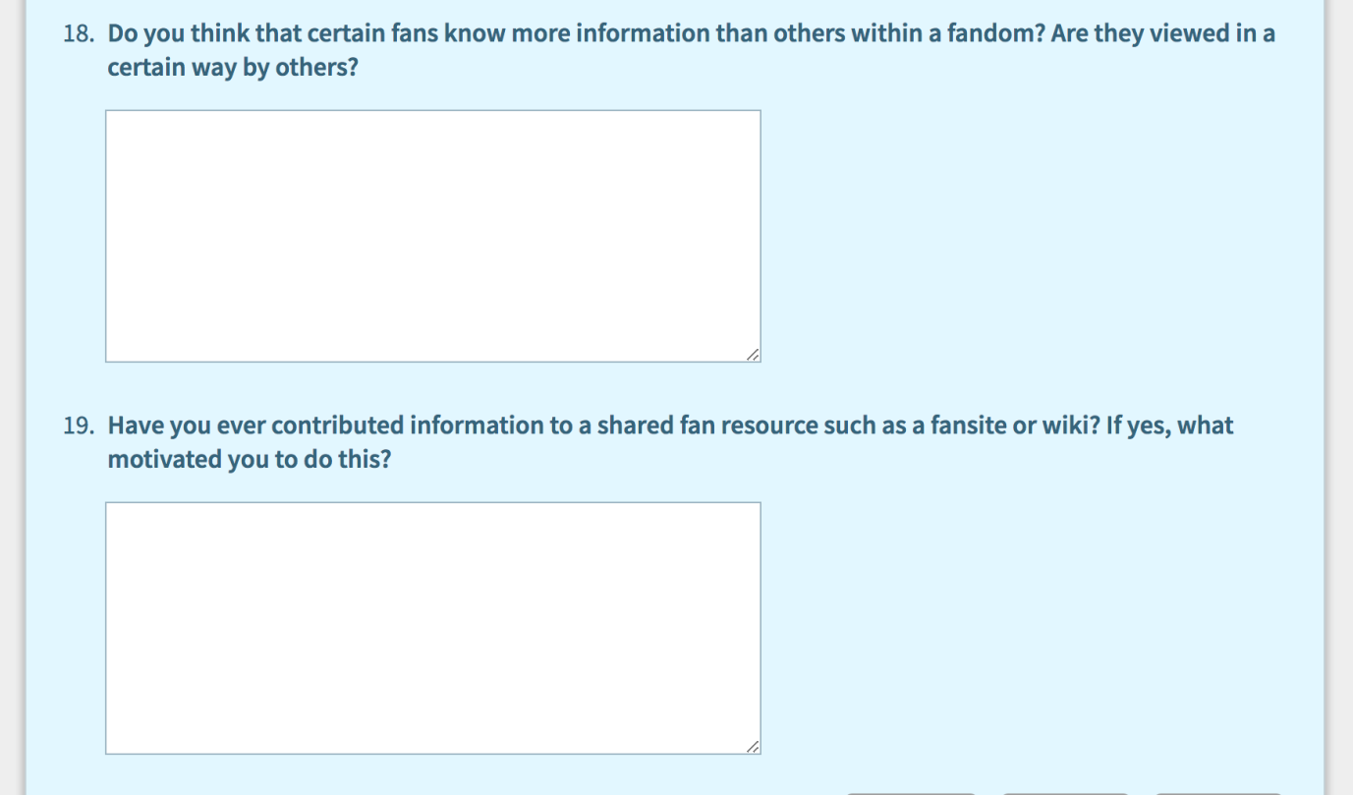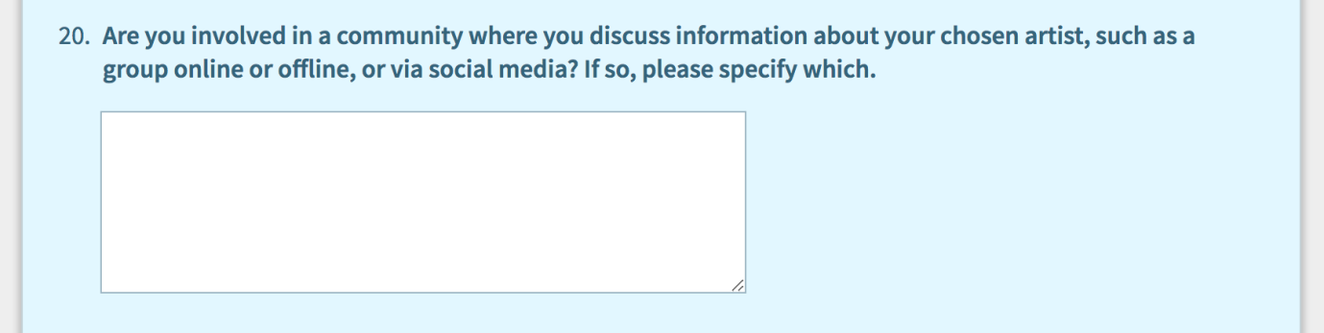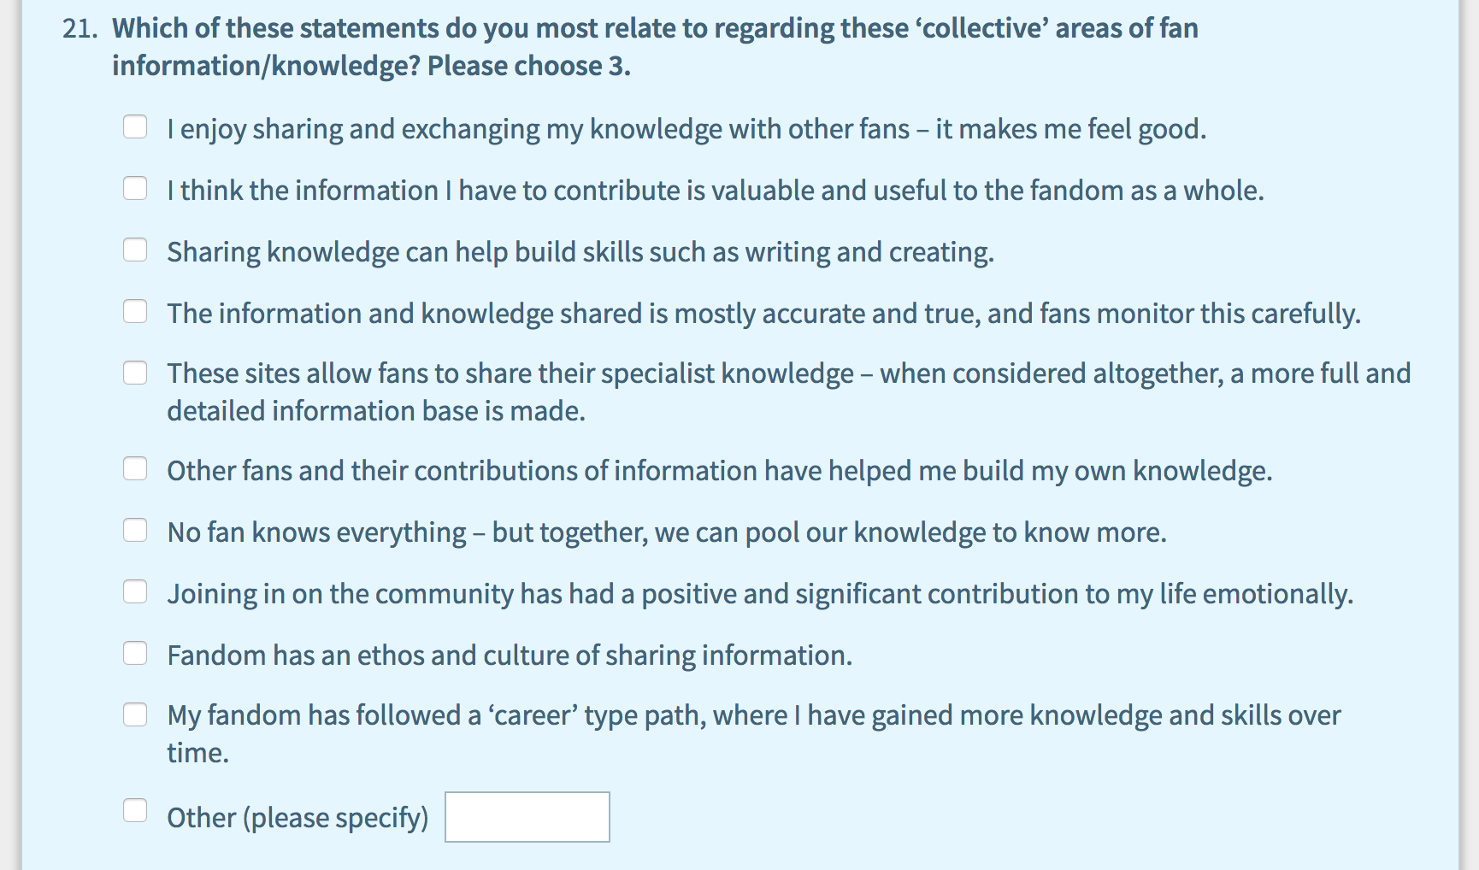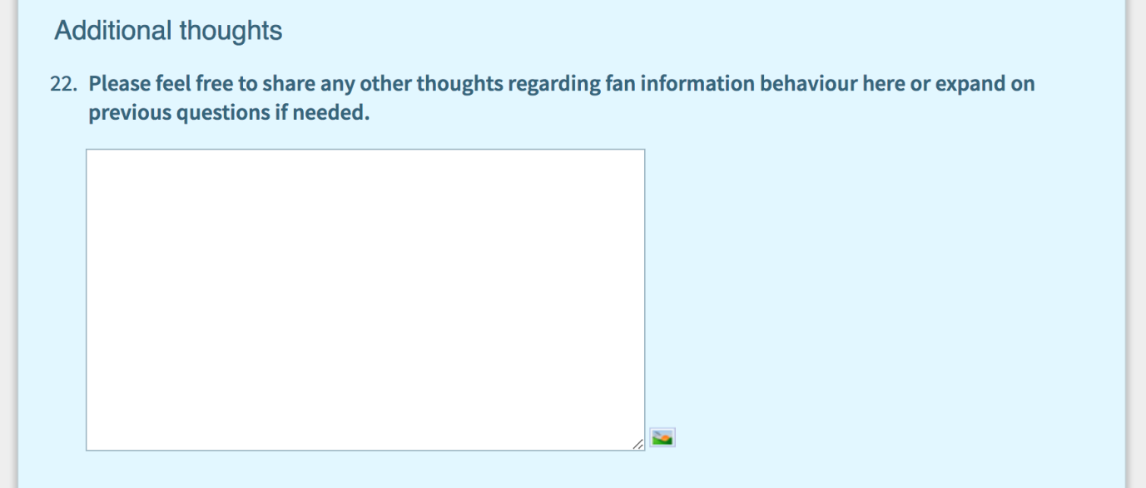

Jenkins H. Textual poachers: television fans and participatory culture. London: Routledge; 1992.
Jenkins H. Fans, bloggers, and gamers : exploring participatory culture. New York: New York University Press; 2006.
Jenkins H. Convergence culture : where old and new media collide. London: New York University Press; 2008.
Levy, P. Collective Intelligence: mankind’s emerging world in cyberspace. Cambridge, MA: Perseus Books; 1997.
Fiske J. Understanding Popular Culture. London: Routledge; 1992.
Fiske J, The cultural economy of fandom. In: Lewis LA, editor. The Adoring audience : fan culture and popular media. London: Routledge; 1992. pp. 30-49.
Abercrombie N, Longhurst B. Audiences. London: Sage; 1998.
Hellekson K, Busse K, editors. The Fan Fiction Studies Reader. Iowa City: University of Iowa Press; 2014.
Busse K, Gray J. Fan Cultures and Fan Communities. In: Nightingale V, editor. The Handbook of Media Audiences. New York: Wiley-Blackwell Publishing, pp. 425-443.
Ibid, p. 426.
Deller, RA. A decade in the life of online fan communities. In: Duits L, Zwaan K, Reijinders S, editors. The Ashgate Research Companion to Fan Cultures. Ashgate: Farnham; 2014. pp. 237 – 248.
Duffett M. Understanding Fandom: An Introduction to the Study of Media Fan Culture. London: Bloomsbury Academic; 2013.
Duffett M. Fan Practices. Popular Music and Society [Online]. 2014; Volume 38 (Issue 1) pp. 1-6. [Accessed 15 April 2018]. Available at: 10.1080/03007766.2014.973764.
International Society for Music Information Retrieval. ISMIR [Online]. ISMIR: Canada; 2017 [Accessed 7 April 2018]. Available at: http://www.ismir.net/.
Bainbridge D, Hu X, Downie JS. A Musical Progression with Greenstone: How Music Content Analysis and Linked Data is Helping Redefine the Boundaries to a Music Digital Library. In: Proceedings of the 1st International Workshop for Digital Libraries for Musicology, London, United Kingdom, 12 September 2014, pp. 1-8.
Bogdanov D, Serra X. Quantifying music trends and facts using editorial metadata from the Discogs database. In: Proceedings of the 18th ISMIR Conference, Suzhou, China, 23-27 October, 2017, pp, 89-95.
Park TH. Introduction to Digital Signal Processing: Computer Musically Speaking. Computer Music Journal [Online]. 2009; Volume 33 (Issue 1) pp. 74-76 [Accessed 7 April 2018]. Available at 10.1162/comj.2009.33.1.74
Inskip C, Butterworth R, MacFarlane A. A study of the information needs of the users of a folk music library and the implications for the design of a digital library system. Information Processing & Management [Online]. 2008; Volume 44 (Issue 2) pp. 647-662 [Accessed 7 April 2018]. Available at: https://doi.org/10.1016/j.ipm.2007.05.004
Lee JH. Analysis of user needs and information features in natural language queries seeking music information. Journal of the American Society for Information Science and Technology [Online]. 2010; Volume 6 (Issue 5) pp. 1025-1045 [Accessed 7 April 2018]. Available at: https://doi.org/10.1002/asi.21302
Lee JH, Downie JS. 2004. Survey of music information needs, uses, and seeking behaviours: preliminary findings. In: Proceedings of the 5th International Conference of the Society for Music Information Retrieval (ISMIR’04), ISMIR, Barcelona, 10-15 October, pp. 441-446.
Laplante A. 2012. Who influences the music tastes of adolescents?: a study on interpersonal influence in social networks. In: Proceedings of the Second International ACM Workshop on Music Information Retrieval, Nara, Japan, pp. 37-42.
Laplante A, Downie JS, 2006. Everyday life music information-seeking behaviour of young adults. In: Proceedings of the 7th International Conference of the Society for Music Information Retrieval (ISMIR’06), ISMIR, Victoria, 8-12 October, pp. 381-382.
Laplante A, Downie JS. The utilitarian and hedonic outcomes of music information-seeking in everyday life. Library & Information Science Research [Online]. 2011; Volume 33 (Issue 3) pp. 202-210 [Accessed 8 April 2018]. Available at: https://doi.org/10.1016/j.lisr.2010.11.002.
Margree P, et al. Information behaviour of music record collectors. Information Research [Online]. 2014; Volume 19 (Issue 4) [Accessed 8 April 2018]. Available at: http://www.informationr.net/ir/19-4/paper652.html.
Kostagiolas PA, et al. Music, musicians and information seeking behaviour: A case study on a community concert band. Journal of Documentation [Online]. 2015; Volume 71 (Issue 1) [Accessed 8 April 2018]. Available at: http://dx.doi.org/10.1108/JD-07-2013-0083.
Savolainen, R. Information behaviour and information practice: reviewing the ‘umbrella concepts’ of information-seeking studies. The Library Quarterly. 2007; Volume 77 (Issue 2), pp. 109-27, p.112.
Kuhlthau CC. Developing a model of the library search process: Investigation of cognitive and affective aspects. Reference Quarterly. 1988; Volume 28 (Issue 2), pp. 232-242.
Ellis D, Modelling the Information-Seeking Patterns of Academic Researchers: A Grounded Theory Approach, The Library Quarterly. 1993; Volume 63 (Issue 4), pp. 469-486.
Savolainen R, Everyday Life Information Seeking. In: Fisher K, Erdelez S, McKechnie L, editors. Theories of Information behaviour. New Jersey; Information Today; 2005, pp. 143-148.
Wilson T, Exploring models of information behaviour: the ‘uncertainty’ project. Information Processing & Management. 1999; Volume 35 (Issue 6), pp. 839-849.
Wilson T, Fifty years of information behaviour research. Bulletin of Association of Information Science and Technology [Online]. 2010; Volume 36: pp. 27-34. [Accessed 11 May 2018]. Available at: doi:10.1002/bult.2010.1720360308
De Kosnik A. Rogue Archives: Digital Culture Memory and Media Fandom. Cambridge, MA; MIT Press, 2016.
Hart C, Schoolbred M, Butcher D, Kane D. "The bibliographical structure of fan information", Collection Building [Online]. 1999; Volume 18 (Issue 2) pp.81-89 [Accessed 10 May 2018]. Available at: https://doi.org/10.1108/01604959910265869
Booth P. Digital fandom; new media studies. New York; Peter Lang Publishing, 2010.
Levy P. Collective intelligence: mankind’s emerging world in cyberspace. Cambridge, MA; Perseus Books, 1997.
Korobkova KA. Schooling the Directioners: Connected Learning and Identity-Making in the One Direction Fandom [Online]. Irvine, CA: Digital Media and Learning Research Hub, 2014 [Accessed 20 April 2018] Available at: https://dmlhub.net/wp-content/uploads/2015/12/Schooling-the-Directioners_Korobkova.pdf
Price L, Robinson L. "Being in a knowledge space": information behaviour of cult media fan communities. Journal of Information Science [Online]. 2016; Volume 43 (Issue 5) [Accessed 9 May 2018]. Available at: http://dx.doi.org/10.1177/0165551516658821
Price L, Serious leisure in the digital world: exploring the information behaviour of fan communities. PhD thesis; City University of London, 2017.
Price L, Robinson L. Fan fiction in the library. Transformative Works and Cultures [Online]. 2017; Volume 25 [Accessed 12 May 2018]. Available at: http://dx.doi.org/10.3983/twc.2017.1090
Hill H, Peckosie JL. Information activities as serious leisure within the fanfiction community. Journal of Documentation. 2017; Volume 73 (Issue 5) pp.843-857.
Stebbins RA. Serious Leisure: A Conceptual Statement. The Pacific Sociological Review [Online]. 1982; Volume 25 (Issue 2), pp. 251-272. [Accessed 10 May 2018]. Available at: doi:10.2307/1388726.
Stebbins RA. (1994). The liberal arts hobbies: a neglected subtype of serious leisure. Society and Leisure. 1994; Volume 17 (Issue 1), pp. 173–186.
Hartel J, Serious leisure. In: Fisher K, Erdelez S, McKechnie L, editors. Theories of Information behaviour. New Jersey; Information Today; 2005, pp. 313-318.
Ibid.
Prigoda E, McKenzie PJ. Purls of wisdom: a collectivist study of human information behaviour in a public library knitting group. Journal of Documentation. 2007; Volume 63 (Issue 1), pp. 90–114.
Lee CP, Trace CB. The role of information in a community of hobbyist collectors. Journal of the American Society for Information Science and Technology [Online]. 2009; Volume 60 (Issue 3), pp. 621–637 [Accessed 10 May 2018]. Available at: https://www.ischool.utexas.edu/~cbtrace/pubs/CBT_JASIST_2009.pdf.
Hartel, J. Managing documents at home for serious leisure: a case study of the hobby of gourmet cooking. Journal of Documentation. 2010; Volume 66 (Issue 6), pp. 847–874.
Cox AM, Griffin B, Hartel J. What everybody knows: embodied information in serious leisure. Journal of Documentation. 2017; Volume 73 (Issue 3), pp. 386-406.
Hartel J, Cox AM, Griffin BL. Information activity in serious leisure. Information Research [Online]. 2016; Volume 21 (Issue 4) [Accessed 7 March 2018]. Available at: http://www.informationr.net/ir/21-4/paper728.html.
Hektor A. What's the use: Internet and information behaviour in everyday life. Linkoping, Sweden: Linkoping University Studies in Arts and Science; 2001 [Accessed 15 May 2018] Available at: http://liu.diva-portal.org/smash/record.jsf?pid=diva2%3A254863&dswid=6661
Hektor A. Information activities on the Internet in everyday life. The New Review of Information Behaviour Research. 2003; Volume 4 (Issue 1), pp. 127-138, p.127.
Hartel J, Cox AM, Griffin BL. Information activity in serious leisure. Information Research [Online]. 2016; Volume 21 (Issue 4) [Accessed 7 March 2018]. Available at: http://www.informationr.net/ir/21-4/paper728.html
Ibid.
Price L, Serious leisure in the digital world: exploring the information behaviour of fan communities. PhD thesis; City University of London, 2017, p.122.
Case DO, Given LM. Looking for information: a survey of research on information seeking, needs, and behaviour. Bingley; Emerald Group: 2016.
Price, p. 138.
Freund K, Fielding D. Research ethics in fan studies. Participations: Journal of Audience & Reception Studies [Online]. 2013; Volume 10 (Issue 1) [Accessed 18 May 2018]. Available at: http://www.participations.org/Volume%2010/Issue%201/16%20Freund%20Fielding%2010.1.pdf
Busse K, Hellekson K. Identity, ethics and fan privacy. In: Larsen K, Zubernis L, editors. Fan Culture: Theory/Practice. Newcastle upon Tyne: Cambridge Scholars Publishing; 2012. pp. 38-56.
Attu R, Terras M. What people study when they study Tumblr: Classifying Tumblr-related academic research. Journal of Documentation [Online]. 2017; Volume 73 (Issue 3), pp.528-554 [Accessed 25 May 2018]. Available at: https://doi.org/10.1108/JD-08-2016-0101
Hartel J, Cox AM, Griffin BL. Information activity in serious leisure. Information Research [Online]. 2016; Volume 21 (Issue 4) [Accessed 7 March 2018]. Available at: http://www.informationr.net/ir/21-4/paper728.html.
Hektor A. Information activities on the Internet in everyday life. The New Review of Information Behaviour Research. 2003; Volume 4 (Issue 1), pp. 127-138.
Kostagiolas PA, et al. Music, musicians and information seeking behaviour: A case study on a community concert band. Journal of Documentation [Online]. 2015; Volume 71 (Issue 1) [Accessed 8 April 2018]. Available at: http://dx.doi.org/10.1108/JD-07-2013-0083
Margree P, et al. Information behaviour of music record collectors. Information Research [Online]. 2014; Volume 19 (Issue 4) [Accessed 8 April 2018]. Available at: http://www.informationr.net/ir/19-4/paper652.html
Westberry S. Reflection on the Principle of Least Effort. Learning Libraries; 2016 June [Accessed 1 August 2018]. Available at: http://learninglibraries.blogspot.com/2016/06/reflection-on-principle-of-least-effort.html.
Abercrombie N, Longhurst B. Audiences. London: Sage; 1998.
Bamgbade BJ, Akintola BA, Agbenu DO, Ayeni CO, Fagbami OO, Abubaka HO. ‘Comparative analysis and benefits of digital library over traditional library’, World Scientific News [Online]. 2015 [Accessed 19 October 2017]. Available at: http://www.worldscientificnews.com/wp-content/uploads/2015/07/WSN-24-2015-1-7.pdf
Duffett M. Fan Practices. Popular Music and Society [Online]. 2014; Volume 38 (Issue 1) pp. 1-6. [Accessed 15 April 2018]. Available at: 10.1080/03007766.2014.973764
Margree P, et al. Information behaviour of music record collectors. Information Research [Online]. 2014; Volume 19 (Issue 4) [Accessed 8 April 2018]. Available at: http://www.informationr.net/ir/19-4/paper652.html
Morimoto L, Stein LE. Tumblr and fandom. Journal of Transformative Works and Culture [Online]. 2018; Number 27 [Accessed 5 August 2018] Available at: http://journal.transformativeworks.org/index.php/twc/article/view/1580/1826
Laplante A, Downie JS. The utilitarian and hedonic outcomes of music information-seeking in everyday life. Library & Information Science Research [Online]. 2011; Volume 33 (Issue 3) pp. 202-210 [Accessed 8 April 2018]. Available at: https://doi.org/10.1016/j.lisr.2010.11.002.
Lee JH. Analysis of user needs and information features in natural language queries seeking music information. Journal of the American Society for Information Science and Technology [Online]. 2010; Volume 6 (Issue 5) pp. 1025-1045 [Accessed 7 April 2018]. Available at: https://doi.org/10.1002/asi.21302.
Booth P. Digital fandom; new media studies. New York; Peter Lang Publishing, 2010.
Dare-Edwards HL. ‘Shipping bullshit’: Twitter rumours, fan/celebrity interaction and questions of authenticity. Celebrity Studies [Online]. 2014; Volume 5 [Accessed 6 July 2018] pp. 521-524. Available at: https://doi-org.libproxy.ucl.ac.uk/10.1080/19392397.2014.981370.
CILIP. What is information literacy? [Online]. CILIP: London; 2018 April 4 [Accessed 10 August 2018]. Available at: https://www.cilip.org.uk/page/informationliteracy.
Ibid.
Kehrberg AK. ‘I love you, please notice me’: the hierarchical rhetoric of Twitter fandom. Celebrity Studies [Online]. 2015; Volume 6 (Issue 1) pp. 85-99 [Accessed 5 August 2018]. Available at: https://doi-org.libproxy.ucl.ac.uk/10.1080/19392397.2015.995472.
Stebbins RA. Serious Leisure: A Conceptual Statement. The Pacific Sociological Review [Online]. 1982; Volume 25 (Issue 2), pp. 251-272. [Accessed 10 May 2018] Available at: doi:10.2307/1388726
Nonnecke B, Preece J, Andrews D. The top five reasons for lurking: improving community experiences for everyone. Computers in Human Behavior [Online]. 2004; Volume 20 (Issue 2) pp. 201-223 [Accessed 19 August 2018]. Available at: https://doi.org/10.1016/j.chb.2003.10.015.
Jenkins H. Textual poachers: television fans and participatory culture. London: Routledge; 1992.
Fiske J. Understanding Popular Culture. London: Routledge; 1992.
Korobkova KA. Schooling the Directioners: Connected Learning and Identity-Making in the One Direction Fandom [Online]. Irvine, CA: Digital Media and Learning Research Hub, 2014 [Accessed 20 April 2018]. Available at: https://dmlhub.net/wp-content/uploads/2015/12/Schooling-the-Directioners_Korobkova.pdf.
Laplante A, Downie JS, 2006. Everyday life music information-seeking behaviour of young adults. In: Proceedings of the 7th International Conference of the Society for Music Information Retrieval (ISMIR’06), ISMIR, Victoria, 8-12 October, pp. 381-382.
Laplante A. 2012. Who influence the music tastes of adolescents?: a study on interpersonal influence in social networks. In: Proceedings of the Second International ACM Workshop on Music Information Retrieval, Nara, Japan, pp. 37-42.
Abercrombie N, Longhurst B. Audiences. London: Sage; 1998.
Fiske J. The cultural economy of fandom. In: Lewis LA, editor. The Adoring audience: fan culture and popular media. London: Routledge; 1992, p. 34.
Gander K, How Social Media Gave Rise To The ‘Stan’ Superfan. The Independent [Online]. 2016, December 16 [Accessed 25 May 2018]. Available at: https://www.independent.co.uk/life-style/social-media-stan-superfan-twitter-facebook-beyonce-justin-bieber-rihanna-britney-spears-eminen-one-a7477876.html
Booth P. Digital fandom; new media studies. New York; Peter Lang Publishing, 2010.
Jenkins H. Convergence culture : where old and new media collide. London: New York University Press; 2008.
Ibid.
Deller, RA. A decade in the life of online fan communities. In: Duits L, Zwaan K, Reijinders S, editors. The Ashgate Research Companion to Fan Cultures. Ashgate: Farnham; 2014, pp. 237 – 248.
Hartel J, Cox AM, Griffin BL. Information activity in serious leisure. Information Research [Online]. 2016; Volume 21 (Issue 4) [Accessed 7 March 2018]. Available at: http://www.informationr.net/ir/21-4/paper728.html
Jenkins H. Convergence culture : where old and new media collide. London: New York University Press; 2008.
Levy P. Collective intelligence: mankind’s emerging world in cyberspace. Cambridge, MA: Perseus Books; 1997.
Wheeldon, E. A social society: The positive effects of communicating through social networking sites [Online]. Online Conference on Networks and Communities; 2010 [Accessed 4 August 2018]. Available at: http://networkconference.netstudies.org/2010/04/a-social-society-the-positive-effects-of-communicating-through-social-networking-sites
Hartel J, Cox AM, Griffin BL. Information activity in serious leisure. Information Research [Online]. 2016; Volume 21 (Issue 4) [Accessed 7 March 2018]. Available at: http://www.informationr.net/ir/21-4/paper728.html.
Hartel J, Serious leisure. In: Fisher K, Erdelez S, McKechnie L, editors. Theories of Information behaviour. New Jersey; Information Today; 2005, pp. 313-318.
CILIP. What is information literacy? [Online]. CILIP: London; 2018 April 4 [Accessed 10 August 2018]. Available at: https://www.cilip.org.uk/page/informationliteracy.

