Portia Antonia Alexis

London School of Economics and Political Science

The Evolution Of Consumer Goods in the Data Economy: A Winning Model For Creating Value

The rise of information and communication technologies is affecting business life significantly. As leading examples, some new sectors emerge by merging technology and business like fintech, where financial services and technological progress are used together. As another important development, the widespread use of social media empowered consumers greatly relative to brands. Consumers are able to produce information, reviews, and ratings on brands, thereby affecting the brand image and purchase behaviours. As a response to such developments, the businesses should also devise detailed strategies on how they incorporate technology in their operations and how they contain possible risks. The current research examines these issues within the context of the consumer goods sector and the data economy.
The first part of the research provides some rationale and discussion on the topic. It is noted that the consumer goods sector is a very dynamic segment of household expenditures. Especially, the fast-moving consumer goods have a very dynamic market with new trends. One of the most important trends in the last decade has been the digitalisation of many business aspects. The relevant consumer studies show that people use digital channels extensively to collect information about consumer goods and also to make online purchases (Deloitte, 2020). The rise of information and communication technologies (like online shopping, brand loyalty cards, and digital payments) leads to extensive accumulation of real-time data. In this context, the brands would be able to collect the relevant consumer data, process it analytical ways, and use the results in the creation of new strategies. However, the literature also shows that the consumer goods sector has been relatively slow in adopting such technologies (Strong, 2014). One structural barrier in the consumer goods sector has been the limited ability of brands to interact with consumers. In other words, the retailers (whether brick and mortar or online) intermediate the relationship between consumers and brands, and in the process they can collect vast amounts of valuable data to use in their strategies. As brands have limited access to such data, their ability to conduct big data analysis can be limited. The current research examines this question and investigates a winning model for value creation in the consumer goods sector within the data economy context.
The second part provides a detailed review of the research topic from both academic sources and business reports. For example, Let’s Nurture (n.d.) notes that digitalization is one of the strongest trends for consumer goods and especially fast-moving consumer goods (FMCG). More than half of the global population is using smartphones and around a quarter of the world’s population purchase items using online channels. One very promising area within the digital consumer goods sector is the utilisation of the augmented reality (AR). A report by KPMG (2018) also examines the recent trend in the packaged consumer goods sector. The report argues that to stay competitive and continue to grow, firms in this sector should integrate clear digital strategies into their business models. In this context, the data analysis stands out as an important capability for companies. Specifically, KPMG (2018) states that “For companies to embrace a digital future, they need to get number crunching to make sense of the plethora of data collected day-on-day. The application of data and analytics should not only apply to one segment of the organisation – it is critical to make sense of information across the whole business to gain insights, and empower every employee to make decisions based on these” (p.10). So, these studies show the importance of data analytics.
The academic studies show that servitisation emerges as a feasible strategy for the sector. One way for the brands to overcome the above restrictions and to form direct relationships with their clients is the creating of services around their brands (Baines and Lightfoot, 2014; Lee et al., 2016). This “servitisation” offers various benefits like stable income stream, higher margins, and more efficient customer relations. But the capture of consumer data like personal information and purchase properties is another crucial factor in the “servitisation” of consumer goods products.
Based on these discussions, the results section presents the findings from the quantitative analysis and qualitative discussions. Quantitative results such as these confirm the expectations that demand (like GDP growth and unemployment rate) and confidence (like consumer confidence index) factors are important for the consumer goods sector. As the last part of the quantitative analysis, OLS regression models are estimated to check the multivariate relationships for the consumer goods categories. GDP is the most significant variable, and it has a positive association with economic growth. The coefficient implies that one percentage points increase in GDP growth is associated with an increase of 0.26 percentage points in the growth rate of the consumer goods. In addition, one percentage points decline in the unemployment rate is associated with a 0.41 percentage points increase in the consumer goods growth rate. Lastly, higher levels of consumer confidence index are also positively associated with higher growth for consumer goods. Then, qualitative analysis finds that increasing the level of engagement with customers through servitisation of consumer goods is an important strategy to increase the competitive advantage of companies. In this way, brands can collect very detailed information on personal characteristics and purchase behaviours. Once servitisation allows the greater access of brands to their consumers, the firms should also devise effective big data mechanisms to use the new information efficiently.
Overall, the correlation and regression analyses showed that GDP and consumer confidence affected the sector positively, whereas the unemployment rate affected it negatively. Then, the qualitative discussions showed that two strategies of servitisation of the consumer products and the establishment of big data analytics are the most feasible strategies to create value for the sector and brands. The study can be extended in terms of examining more detailed consumer goods categories and by creating primary data for the perspectives of consumers and brands. In this way, additional and more robust evidence can be obtained on the relevance of the proposed model of servitisation and big data analytics.

Abstract

The research examines the relevance of the data economy for the consumer goods sector and aims to derive a winning model of value creation. A major structural barrier in this sector restricting the direct relationship of brands and consumers has been the intermediary role of retailers. The retailers use extensive consumer data in terms of personal information and purchasing behaviours. However, due to access problems, brands are not able to implement such strategies. Therefore, the winning model should try to eliminate this barrier and create direct links between the brands and consumers. This research conducts quantitative data analysis using macroeconomic data for the case of the UK, along with a qualitative analysis of the literature to arrive at a model. The quantitative analysis shows that in the UK, the consumer goods sector displayed a growth rate very close to the GDP growth. However, there have been significant differences between sub-categories. Clothing and footwear displayed very large growth rates, while the size of the alcohol and tobacco sector declined in the last two decades. The correlation and regression analyses showed that GDP and consumer confidence affected the sector positively, whereas the unemployment rate affected it negatively. Then, the qualitative discussions showed that two strategies of servitisation of the consumer products and the establishment of big data analytics are the most feasible strategies to create value for the sector and brands.

The Future for Consumer Goods in the Data Economy: A Winning Model For Creating Value

- Introduction

The consumer goods sector is a very dynamic segment of household expenditures. Especially, the fast-moving consumer goods have a very dynamic market with new trends. One of the most important trends in the last decade has been the digitalisation of many business aspects. The relevant consumer studies show that people use digital channels extensively to collect information about consumer goods and also to make online purchases (Deloitte, 2020). The rise of information and communication technologies (like online shopping, brand loyalty cards, and digital payments) leads to extensive accumulation of real-time data. In this context, the brands would be able to collect the relevant consumer data, process it analytical ways, and use the results in the creation of new strategies. However, the literature also shows that the consumer goods sector has been relatively slow in adopting such technologies. One structural barrier in the consumer goods sector has been the limited ability of brands to interact with consumers. In other words, the retailers (whether brick and mortar or online) intermediate the relationship between consumers and brands, and in the process they can collect vast amounts of valuable data to use in their strategies. As brands have limited access to such data, their ability to conduct big data analysis can be limited. The current research examines this question and investigates a winning model for value creation in the consumer goods sector within the data economy context.
In order to the relevance of the data economy for the consumer goods sector, the research proceeds using two methods. One is the quantitative approach where the macroeconomic data on the consumer goods categories is examined using summary statistics, cross-correlations, and regression analysis. The other is a qualitative analysis of the existing secondary research to offer some perspectives on the possible strategies to improve the competitive advantage of consumer goods brands using big data analytics. Towards these research objectives, the current research is structured as follows. The second chapter provides a literature review of the topic. It specifically focuses on the characteristics and dynamics of the consumer goods sector and then examines the growing field of the data economy. This information is used to combine the data economy and the consumer goods sector. Then, the third chapter presents the research methodology followed in the study. The results are presented in the fourth chapter in terms of quantitative analysis and qualitative discussions. Finally, the last chapter concludes the analysis.
- Literature Review
Consumer goods refer to a small portion of household final consumption expenditures. In the UK, the GDP was £2,090 billion in 2019 (ONS, 2020a). The largest GDP item is the household final consumption expenditures. In the same year, the consumption expenditures were £1,318 billion, or 63% of GDP. Within the household final consumption expenditures, there are categories of net tourism, food and drink, alcohol, tobacco and narcotics, clothing and footwear, housing, furnishings, household equipment and routine maintenance of the house, health, transport, communication, recreation and culture, education, restaurants and hotels, and miscellaneous. Among these categories, the housing expenditures constitute the largest item with 25.9% share, followed by miscellaneous with 13.3% share, transportation with 12.8% share, recreation and culture with 11.1% share, and restaurants and hotels with 9% share (ONS, 2020b). It is seen that the largest consumption items for the households are different services ranging from housing to recreation. One can form a narrower category of “consumer goods” within the household expenditures. This category would include the items of “food and drink” with 7.66% share in 2019 in the household final consumption expenditures, “alcohol, tobacco and narcotics” with 3.04% share, “clothing and footwear” with 5.33% share, and “furnishings, household equipment and routine maintenance of the house” with 4.97% share. The category of “miscellaneous goods and services” also includes some consumer good categories like “Electrical appliances for personal care” with 0.19% share in the household final consumption expenditures, “Other appliances, articles and products for personal care” with 1.67% share, and “Jewellery clocks and watches” with 0.74% share. When all these categories are combined under the consumer goods classification, their share in the household final consumption expenditures becomes 23.61% in 2019. So, consumer goods constitute less than one-quarter of total household expenditures in the UK.
As the consumer goods constitute a major part of the GDP and the household final consumption expenditures, understanding the characteristics and the dynamics of this sector is important. In a report by the UK Parliament (2017) for the House of Commons Committee on Exiting the European Union notes that there is significant international trade in the consumer goods in the UK. So, the domestic market has a dependence on imports of consumer goods. Domestic production is mostly restricted to niche and high-end products. Specifically, UK Parliament (2017) states that “Most UK producers of consumer goods are small, niche, high-end producers, as these have been the most able to withstand international competition from low-cost producers, mainly from Asia and Eastern Europe” (p.3). The report also examines market characteristics. For example, it is found that there are low concentration and a large number of companies in most consumer good categories. In the furniture manufacturing sector, the top four largest firms account for less than 10% of the sector, while in the textile manufacturing sector, the top four largest companies have a share of around 13%. The report estimates that there are close to 17 thousand employers in the consumer goods sector, while this number increases to more than 57 thousand if sole-traders and unregistered businesses are included. The report also shows some numbers of import dependence. For example, 61% of domestic demand for textiles is satisfied by imports. This ratio is lowest for furniture with 41% but very high for leather and related products with 96% and for wearing apparel with 98%. Then, it can be argued that importers and retailers are the main players in the consumer goods sector, with producers playing a more limited role. In this context, the retailers (like supermarket chains) matter greatly as they are the main players that present consumer goods to the final use of consumers. In addition, online retailing channels have been gaining further importance in the consumer goods sector.
Given the importance of the consumer goods sector, examining the relevant trends in this sector is also an important research and business topic. In this context, there are some business reports that examine the recent developments and trends in the consumer goods sector globally and in the UK. For example, Let’s Nurture (n.d.) notes that digitalization is one of the strongest trends for consumer goods and especially fast-moving consumer goods (FMCG). More than half of the global population is using smartphones and around a quarter of the world’s population purchase items using online channels. One very promising area within the digital consumer goods sector is the utilisation of the augmented reality (AR). According to this report, AR-based shopping is expected to reach $120 billion in 2020. This technology has some advantages in the context of online shopping as it provides some comfort and ease of shopping and improves the shopping experience of online consumers. In addition, it has a great value for the people who cannot leave their homes for shopping purposes. A report by KPMG (2018) also examines the recent trend in the packaged consumer goods sector. The report argues that to stay competitive and continue to grow, firms in this sector should integrate clear digital strategies into their business models. In this context, the data analysis stands out as an important capability for companies. Specifically, KPMG (2018) states that “For companies to embrace a digital future, they need to get number crunching to make sense of the plethora of data collected day-on-day. The application of data and analytics should not only apply to one segment of the organisation – it is critical to make sense of information across the whole business to gain insights, and empower every employee to make decisions based on these” (p.10).
In another business report, Deloitte (2016) also emphasises the importance of digitalisation in the consumer goods sector. Figure 1 provides some of its findings. It is seen that 56% of consumers make an online purchase from their houses. 48% use laptops or computers, while 32% use smartphones to do relevant online shopping. As another important finding, 38% of consumers use their smartphones to share feedbacks, compare products or seek expert advice on a certain product. 17% of consumers also use digital payments for their purchases in stores, and even when in-store, 18% of consumers prefer to make their requests by smartphones. Overall, these results show that digitalisation is changing the purchasing behaviour of consumers in significant ways. In response, businesses should devise strategies to adapt to these changes. The digitalisation of consumer services and relations, along with the efficient use of data analysis stand out as important strategies that businesses in the consumer goods sector should implement.

Figure 1: Digitalisation in the Consumer Goods Sector
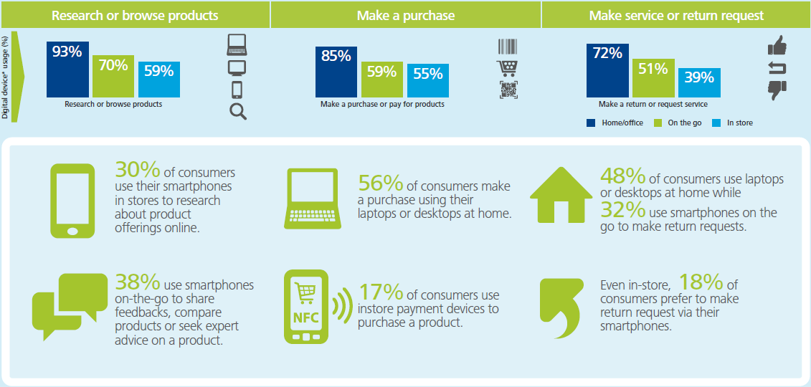
Source: Deloitte (2020).

Strong (2014) examines the implications of the data economy for the consumer goods sector. The author argues that data is changing business relations in significant ways. In this context, social media has become a central platform for the communication of people (Kietzmann et al., 2011; Abuhashesh, 2014; Perrin, 2015; Hansen and Levin, 2016; He et al., 2017). In addition, people follow brands on social media, they share experiences about goods and services and review the relevant feedback and ratings on social media before making expenditures (Chen et al., 2011; Mangold and Smith, 2012; Zhang et al., 2012; Yates and Goharian, 2013; Leeflang et al., 2014). In addition, e-commerce is becoming a central dimension of business life for many sectors. However, Strong (2014) notes that consumer goods firms have been relatively slow in adopting such technologies and strategies. However, this slow adoption of digital technologies can be detrimental to the sector. Specifically, Strong (2014) states that “Data now feels so central to business success that without an ongoing, data-mediated relationship with their customer base, we may be looking at an environment where data-poor brands will struggle to compete effectively”. But there can be some asymmetry in access to the relevant data between the brands (or manufacturers) and the retailers that sell these brands. Namely, the retailers own the final step of the relationship between consumers and brands and thereby collect data in very large sizes. However, the brands might not have enough access or control at this final stage, and their data capabilities can be constrained due to these limitations.
One way for the brands to overcome the above restrictions and to form direct relationships with their clients is the creating of services around their brands (Vandermerwe and Rad, 1988; Neely, 2008; Roy et al., 2009; Baines and Lightfoot, 2014; Lee et al., 2016). This “servitisation” offers various benefits like stable income stream, higher margins, and more efficient customer relations. But the capture of consumer data like personal information and purchase properties is another crucial factor in the “servitisation” of consumer goods products. Strong (2014) gives some examples of successful servitisation in the consumer goods sector. For example, a US firm, Dollar Shave Club, offers online subscriptions for deliveries of razors and other grooming products. Another firm, Graze, employ digital channels and social media platforms to promote its delivery of healthy snacks to customers. The companies can provide some motivations (like sales, discounts, promotions, and campaigns) to their consumers so that consumers would switch from the retail channels to the online channels of brands. In this way, consumer goods brands can establish a more direct link to their consumers and get access to very valuable data. Based on these discussions, it can be argued that the servitisation strategies can be a winning model to create additional value in the data economy.
In a recent paper, Lammi and Pantzar (2019) argue that new technologies are producing revolutionary changes in business strategies and consumer relations. The authors state that the capitalist system moved from the era of consumer citizen to the era of data citizen. Figure 2 provides a graphical representation of the data citizen, which was supported by technological developments like the internet, social media, new generation smartphones, and the application of technology to many services (such as the fusion of finance and technology as fintech). As a result of these supportive factors, the new field of data economy emerged. Lammi and Pantzar (2019) argue that the data is the new and main commodity in the current era and the leading global firms like Google, Facebook, Twitter, and Instagram are based on their data capabilities. A major result of this transformation is that consumers are also empowered significantly (Wathieu et al., 2002; Wright et al., 2006; Füller et al., 2009; Pires et al., 2010; Yuksel et al., 2016). They produce information about brands on the internet and social media platforms, and the digital word-of-mouth becomes very extensive and quick. Therefore, consumers gain the ability to affect the brand image of companies and the purchasing decisions of other consumers. Therefore, businesses should get involved in this process to be able to control their brand images and manage their consumer relations.

Figure 2: Emergence of Data Citizen
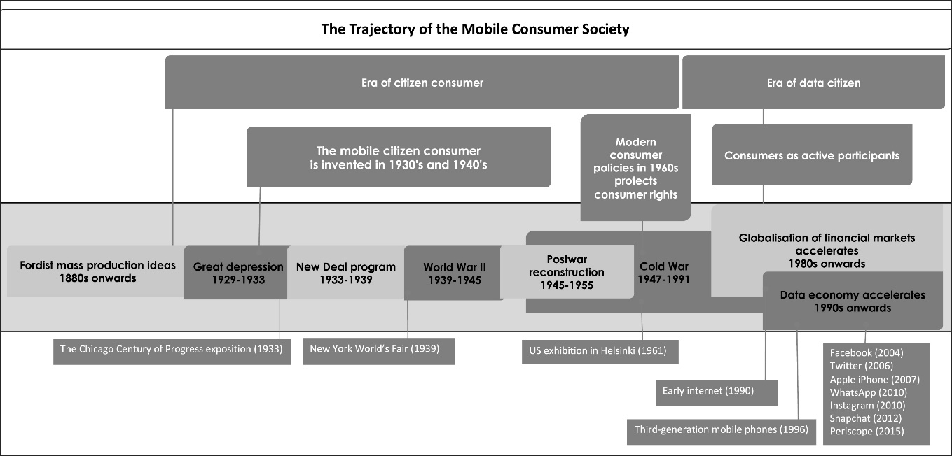
Source: Lammi and Pantzar (2019).

Based on the above discussions, it can be argued that “data economy” will be the new business model in the digital age (Otto and Aier, 2013; Allen, 2016; Zech, 2016; Elvy, 2017; Opher et al., 2016). According to McCallum and Gleason, 2013), “modern businesses see data as a gold mine” (p.1). These authors argue that a successful business model within the context of the data economy would involve the following sequential steps: collect, hold, filter, enhance, simplify access, obscure, and advise. Overall, these studies show that the data economy and servitisation can present important opportunities for the consumer goods sector.

- Methodology
  - Research Methodology

The research philosophy and approach are important dimensions of conducting scientific research activities in both natural and social sciences (Saunders et al., 2015; Hair, 2015). In the research philosophy dimension, positivism and interpretivism are the common philosophies. The positivism argues that there is a reality (like physical/natural reality or social reality) independent of researchers or observers, and the researchers can obtain its information through scientific methods like experiments and data analysis. In the process, the researchers would derive some theories and facts for the relevant realities. Then, the following research process would start from these theories and facts and try to confirm or reject them using the new data, information, and cases. In contrast, the interpretivist research philosophy would assume that reality might be subjective and be affected by the perspectives of the researchers and observers. Then, the researchers would try to explore the new data, information, and cases in order to identify some causal relationships in the data. For the case of the current research, both philosophies are relevant. There are two parts of this research. The first part examines the characteristics and dynamics of the consumer goods sector in the UK. So, for this part, a positivist research philosophy becomes more relevant. Then, the second part provides some analytical discussions on the winning model of the data economy for consumer goods. As this topic is very recent and involves subjective judgements, an interpretivist research philosophy becomes more relevant.
Regarding the research approach, Saunders et al. (2018) discuss the options of deductive inference and inductive inferences as the leading options. In the case of the deductive research approach, the researchers would try to test the validity of some hypotheses coming from the existing theories and evidence. In the case of the inductive inference, there would be no hypotheses to test, but the researcher would examine the new data, information, and cases to arrive at some causal findings and hypotheses. So, the inductive inference would proceed from the specific to general and follow a bottom-up research approach. The current research again utilises both research approaches. The first part of the research assumes that the economic theory implies that the dynamics of consumer goods would be closely related to some macroeconomic variables like economic growth, unemployment rates, and consumer confidence. Therefore, this part relies on deductive inference methods. In contrast, the second part does not assume any theory for the winning model of the data economy. So, inductive inference methods are used in that part. Overall, this research follows mixed-methods in its research methodology.

  - Research Limitations and Ethical Concerns

There are some research limitations in the current study. Due to data availability concerns, only publicly available secondary data (like the UK GDP growth, unemployment rate, consumer confidence) is used in the quantitative analysis. While this quantitative analysis provides some valuable information on the dynamics and properties of the consumer goods sector in the UK, the lack of more detailed data can be considered as a limitation. Instead of focusing on such broad categories, conducting more detailed quantitative analysis of the specific consumer goods would also provide additional insights into the research question. Similarly, specific data on the consumer purchasing behaviour of consumer goods and the firm strategies of data economy can be examined by collecting primary data from consumers and firms. Therefore, the lack of primary data emerges as another research limitation. These research limitations can be addressed in future research. Regarding any ethical concerns in the research process, as the study is conducted on publicly available secondary data, there are no issues of privacy or security. In addition, the researcher does not have any conflicts of interest in conducting this research. Hence, there are no ethical concerns left in the current research.

- Results
  - Quantitative Analysis
The quantitative analysis in this research is based on the macroeconomic data for the UK. The publicly available data from ONS (2020a, 2020b) are searched extensively to get the relevant data on the consumer goods sector. There is no defined “consumer goods sector” that the relevant data is readily available. So, different variables from the final consumption expenditures of households should be collected together to arrive at this classification. Table 1 shows the size of the consumer goods sector and its components in the UK covering the period of 1997-2019.
Table 1: The Consumer Goods Sector in the UK (1997-2019, chained volume, million £)
 | Food and drink | Alcohol and tobacco | Clothing and footwear | Furnishings | Misc. | Total Consumer Goods
1997 | 81,657 | 54,712 | 14,935 | 37,199 | 13,281 | 201,784
1998 | 84,134 | 54,427 | 16,436 | 39,452 | 13,522 | 207,971
1999 | 85,847 | 53,970 | 18,065 | 40,928 | 14,122 | 212,932
2000 | 85,935 | 52,804 | 20,682 | 44,221 | 14,932 | 218,574
2001 | 86,905 | 52,158 | 23,844 | 47,716 | 15,987 | 226,610
2002 | 87,576 | 52,900 | 27,802 | 49,243 | 17,653 | 235,174
2003 | 90,891 | 53,666 | 30,783 | 49,839 | 18,817 | 243,996
2004 | 92,081 | 52,344 | 33,077 | 49,985 | 20,715 | 248,202
2005 | 93,204 | 53,110 | 35,877 | 51,100 | 20,638 | 253,929
2006 | 93,390 | 51,569 | 38,888 | 52,789 | 21,385 | 258,021
2007 | 93,483 | 50,449 | 41,352 | 53,959 | 21,517 | 260,760
2008 | 89,511 | 50,348 | 45,901 | 50,378 | 20,261 | 256,399
2009 | 86,979 | 49,646 | 50,339 | 46,483 | 19,455 | 252,902
2010 | 84,531 | 48,810 | 52,267 | 46,863 | 19,635 | 252,106
2011 | 86,414 | 47,428 | 53,703 | 46,076 | 19,072 | 252,693
2012 | 85,399 | 45,831 | 54,888 | 45,617 | 20,374 | 252,109
2013 | 87,165 | 45,911 | 58,729 | 46,137 | 20,332 | 258,274
2014 | 89,845 | 44,232 | 59,914 | 47,724 | 22,916 | 264,631
2015 | 88,948 | 42,392 | 62,597 | 51,625 | 25,333 | 270,895
2016 | 95,238 | 40,997 | 64,769 | 54,318 | 26,775 | 282,097
2017 | 98,489 | 40,441 | 65,309 | 58,374 | 28,640 | 291,253
2018 | 100,216 | 40,982 | 65,460 | 63,320 | 31,901 | 301,879
2019 | 100,922 | 40,041 | 70,255 | 65,519 | 34,290 | 311,027

Note: Miscellaneous category includes “Electrical appliances for personal care”, “Other appliances, articles and products for personal care”, and “Jewellery clocks and watches”.

It is seen that the largest consumer goods category is the food and drink sector. The size of this sector was £82 billion in 1997, and it increased by around 25% in real terms to £101 billion in 2019. The third-largest sector, as of 2019 is the clothing and footwear sector. The size of this sector was £15 billion in 1997, and it increased by 370% to £70 billion in 2019. This is an astonishing growth compared to other consumer goods, household expenditures, or GDP growth. The third-largest category as of 2019 is the furnishings and home equipment. The size of this sector was £37 billion in 1997, and it almost doubled to £66 billion in 2019. The fourth-largest consumer goods sector is alcohol and tobacco. In contrast to other sectors, this sector decreased from £55 billion in 1997 to £40 billion in 2019. Lastly, the miscellaneous consumer goods increased by 158% from £13 billion in 1997 to £34 billion in 2019. Overall, the total size of the consumer goods sector increased from £202 billion to £311 billion. So, the increase in consumer goods was 54.14% in this period, which is smaller than the increase in the total household consumption expenditures, which grew by 64%. However, it was almost identical to the GDP growth rate of 54.11%.
Figure 3: Dynamics of Different Consumer Goods Categories in the UK (1997=100)

The diverging dynamics of the specific consumer goods categories are shown in Figure 3 as well. The graph takes the initial year of 1997 as 100 for all categories. It is seen that while the consumption of alcohol and tobacco declined significantly, the other categories displayed positive growth in this period, with the consumption of the clothing and footwear displaying the largest increase.
Table 2 presents the summary statistics of the macroeconomic variables used in the quantitative analysis. It is seen that the average annual growth rate of the clothing and footwear sector was 7.4%, followed by 4.5% growth in the miscellaneous category and 2.7% in the furnishings category. The food and drink sector displayed a lower than average growth with 1% annual increase, and the alcohol and tobacco category displayed annual decline rates of -1.4%. In this period, the total consumer goods sector registered an average annual growth rate of 2%, which was the same as the GDP growth rate, but lower than the growth rate of total household expenditures. In this period, the unemployment rate averaged at 5.8%.
Table 2: Summary Statistics (1998-2019)
Variable | Obs | Mean | Std. Dev. | Min | Max
Food and drink (% Growth) | 22 | 1.00 | 2.50 | -4.25 | 7.07
Alcohol and tobacco (% Growth) | 22 | -1.39 | 1.75 | -4.16 | 1.46
Clothing and footwear (% Growth) | 22 | 7.39 | 4.64 | 0.23 | 16.60
Furnishings (% Growth) | 22 | 2.70 | 4.39 | -7.73 | 8.47
Miscellaneous (% Growth) | 22 | 4.53 | 5.20 | -5.84 | 12.71
Total Consumer Goods (% Growth) | 22 | 2.00 | 1.70 | -1.67 | 4.14
Total HH expenditures (% Growth) | 22 | 2.28 | 1.81 | -3.06 | 4.66
GDP (% Growth) | 22 | 2.00 | 1.66 | -4.25 | 3.64
Unemployment Rate (%) | 22 | 5.77 | 1.30 | 3.80 | 8.10
Consumer Confidence Index | 22 | -9.11 | 10.85 | -29.50 | 3.33

In order to see the relationship between different categories of consumer goods and other macroeconomic variables (like GDP growth, unemployment rate, and consumer confidence index), one can use the cross-correlation coefficients. Table 3 shows the relevant cross-correlation coefficients. It is seen that furnishing expenditures have the highest correlation coefficient with both the GDP and the total household expenditures. This is followed by the categories of food and drink, miscellaneous, clothing and footwear, and alcohol and tobacco. The positive cross-correlations coefficients for the consumer goods categories, except for the alcohol and tobacco group, imply that income is a very important determinant of consumer goods expenditures. In addition, all categories of consumer goods have negative correlation coefficients with the unemployment rate, implying that unemployment is negatively associated with consumer goods expenditures. The correlation is again highest (in absolute value) for furnishings, followed by miscellaneous, and the food and drink sector. Finally, all categories of the consumer goods sector have positive correlations with the consumer confidence level. Overall, these results are in line with the expectations that demand factors (like income and employment) and confidence would affect the household expenditures on consumer goods positively.
Table 3: Cross-correlations between Consumer Goods Categories and Macro Variables
 | Food and drink | Alcohol and tobacco | Clothing and footwear | Furnishing | Misc.
Total HH expenditures (% Growth) | 0.58 | 0.06 | 0.23 | 0.74 | 0.52
GDP (% Growth) | 0.49 | 0.05 | 0.12 | 0.68 | 0.43
Unemployment Rate (%) | -0.34 | -0.22 | -0.15 | -0.55 | -0.50
Consumer Confidence Index | 0.46 | 0.09 | 0.34 | 0.75 | 0.61

As the last part of the quantitative analysis, OLS regression models are estimated to check the multivariate relationships for the consumer goods categories. Table 4 presents the relevant results for the total consumer goods sector. It is seen that all three explanatory variables are statistically significant at least at 10% level. GDP is the most significant variable, and it has a positive association with economic growth. The coefficient implies that one percentage points increase in GDP growth is associated with an increase of 0.26 percentage points in the growth rate of the consumer goods. In addition, one percentage points decline in the unemployment rate is associated with a 0.41 percentage points increase in the consumer goods growth rate. Lastly, higher levels of consumer confidence index are also positively associated with higher growth for consumer goods. Overall, these results confirm the expectations that demand and confidence factors are important for the consumer goods sector. When discussing the relevance of the data economy for consumer goods, one should also keep macroeconomic factors in mind.

Table 4: Regression Results for Total Consumer Goods Sector

  - Qualitative Discussions
The previous sections showed that the data economy has been changing the business life in major ways, while the consumer goods sector has been slow in catching that trend. Based on the above analysis and the detailed literature review, this part argues that two business strategies are very crucial to have a winning model for creating value in the consumer goods sector within the context of the data economy. The first one is the “servitisation” of the consumer goods and the second one is the establishment of an efficient “big data” capability. Regarding the first strategy of “servitisation”, Broström and Halvarsson (2016) provide the following definition: “Servitization as a phenomenon is based on having a service-focus rather than a goods-focus in the firm’s operations” (p.8). In the goods-focused approach, the main value-added is derived from the production of the goods by brands and their consumption by clients. In this structure, the relationships between the brands and consumers are mediated by the retailers. This can decrease the power of brands in terms of accessing and managing consumer data. The servitisation process creates new opportunities for the brands to form direct contacts with their customers. Figure 4 shows a model of servitisation. It is seen that at the very low levels of servitisation, the relationship between brands and consumers is only at the transaction level. Brands can move towards higher levels of servitisation. In the second stage, they can focus on both product and service delivery. In the third stage, they can engage in the customization of products and services according to customer needs. So, increasing the level of engagement with customers through servitisation of consumer goods is an important strategy to increase the competitive advantage of companies. In this way, brands can collect very detailed information on personal characteristics and purchase behaviours.
Figure 4: Servitisation
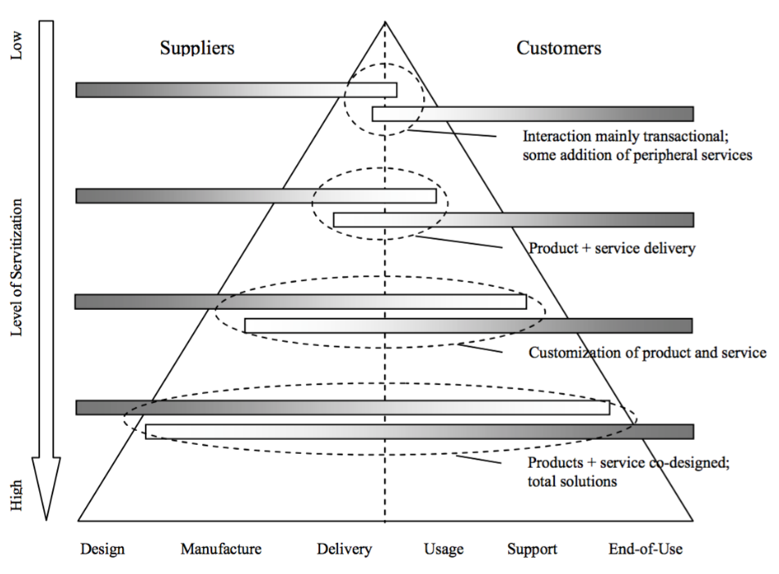
Source: Broström and Halvarsson (2016).

Once servitisation allows the greater access of brands to their consumers, the firms should also devise effective big data mechanisms to use the new information efficiently. In this context, Opher et al. (2016) argue that data is one of the most important assets for companies. However, to be able to utilise this asset, the firms need to arrange their organisational structure along with technical and human capital infrastructure accordingly. This process would require detailed investments and managerial effort. However, it would pay positively in terms of higher competitive advantage for the consumer goods firms. Overall, these discussions argue that servitisation and big data analytics are the winning strategies for creating value in consumer goods within the context of the data economy.

- Conclusion
The research examines the relevance of the data economy for the consumer goods sector and aims to derive a winning model of value creation. Towards this aim, it provides a detailed literature review. The relevant discussions show that the consumer goods sector, and especially the fast-moving consumer goods sector, is a very dynamic market. Some segments of this market, like furnishing, clothing, and footwear, displayed strong growth, while some other segments like alcohol and tobacco, displayed declines over time. In addition, the utilisation of information and communication technologies by the consumer goods brands has been relatively limited in consumer relations and big data dimensions. A major structural barrier in the relationship has been the intermediary role of retailers between consumer goods and brands. The retailers use extensive consumer data in terms of personal information and purchasing behaviours. Therefore, the winning model should try to eliminate this barrier and create direct links between the brands and consumers.
The quantitative analysis shows that in the UK, the consumer goods sector displayed a growth rate very close to the GDP growth. However, there have been significant differences between sub-categories. Clothing and footwear displayed very large growth rates, while the size of the alcohol and tobacco sector declined in the last two decades. The correlation and regression analyses showed that GDP and consumer confidence affected the sector positively, whereas the unemployment rate affected it negatively. Then, the qualitative discussions showed that two strategies of servitisation of the consumer products and the establishment of big data analytics are the most feasible strategies to create value for the sector and brands.

References:
Abuhashesh, M.Y., 2014. Integration of social media in businesses. International Journal of Business and Social Science, 5(8).
Allen, A.L., 2016. Protecting one's own privacy in a big data economy. Harv. L. Rev. F., 130, p.71.
Baines, T. and Lightfoot, H.W., 2014. Servitization of the manufacturing firm. International Journal of Operations & Production Management.
Broström, J. and Halvarsson, J., 2016. Servitization Challenges: exploring the business-to-consumer context.
Chen, Y., Fay, S. and Wang, Q., 2011. The role of marketing in social media: How online consumer reviews evolve. Journal of interactive marketing, 25(2), pp.85-94.
Deloitte, 2020. Consumer product trends: Navigating 2020. Available at: https://www2.deloitte.com/content/dam/Deloitte/uk/Documents/consumer-business/deloitte-uk-cpg-trends-2016.pdf (Accessed 06 April 2020).
Elvy, S.A., 2017. Paying for privacy and the personal data economy. Colum. L. Rev., 117, p.1369.
Füller, J., MüHlbacher, H., Matzler, K. and Jawecki, G., 2009. Consumer empowerment through internet-based co-creation. Journal of management information systems, 26(3), pp.71-102.
Hair, J.F., 2015. Essentials of business research methods. ME Sharpe.
Hansen, J.M. and Levin, M.A., 2016. The effect of apathetic motivation on employees' intentions to use social media for businesses. Journal of Business Research, 69(12), pp.6058-6066.
He, W., Wang, F.K., Chen, Y. and Zha, S., 2017. An exploratory investigation of social media adoption by small businesses. Information Technology and Management, 18(2), pp.149-160.
Kietzmann, J.H., Hermkens, K., McCarthy, I.P. and Silvestre, B.S., 2011. Social media? Get serious! Understanding the functional building blocks of social media. Business horizons, 54(3), pp.241-251.
KPMG, 2018. KPMG Organic Growth Barometer 2018. Available at: https://home.kpmg/uk/en/home/insights/2018/06/kpmg-organic-growth-barometer-2018.html (Accessed 06 April 2020).
Lammi, M. and Pantzar, M., 2019. The data economy: How technological change has altered the role of the citizen-consumer. Technology in Society, 59, p.101157.
Lee, S., Yoo, S. and Kim, D., 2016. When is servitization a profitable competitive strategy?. International Journal of Production Economics, 173, pp.43-53.
Leeflang, P.S., Verhoef, P.C., Dahlström, P. and Freundt, T., 2014. Challenges and solutions for marketing in a digital era. European management journal, 32(1), pp.1-12.
Let’s Nurture, n.d. Consumer Goods: Digital Solutions. Available at: https://www.letsnurture.com/industry/consumer-goods.html (Accessed 07 April 2020).
Mangold, W.G. and Smith, K.T., 2012. Selling to Millennials with online reviews. Business Horizons, 55(2), pp.141-153.
McCallum, Q.E. and Gleason, K., 2013. Business models for the data economy. O'Reilly Media, Inc.
Neely, A., 2008. Exploring the financial consequences of the servitization of manufacturing. Operations management research, 1(2), pp.103-118.
ONS, 2020a. Gross Domestic Product: chained volume measures: Seasonally adjusted £m. Available at: https://www.ons.gov.uk/economy/grossdomesticproductgdp/timeseries/abmi/qna (Accessed 08 April 2020).
ONS, 2020b. Consumer trends: chained volume measure, seasonally adjusted. Available at: https://www.ons.gov.uk/economy/nationalaccounts/satelliteaccounts/datasets/consumertrendschainedvolumemeasureseasonallyadjusted (Accessed 08 April 2020).
Opher, A., Chou, A., Onda, A. and Sounderrajan, K., 2016. The rise of the data economy: driving value through internet of things data monetization. IBM Corporation: Somers, NY, USA.
Otto, B. and Aier, S., 2013. Business models in the data economy: A case study from the business partner data domain.
Perrin, A., 2015. Social media usage. Pew research center, pp.52-68.
Pires, G., Rita, P. and Stanton, J., 2010. Assessing relevancy of ICT driven consumer empowerment for business.
Roy, R., Shehab, E., Tiwari, A., Baines, T.S., Lightfoot, H.W., Benedettini, O. and Kay, J.M., 2009. The servitization of manufacturing. Journal of manufacturing technology management.
Saunders, M.N., Lewis, P., Thornhill, A. and Bristow, A., 2015. Understanding research philosophy and approaches to theory development.
Saunders, M.N.K., Lewis, P. and Thornhill, A., 2019. Research Methods for Business Students. 8th edn. Harlow.
Strong, C., 2014. The Future for Consumer Goods in the Data Economy. Wired. AVAİLABLE AT: https://www.wired.com/insights/2014/12/consumer-goods-data-economy/ (Accessed 07 April 2020).
UK Parliament, 2017. Consumer Goods Sector Report. Available at: https://www.parliament.uk/documents/commons-committees/Exiting-the-European-Union/17-19/Sectoral%20Analyses/9-Sectoral-Analyses-Consumer-Goods-Report.pdf (Accessed 07 April 2020).
Vandermerwe, S. and Rada, J., 1988. Servitization of business: adding value by adding services. European management journal, 6(4), pp.314-324.
Wathieu, L., Brenner, L., Carmon, Z., Chattopadhyay, A., Wertenbroch, K., Drolet, A., Gourville, J., Muthukrishnan, A.V., Novemsky, N., Ratner, R.K. and Wu, G., 2002. Consumer control and empowerment: a primer. Marketing Letters, 13(3), pp.297-305.
Wright, L.T., Pires, G.D., Stanton, J. and Rita, P., 2006. The internet, consumer empowerment and marketing strategies. European Journal of Marketing.
Yates, A. and Goharian, N., 2013, March. ADRTrace: detecting expected and unexpected adverse drug reactions from user reviews on social media sites. In European Conference on Information Retrieval (pp. 816-819). Springer, Berlin, Heidelberg.
Yuksel, M., Milne, G.R. and Miller, E.G., 2016. Social media as complementary consumption: The relationship between consumer empowerment and social interactions in experiential and informative contexts. Journal of Consumer Marketing.
Zech, H., 2016. A legal framework for a data economy in the European Digital Single Market: rights to use data. Journal of Intellectual Property Law & Practice, 11(6), pp.460-470.
Zhang, Z., Li, X. and Chen, Y., 2012. Deciphering word-of-mouth in social media: Text-based metrics of consumer reviews. ACM Transactions on Management Information Systems (TMIS), 3(1), pp.1-23.

