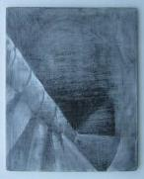

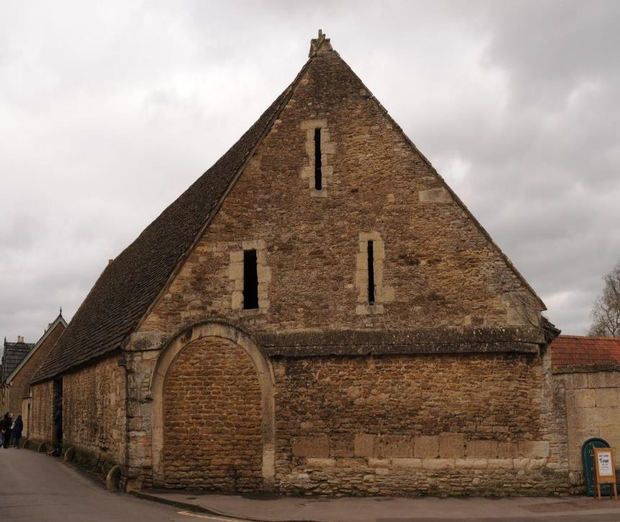

National Trust: Lacock

Barn Graffiti & Apotropaic Survey Report

March 2019

Tony Hack (B.A.) - Project Director

Acknowledgements
Wiltshire Medieval Graffiti Survey would like to thank the following persons for their time and generosity; Martin Papworth, Ann Cox, Dorothy Treasure, Judith Thomson, Christina Staff, Claire Radnedge and all the NT staff including front of house in the Fox Talbot Museum Barn who made our visits all the more enjoyable.

Introduction
Wiltshire Medieval Graffiti Survey were kindly granted an archaeological licence by the National Trust to conduct a non-invasive photographic survey of three barns associated with the historic Lacock Abbey complex. The aim of which is to record any remaining graffiti & symbolism that is accessible, historically important and may add to the knowledge and understanding of the buildings.

Wiltshire Medieval Graffiti Survey

This project was set up in 2014 in order to record historical graffiti and re-use of stone throughout the county of Wiltshire. We continue to support and communicate with similar projects through the UK and Europe, allowing for the development of common recording techniques and a shared terminology for classification.

Research Aims & Objectives

(i) To systematically record historical graffiti, inscriptions, re-uses of stone using non-invasive methods.

(ii) To present findings in a format that is comprehensive and offers a typology that may include; apotropaic symbolism, folk art, names and dates and Christian
symbolism.

(iii) To increase knowledge and understanding of a building from a social perspective. How folk made their mark and why. How the location of these marks is
represented in terms of a buildings use and how this may have changed over time.

(iv) To disseminate results to interested parties, share research in order to increase understanding on a wider scale.

(v) To promote and encourage both academic and public interest and participation.

Methodology

WMGS uses only non-invasive techniques when recording which is generally in the form of digital photography using an oblique, raking light. Photographic scales are used for reference via a clip holder; There is no physical interaction with the stone (or any medium) surface to preserve fabric and prevent erosion.
A measured site plan is drawn to show the location of graffiti and a photographic log records frame number, location and a brief description.
For complex, unusual and significant pieces other forms of recording such as Reflectance Transformation Imaging (R.T.I.) may be used. This is a recording methodology that allows a computer program to incorporate multiple lighting patterns into a format that can be manipulated to enhance detail.
Photogrammetry can also be used to re-create and enhance using multiple camera positions to facilitate the construction of a 3D model.
We recently used this on the “Calne Fates” memorial stone found in St Mary’s School in Calne and currently on display in the Wiltshire Museum, Devizes.
A Sketchfab model can be found here;
https://sketchfab.com/3d-models/parcae-3d-2-bf539fd85dd84621b2f57da5a2a1f6b6
Outside of the formal recording we encourage participation by artists to produce other dimensions to the survey. This is often in the form of creative drawing & painting and extends to using analogue film to create artwork using double exposure and other techniques. We find that this broadens the scope of the project and allows us to present and engage with the public in a variety of ways.

The Lacock Barns
The three barns covered by the survey are the Tithe Barn, Manger Barn and the Fox Talbot Museum Barn.
The Tithe Barn is unlocked daily and is openly accessible. It stands alone, encapsulated in time, allowing visitors a glimpse of its history. The crux roof is renowned piece of architecture, skilfully assembled and standing the test of time long after the barn’s function has become redundant.
The Manger Barn has dual function as a conference room/art gallery as well as housing conservation works. Our survey was restricted to the refurbished conference room so as not to disturb any conservation work although a cursory inspection revealed little to justify a formal survey.
The Fox-Talbot Museum Barn is heavily dry-lined which restricts any information we may have gleaned from its walls however by its very nature as a working building it has new life breathed into it and as such any future remedial work may enable a closer look. It should be viewed that this survey is limited in its results.
Within the barns are incised graffiti that are within stone and timber. For ease of location they will be presented separately. Within the barns are a selection of apotropaic compass-drawn motifs that are associated with ritual protection practices (apotropaic: Greek literal translation “to turn away, avert”). Geometric designs including consecration cross style and multi-petalled hexfoils, often left incomplete, add to the mystique. Also recorded are tally marks (possibly associated with goods into the barn or out), carpenter’s marks and folk art.
The Tithe Barn
Latitude: 51.415 / 51°24'54"N Longitude: -2.1214 / 2°7'16"W
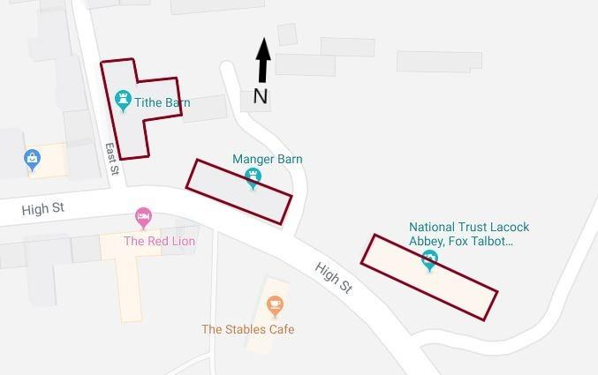
The tithe barn is a 14thC construction with oolitic limestone coursed rubble stone with raised cruck timber roof structure. Of North-South orientation the barn comprises 8 bays with a 4-bay east wing (Pevsner, 1975).

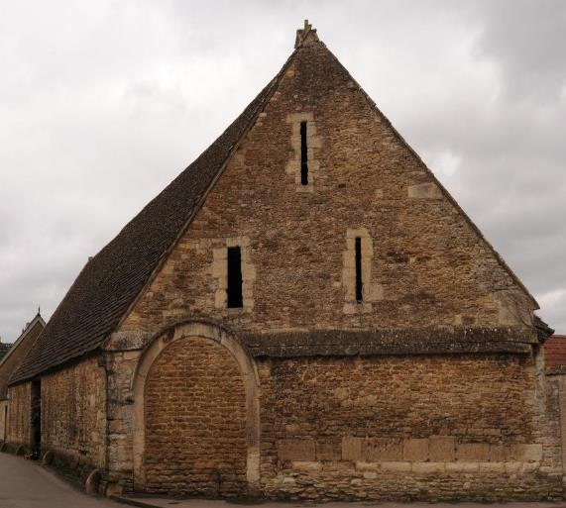

Tithe Barn Schematic

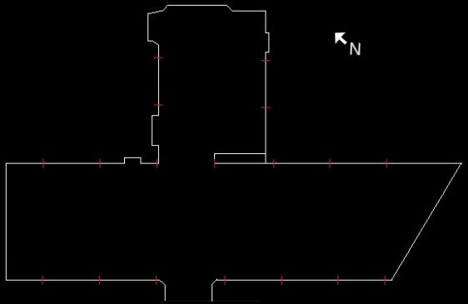
For ease of location and identification a schematic of the Tithe Barn floor plan is used for each location. The schematic is coded using a white band to identify the location of the grouped graffiti. This together with the annotated and overlain images will ease identification.
East Porch
The variety and density of the incised graffiti is most prevalent within the east porch. Therefore, it is natural to begin here in order to understand how the graffiti is represented and even how the barn may have been used. It is important at this juncture to mention that the barn has evidence of lime render throughout, much of which no longer remains. What does remain is in small areas and contains incised overlain circles that are common within the render within Lacock Abbey which in itself suffers from removal of render. With this in mind it is important to consider that within the barn may have been a significant amount of apotropaic graffiti that has been lost to time. We can only speculate on how much but as the remaining render contains evidence then we can assume that this decoration may have been consistent throughout. The lime render providing a suitable surface for easy execution and akin to the soft dressed limestone stone of the monastic barn at Bradford on Avon where apotropaic symbols can be measured by the hundred.
East Porch North Threshold

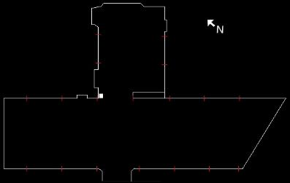

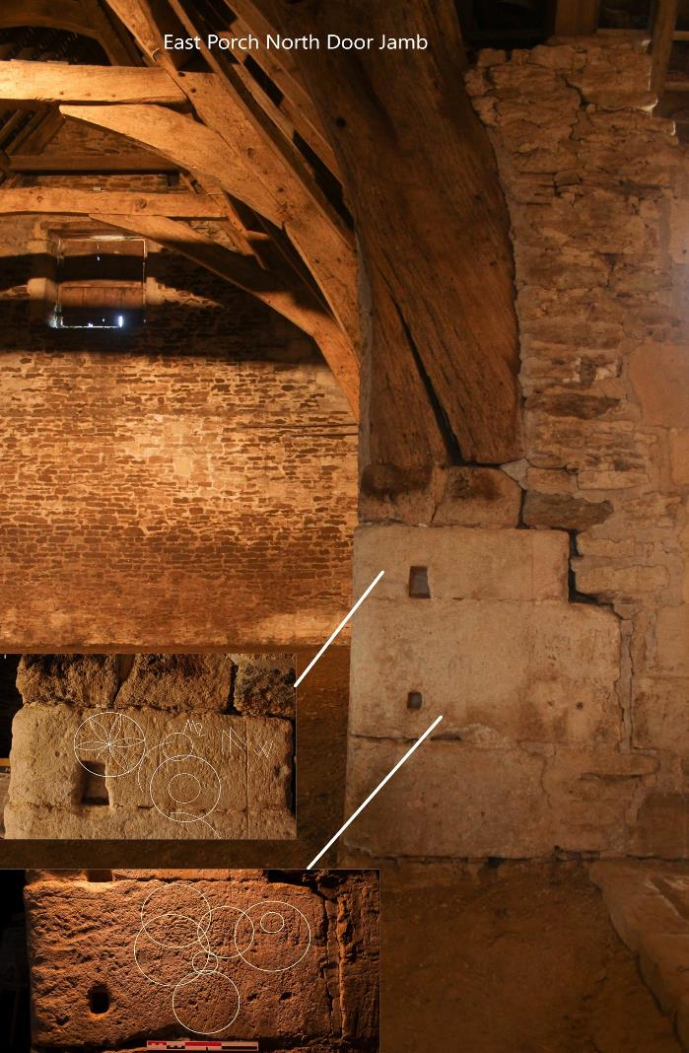
As the threshold between the main barn and the porch is traversed opposing stone jambs hold protective symbols that define the change in spatial terms. This crossing from one space to another is significant and is duly protected.
East Porch South Threshold

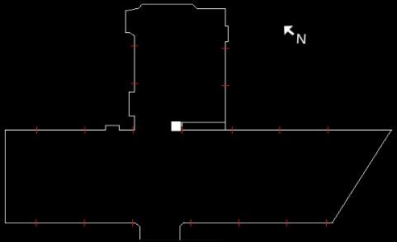
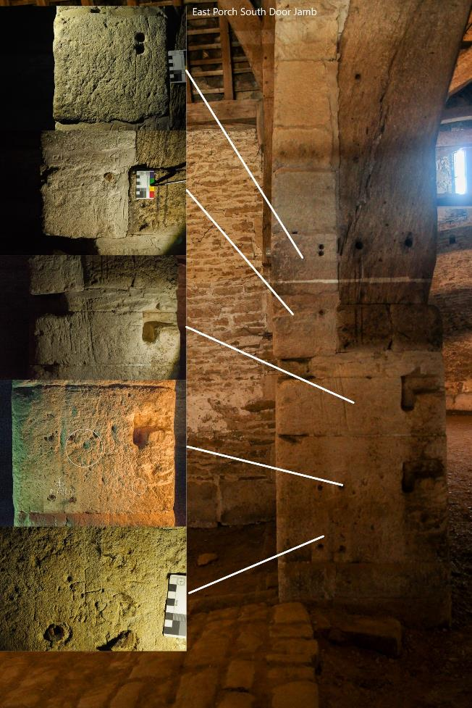
The south jamb also contains apotropaic motifs in the form of compass drawn circles and what we perceive as a “Marian” motif associated with the Virgin Mary. Additional Marian Marks can be seen in the barn in the form of conjoined “V’s” or “M” representing Virgo virginum (Virgin of Virgins) & Mary which may also offer an explanation for the hexafoil/circle motifs associated as they may be with Mary (Easton, 2016). These are on an eroded surface subject to wear as can be expected within a working barn and the position of these stones leave them vulnerable to damage.
East Porch North Wall Side Door
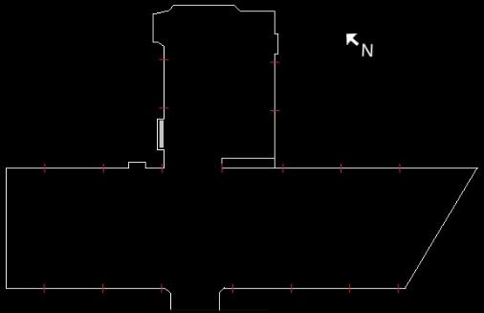

The small side door to the porch (see location diagram above) holds several “tally“ marks primarily associated with “goods in or out”. It could be argued that the number of tally marks does not equate to the amount of goods moved but may be more of a protective nature. The right-hand door jamb contains an apotropaic mesh, a multiple tally mark & a rare tally with dots under the verticals. Possibly a multiplication or a reinforcement of the motif, this is a single motif that shares attributes with a similar singular example at Bradford on Avon monastic barn.

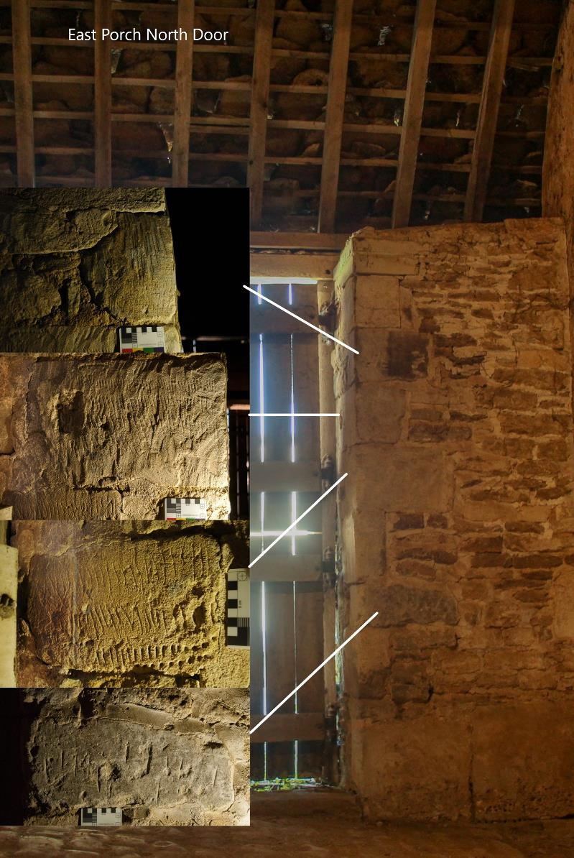

East Porch: North Wall
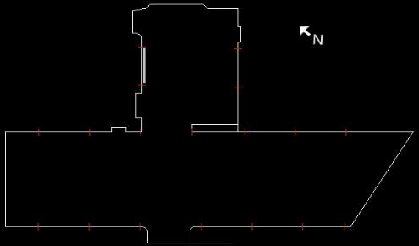
The north wall of the porch contains a dressed piece of stone affectionately known to us as the “Nun Stone” depicting as it does a stylised female figure in an authoritarian pose. It would be romantic to suggest it is of an age where nuns were still in residence at Lacock as it could easily represent a 20th C nurse. Whatever its age one can assume it was incised by a male who was feeling the brunt of a female overseer. The figure can be regarded as a crude but effective piece of folk art and it does share a relationship with the concentric circles within the same stone as the perpetrator has respected its existence and shared the space unlike the later “ET” initials whose perpetrator may not have seen or regarded the pieces. The piece compliments the folk art found elsewhere in Lacock particularly with regard to the hooded figure in the abbey as documented by Violet Pritchard in the 1960’s (Pritchard, 1967).
It has been reported by one of our members that when she first noticed the figure that within the last few years “button- hole” marks have been made down the front of the figure, therefore we cannot include those as part of the original piece and are quite sadly modern vandalism.

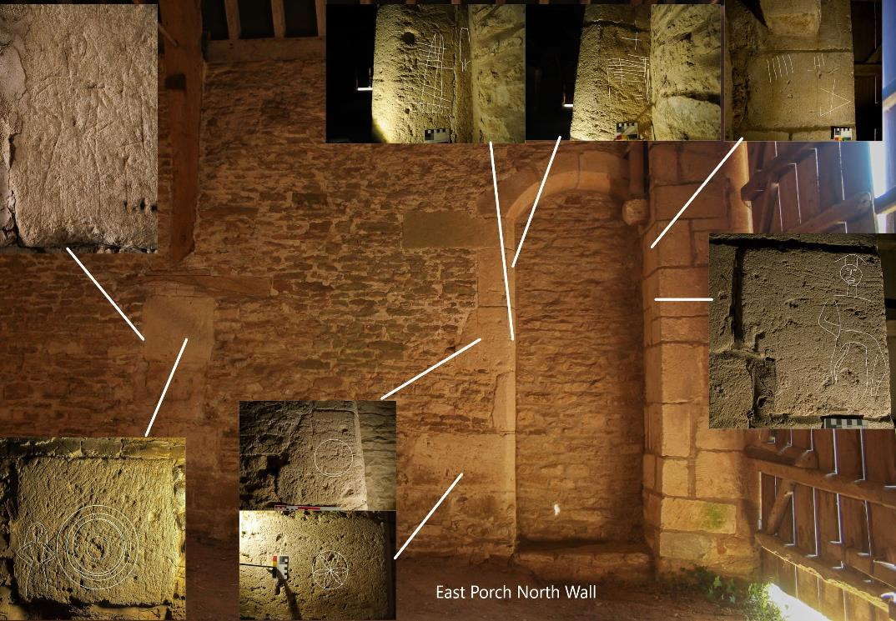
The “Nun” Stone

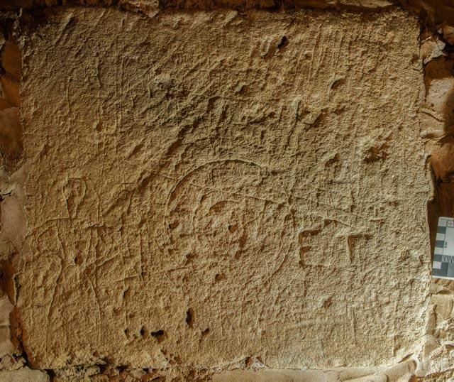
Within the r/h door jamb of the bricked-up doorway lies another figure that appears to represent perhaps a school master in flowing gown and topped with a mortar board hat. Crudely executed this figure may be unfinished.
Apotropaic marks are prominent at this entrance only to the left of the doorway. Of interest is that compass drawn circles within the barn exist in singular and multiple forms whereas the hexafoils exist only in a singular context. Perhaps the value of the single hexafoil was important to the instigator containing as it does the ability to allow for the laying out of multiple geometric shapes within its circumference (Champion, 2015).
Also, within the vicinity of the doorway are “mesh” type scratchings. These contain both vertical & horizontal lines that overlay each other. A deliberate action that may offer some apotropaic function. The doorway also contains a single tally mark that shares space with what appears to be a mason’s mark, although its well-defined lines shows little repetition throughout the building as may be expected.

East Porch East Doorway
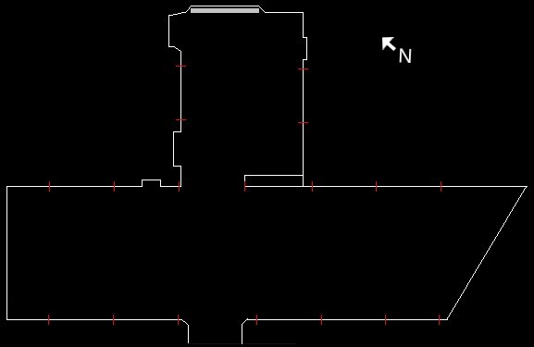

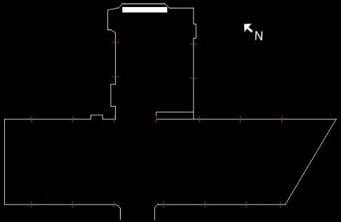
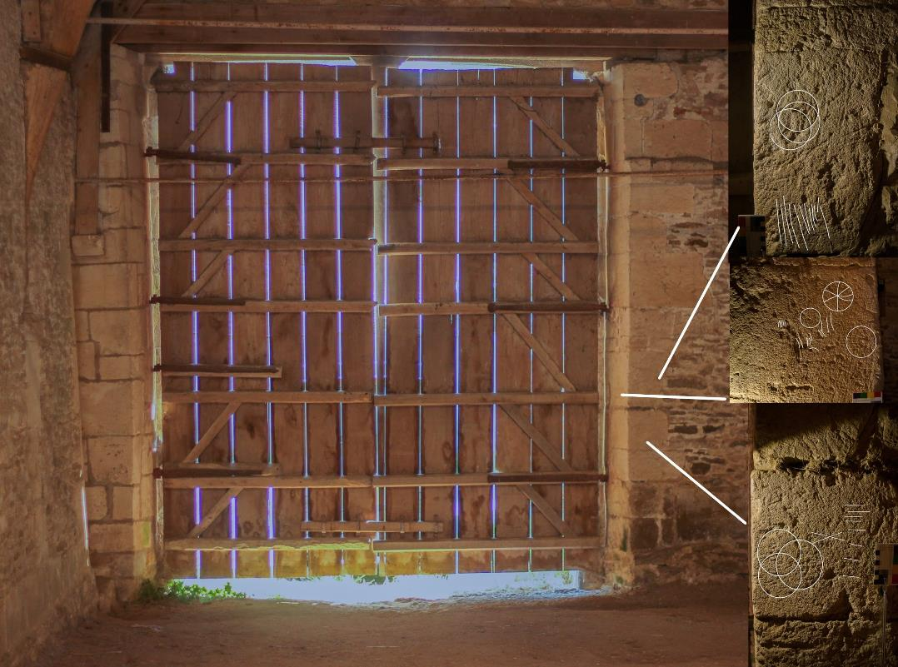

To the right of the porch main door are several small compass-drawn motifs, essentially single overlapping circles. Interestingly there are accompanying tally marks reinforcing the apotropaic nature or perhaps complimenting. To the left side of the door are a series of barely discernible marks that remain elusive in interpretation although there are some faint initials. An obvious graffito is the IS 1719 (the crossed I representing J pictured below) above but unrelated tally marks.

East Porch Main Doorway L/H
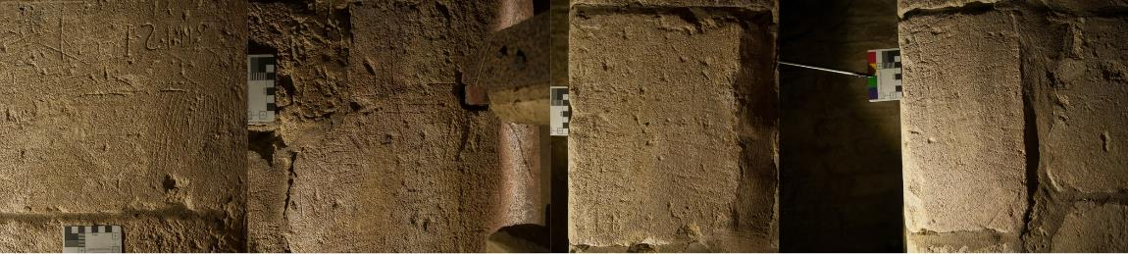

East Porch South Wall Render
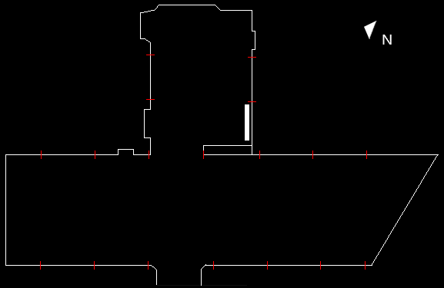
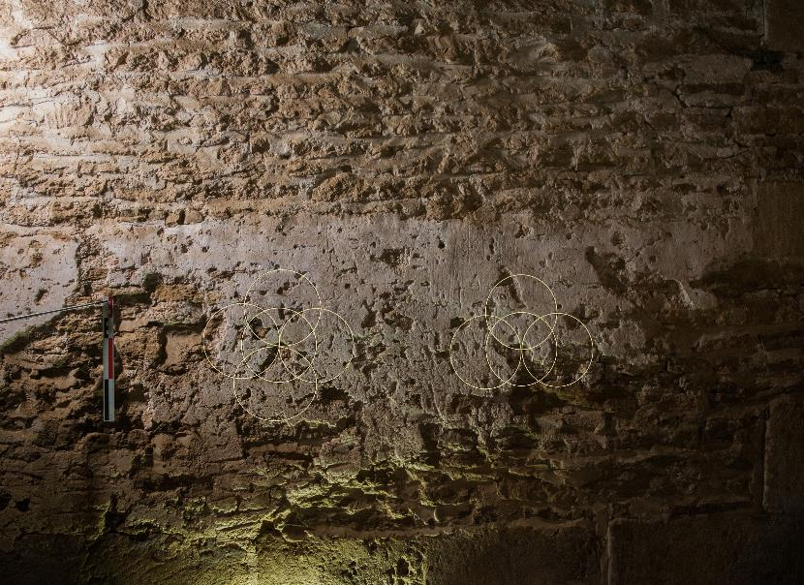
The remaining lime render hosts remnants of interlocking compass drawn circles which can also be found within Lacock Abbey. Apotropaic in nature, the multiple circles pictured here form a consecration cross style motif within the centre circle.

East Porch West Wall
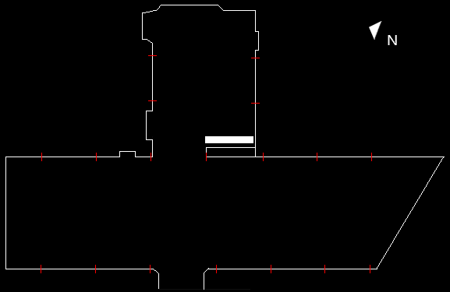
Overlain view of the porch west wall with annotated images. The dressed stone features both apotropaic symbols and tally marks and in one instance a combination of the two which is replicated at a small stone barn at Ditteridge, Wiltshire.

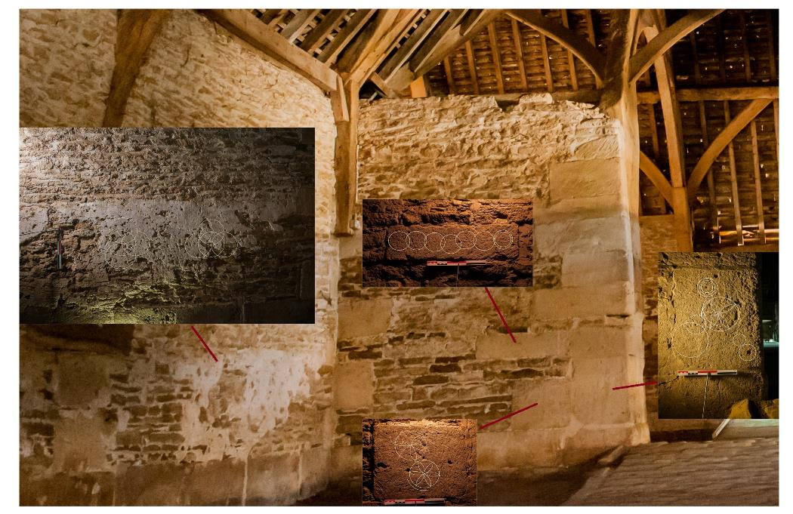

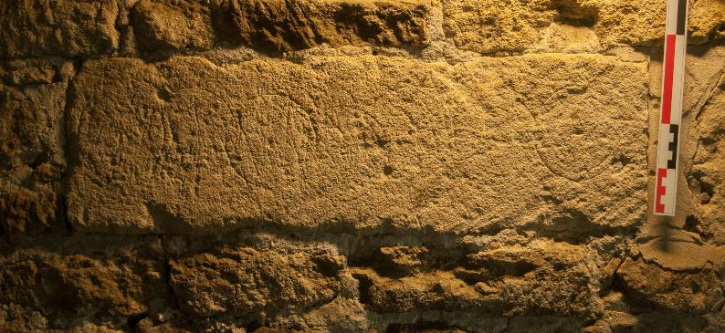
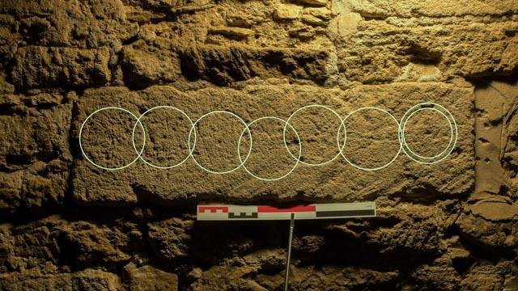
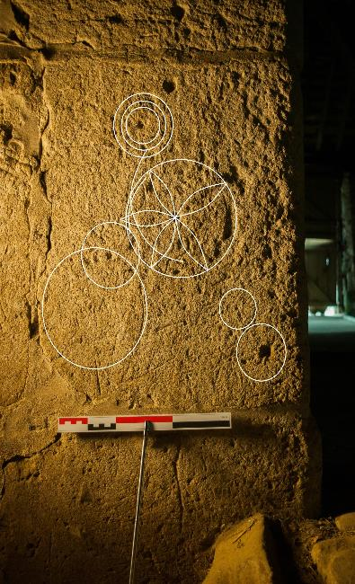
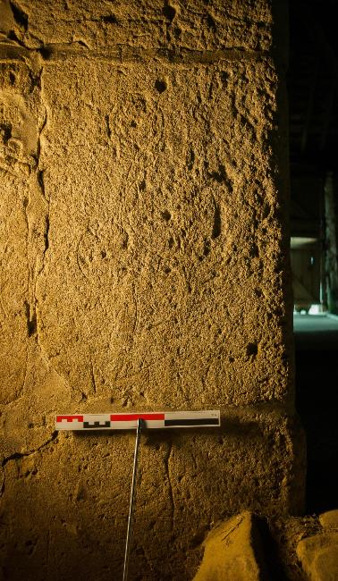

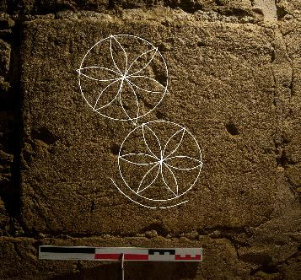
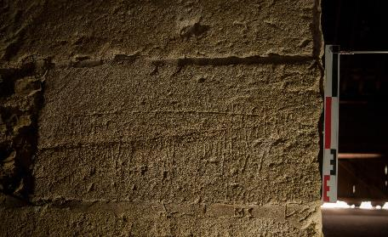
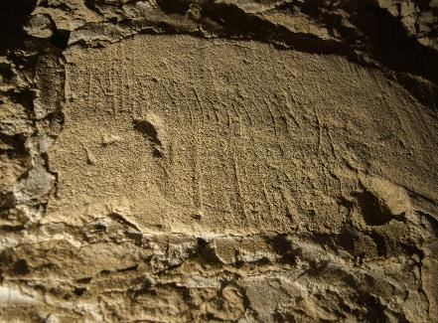
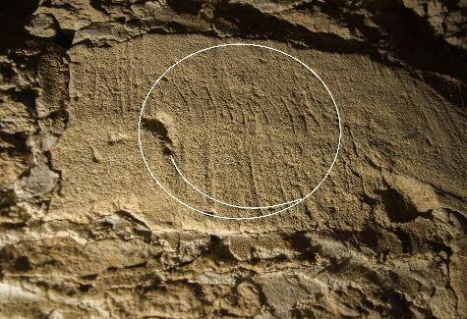
Above the apotropaic marks lie dressed stone with tally marks. Note the compass drawn circle which lies under the vertical stroke of the tally denoting its earlier phase but offering no date of execution or how long it predates the tally.

Tithe Barn Main

South East Wall Bays: Cruck Supports Bay 4
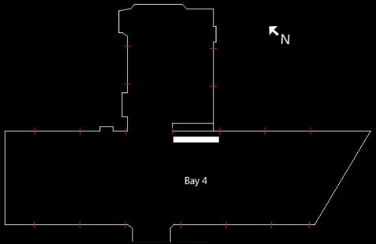
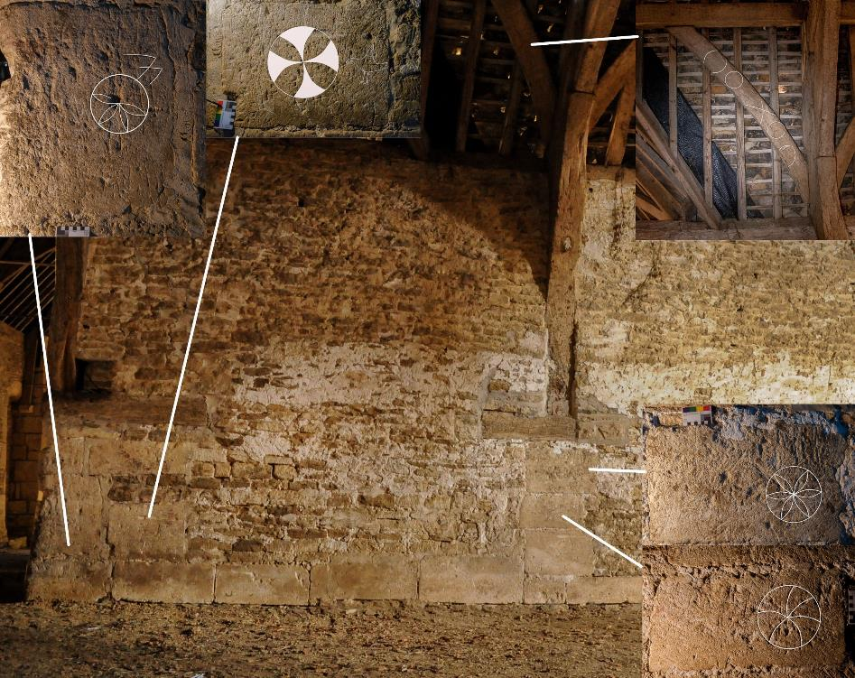

Bay 4 lies to the immediate right of the east porch entrance and the dressed stone is liberally adorned with protective symbols. From clockwise we note a partial hexafoil that is intersected by a large “M” as a Marian mark. Adjacent is a consecration cross style motif juxtaposed with a second significant piece of folk art in the form of a bird with out-stretched wings. The body of the bird is infilled with rough hatching marks.

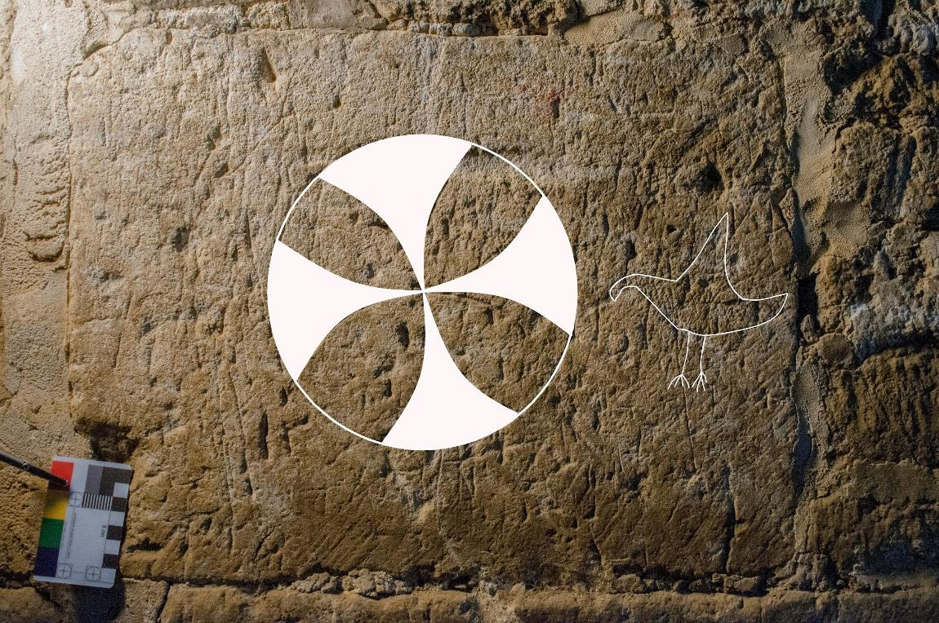

Compass Drawn circles Bays 6 & 7

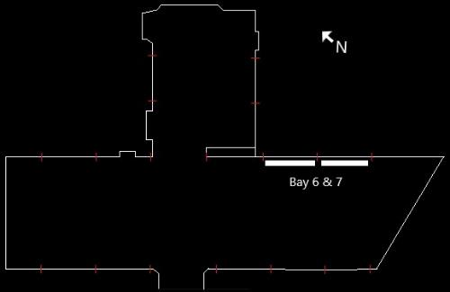

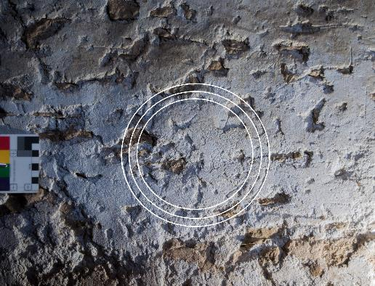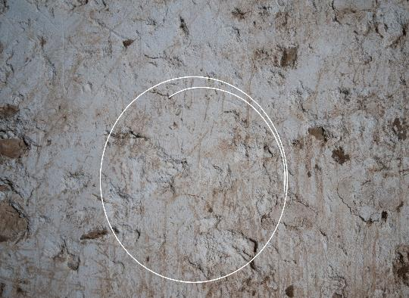
Further render marks are visible within bays 6 & 7 and although not of the grandeur of the porch motifs give an insight into the style of motifs used within the render.
Tithe Barn South Wall
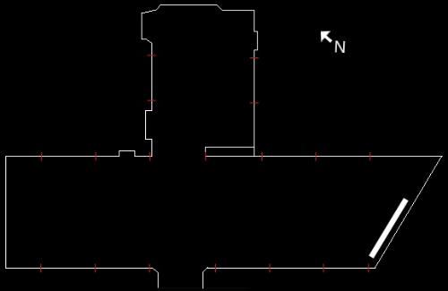
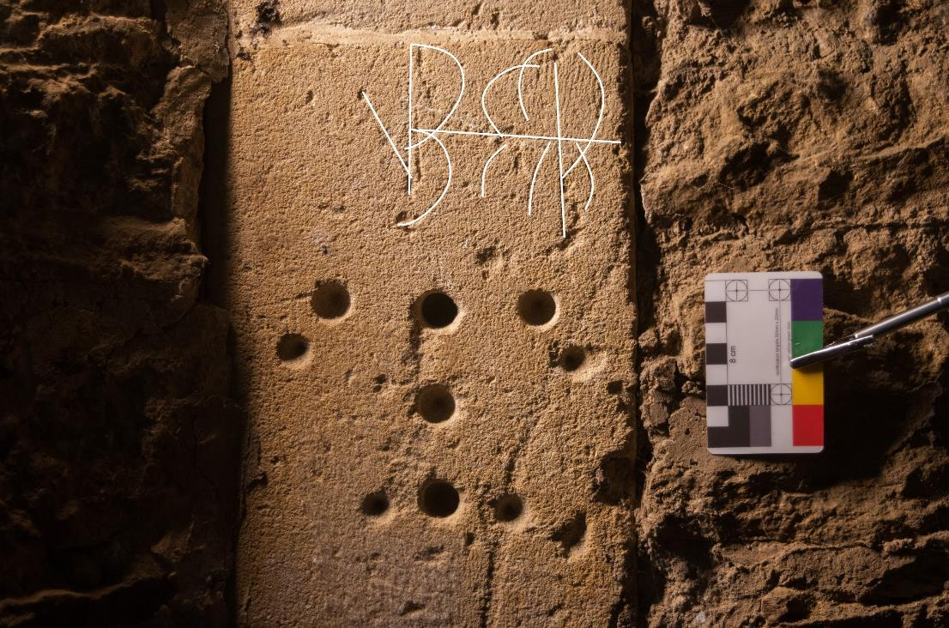

The precisely situated holes drilled into stone in the south wall inspired some creative thinking and the thought that it was from two different attempts with different sized bits was concluded. Its position indicated it may have been for a gate fixing however the suggestion that ecclesiastical buildings were often drilled for medicinal powder that was consumed in order to absorb a higher protective power won the day. We remain wary of this view as it refers to churches in the main, however, it stimulates the thought process and may offer an ecclesiastical attribute to the tithe barn.
West Entrance
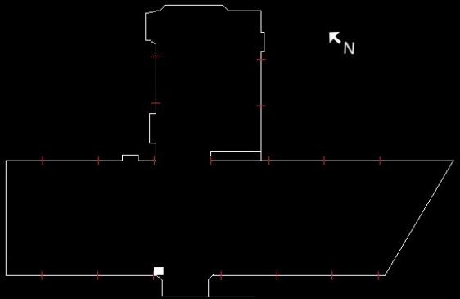
There are indeterminable scratchings either side of the west entrance however this stone revealed an almost indistinguishable concentric circle motif that offers protection from the perceived malevolent external forces. It would not be inconceivable to expect more examples in such an area and it may be that there were but have been lost to time, erosion or restoration as they lie in a vulnerable position related to the road.
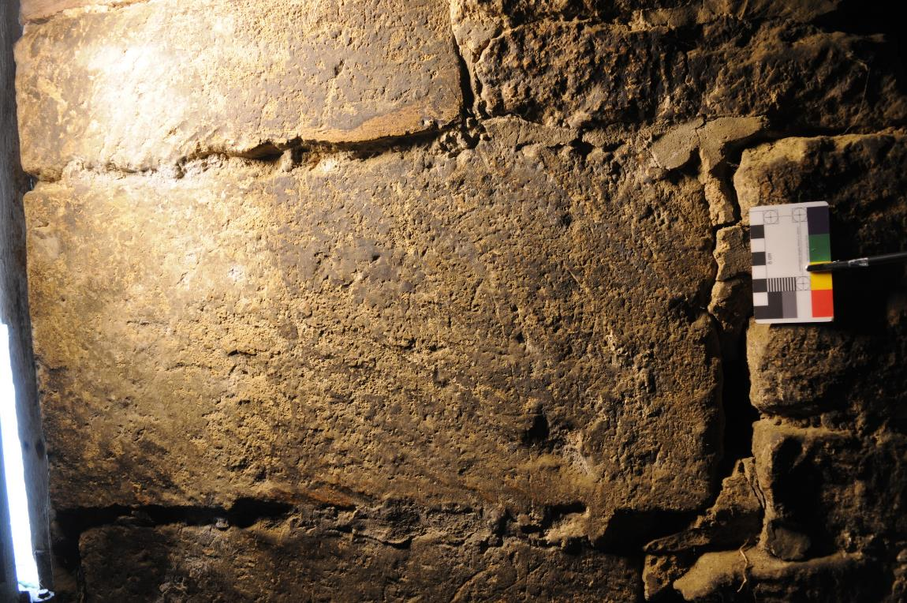
Annotated Concentric Circle Motif
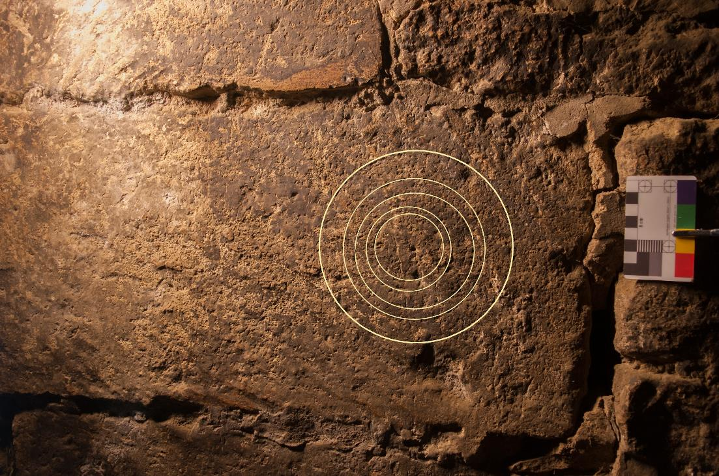
Tithe Barn North Wall
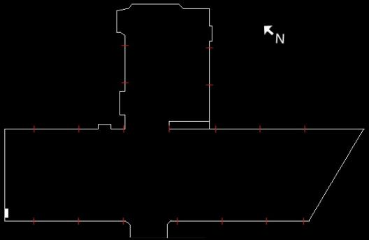
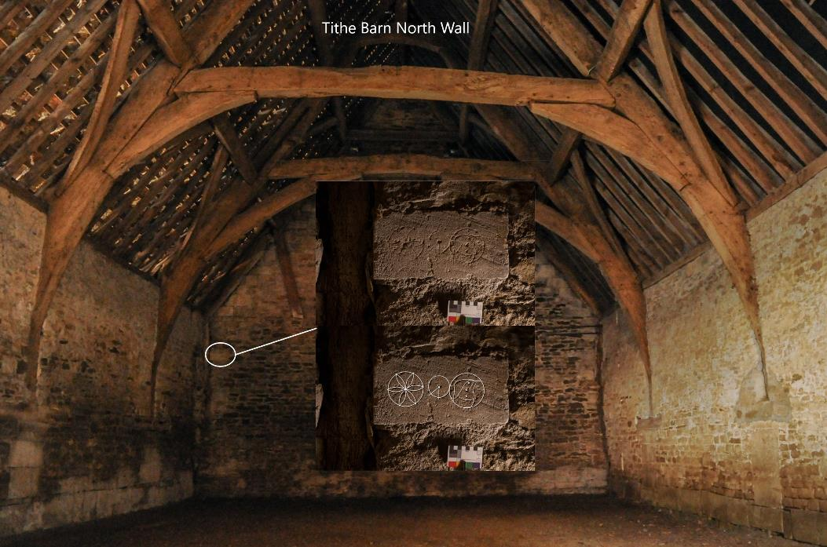
The north wall of the barn is today mostly devoid of any inscribed stone. Adjoining the west wall at approximately 2.5 metres from the floor, however, is a beautifully executed stone comprising of a hexafoil and two compass drawn circles, one with a unique design within its circumference.

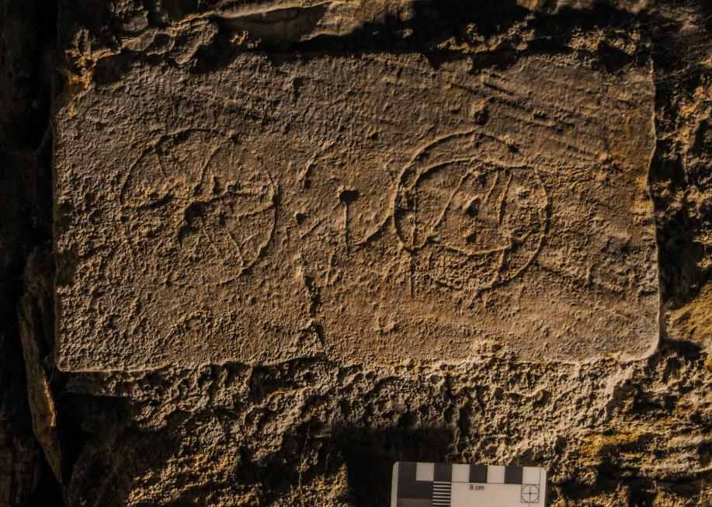
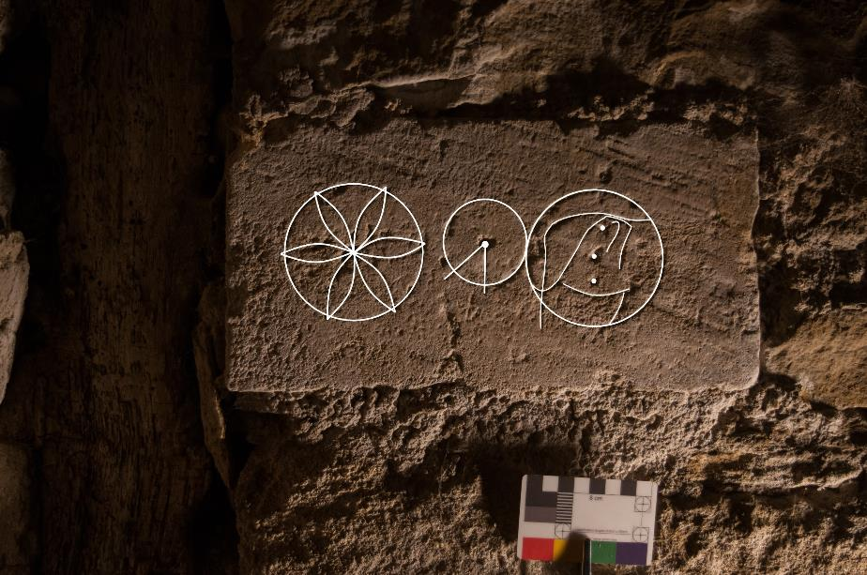

Timber Markings
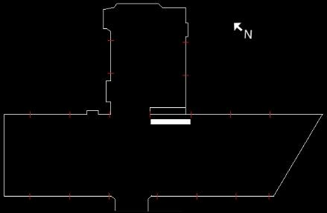
Bay 5 Roof Wind brace

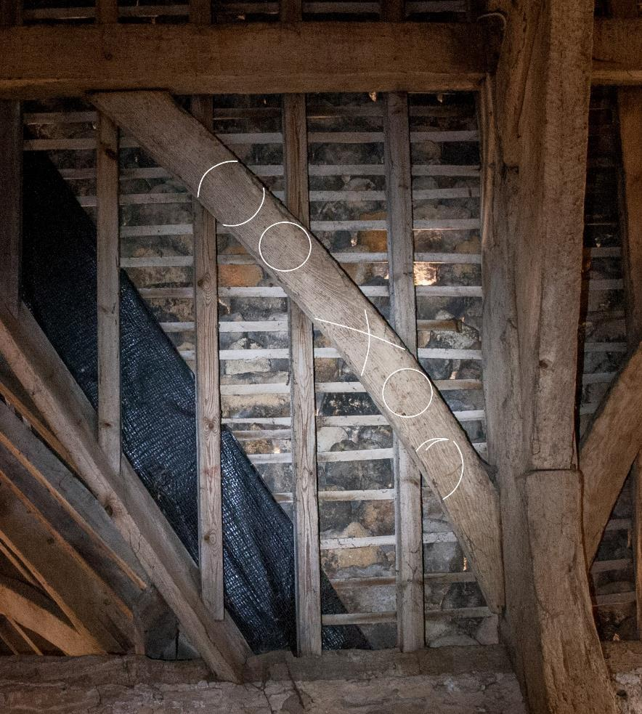
Surviving timbers provide us with a variety of compass drawn motifs. Bay 5 wind brace has examples of carpenter’s setting out marks and includes complete compass drawn circles. Further evidence is found within cruck 5 west where a consecration cross style motif appears at the cruck base and is supported by other designs including a unique piece to Lacock with an off-centre arrow finishing the circle interior and a hexafoil design above. Similar examples can be found within Wiltshire at the monastic barn at Place Farm, Tisbury and further afield at the Great Coxwell barn in Oxfordshire as noted by Timothy Easton (2016).
Cruck 5 West

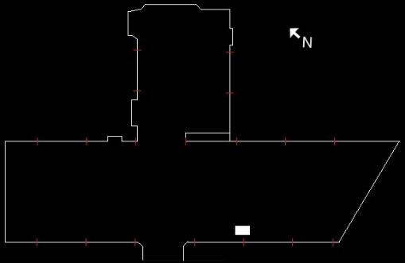

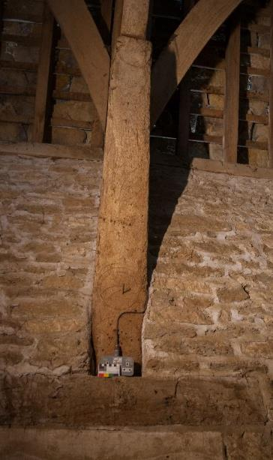
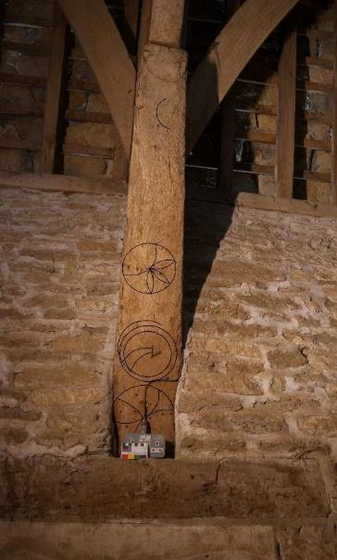
Cruck 6 East
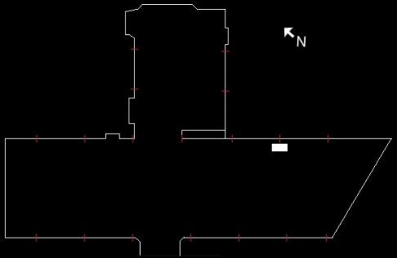
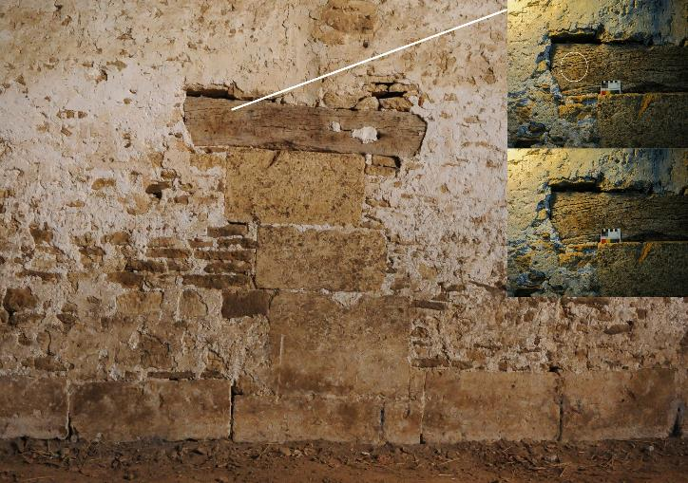
Cruck 6 East contains a single compass drawn circle that is evident under an oblique light. The age and condition of the timber cruck support does not lend itself to revealing any further motifs with the current technology.
Cruck 2 West
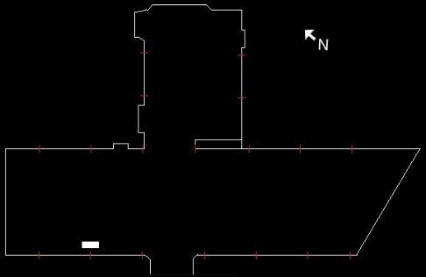

Cruck 2 west support contains a number of compass drawn symbols across the breadth of the timber, from a simple, single inscribed circle adjacent to a well-defined hexafoil that makes full use of the height of the available surface, to complex geometric overlays that encourage a personal glimpse of past superstition and belief.

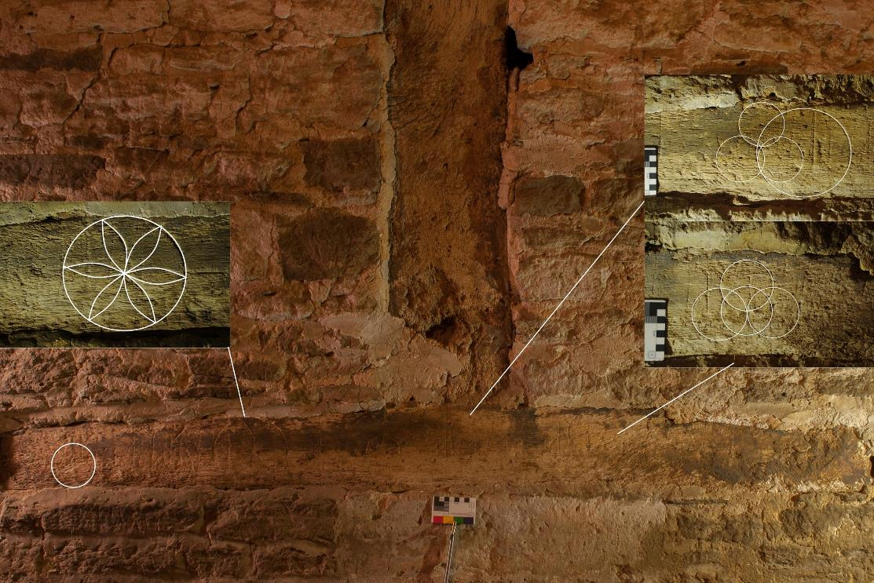

Close up of cruck 2 support (west) geometric motifs

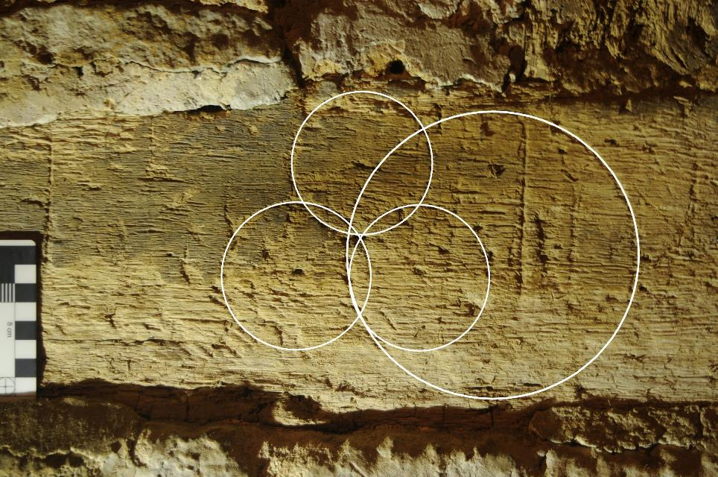

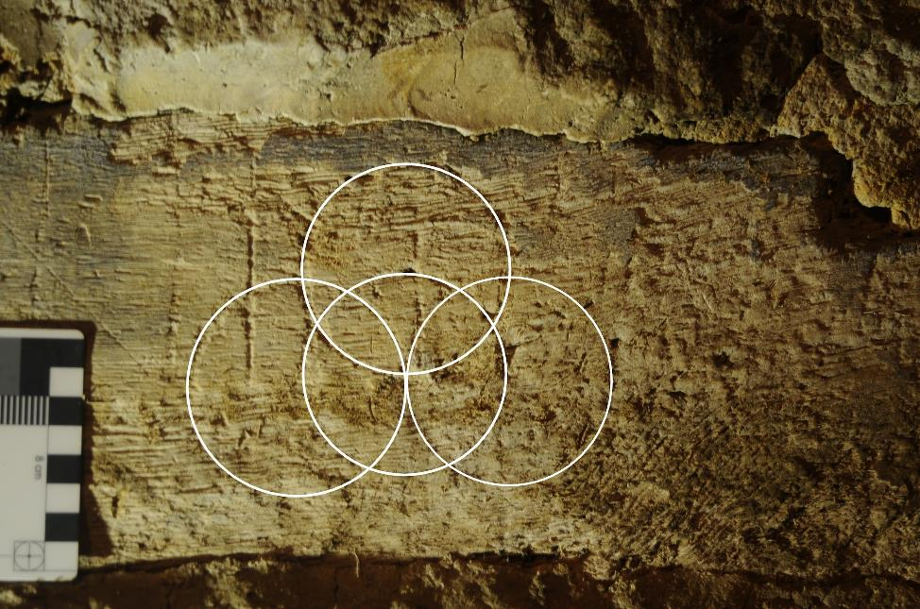
A simple compass drawn circle motif on cruck 2 (west)

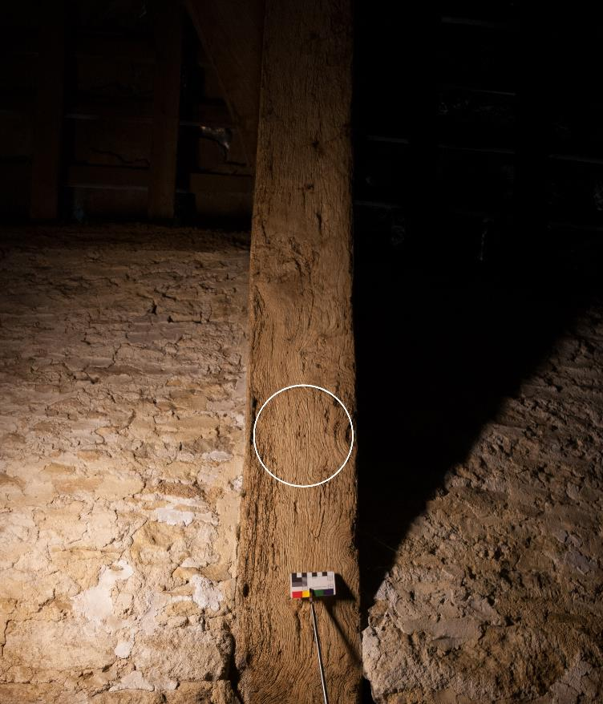

Tithe Barn Conclusion
The Lacock tithe barn contains many motifs that are representative of ritual protection marks found within similar contexts throughout Wiltshire and indeed the country. In examining the intended purpose of the motifs, their location and style we can draw upon many examples recorded throughout the country intended to avert malevolent influences and offer protection from unknown forces. Easton (2016) offers that the symbols may have been a part of a supporting network of apotropaic devices such as strategically placed bunches of herbs, symbolic plants and other transient forms now lost to time. The remaining symbols in the Lacock tithe barn offer a glimpse of these superstitions and folklore as they themselves are subject to erosion and decay. The desire to protect the harvest in which cost, time and labour has been invested with a potential yet to be realised can be acknowledged. With our modern understanding of airborne pathogens and the supporting science it is easy to dismiss such cultural belief systems, however, the ubiquitous nature of the symbolism on surviving buildings and fabric inform us of a time when this was deemed the norm and an essential component within daily life.
The preservation and status of the tithe barn as an important historic building within the timeless setting that is Lacock have enabled their preservation and their recording. This is less evident within the remaining two barns due to restoration and changes in function and this progressive stance contributes to the building’s survival and evolution, however we cannot rule out future surveys that may reveal more within the Fox Talbot barn for example. The recording of the tithe barn provides a detailed photographic survey of the historic graffiti contained within, it allows for further research and understanding of the subject as more data is collated and will allow appropriate conservation measures to be taken when necessary.

Manger Barn
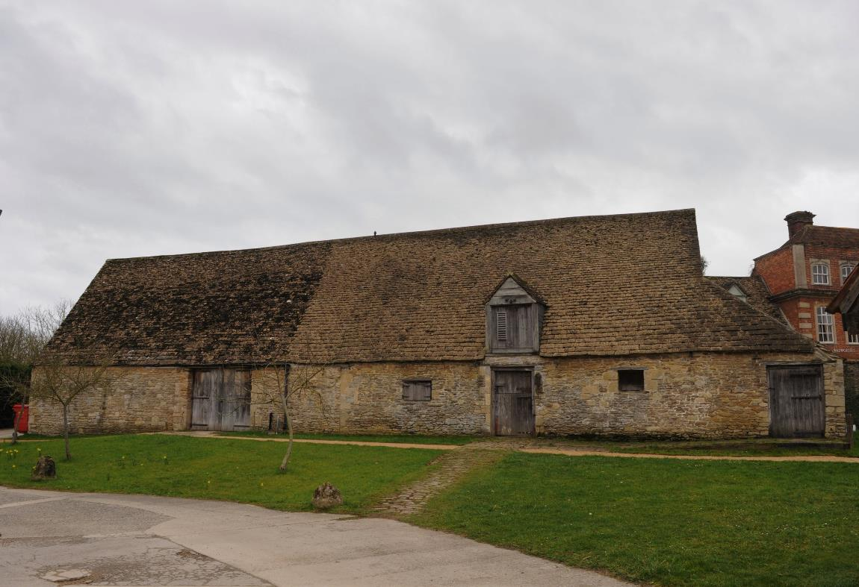
Access to the Manger Barn was restricted to the conference room as the conservation area was being used and it would have been inappropriate to disturb the contents. We did have a cursory inspection but could find little of note. There was a similar story within the remainder of the barn due in no small part to the rubble stone construction and a recent restoration. Of interest however were the carpenters’ marks within the roof timbers, a set of tally marks and a welcome nod to the past with the placing of glass bottle remnants into the modern lime mortar which had apparently been found within the barn during restoration in the early 21st C, a nice touch.
Manger Barn Schematic

South
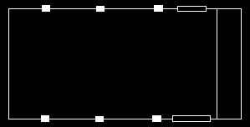
North
The Manger Barn lies roughly east to west within Manor Farm and the east end area surveyed can be seen within the above schematic. Dendrochronology reveals the timber to have been felled 1359 within the roof structure and post near the main entrance. An earlier reused cruck truss is dated at 1252-77 (P. Slocombe, personal communication September 2019). The bays can be viewed as 1,2,3,4 from the west.
The north main door which is of new construction but retains the original jambs contains little in the way of inscribed stone however a group of tally marks can be seen in the l/h jamb upon entering.

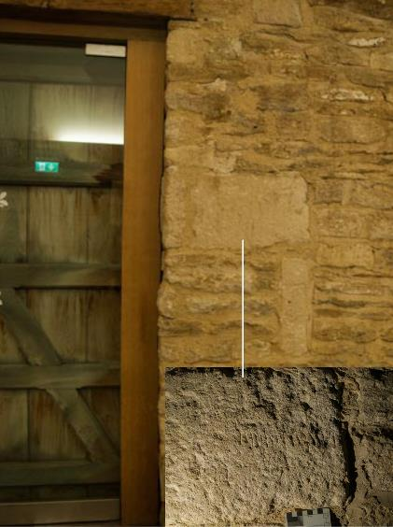
This is repeated on the south door, bay 1 albeit in an eroded form. It also stimulates the debate on tally marks and their function as there are not enough to account for movements and general use throughout the Lacock barns whatever the season or time period although we are unaware whether other stones were replaced.
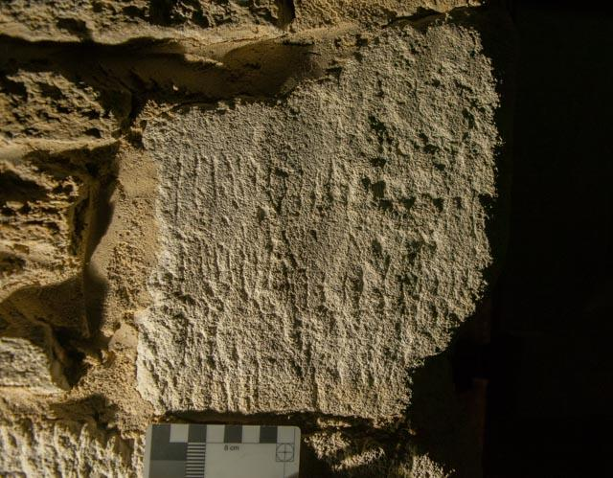
The pieces of glass bottle found in the barn during the restoration are embedded in the lime mortar approximately 1m from ground level in the partitioned kitchen and storage areas in the west and south wall respectively. There is another piece with the central east wall also.

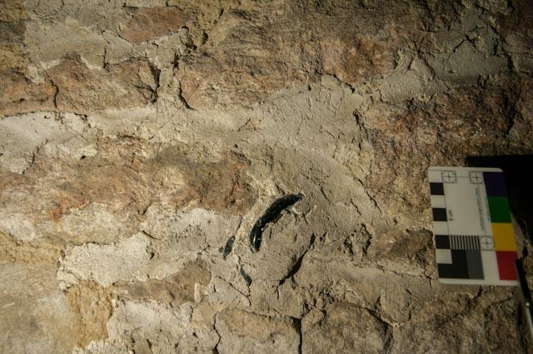

Working from the main entrance there are significant carpenter’s marks that adorn the supporting beams that run the length of the walls. They allow for the alignment of the pegged joints and correct placement within the building.
Bay 2 North

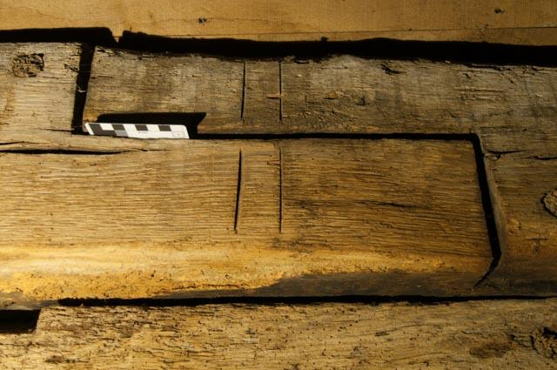

Bay 2 South
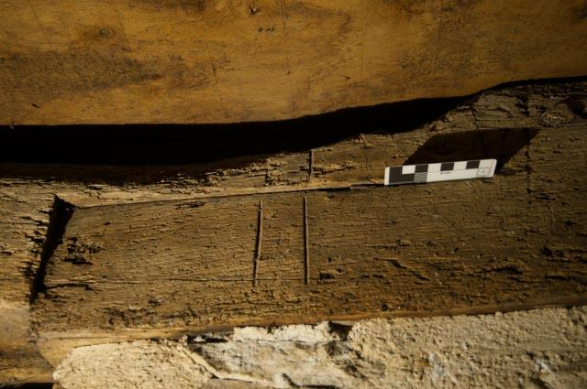

Bay 2 North Cross Beam

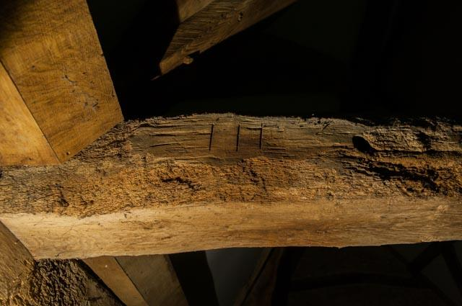

Bay 3 North
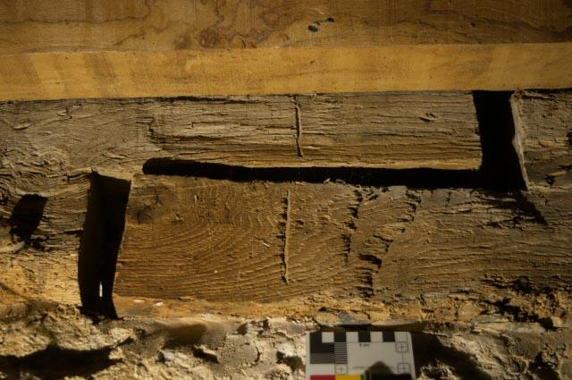
Bay 4 North

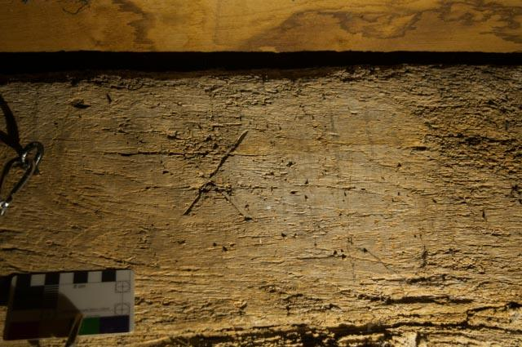

East Wall North
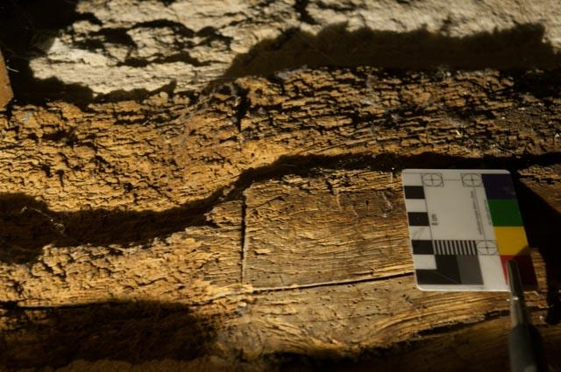

East Wall South

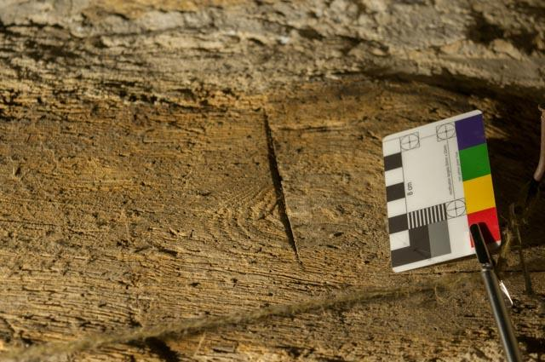

Bay 4 South

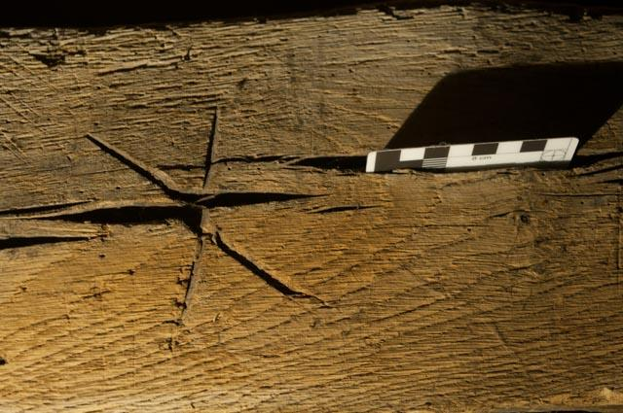
Bay 3 South

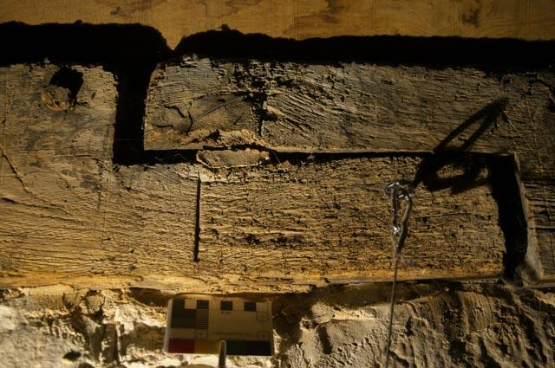

So, we can see a pattern of equal numbers on opposing sides of the barn. This makes perfect sense if building either off site or laying and cutting nearby. It eases identification and the simple numerals and uses of the letter “X” are recognisable by all
Bay 3 on the south side throws up a couple of anomalies however, as the identification marks are supported by what appear to be apotropaic marks either side of the joint, particularly the motif on the west (r/h) side of the joint. This gives the impression of a conjoined VV or an “M” as a Marian mark as witnessed in the tithe barn. Closer examination of the vertical incisions and comparison with the l/h motif however indicates that the likelihood is a setting out mark possibly with a rase knife (Pacey, 2007).

Bay 3 South, West side of the joint (r/h)

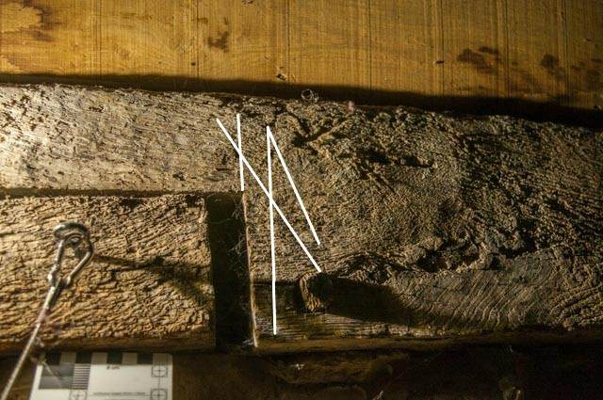
East side (l/h)
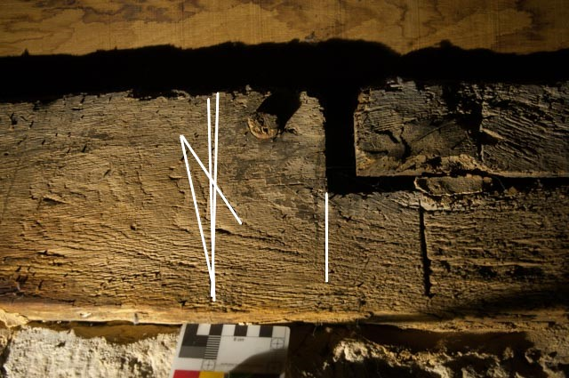
Truss 2 Centre

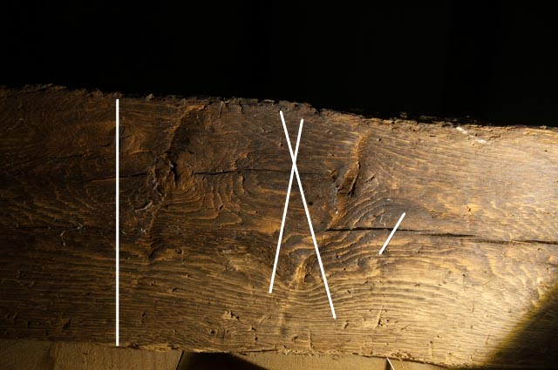

The Fox-Talbot or Lodge Barn
A wonderful building which doubles as reception for the Lacock estate and houses the most excellent Fox-Talbot photographic museum. The 16thC barn is integrated with a lodge house and due to its function reveals only a minor amount of graffiti that we are able to record. So please view this a taste of what may be within this building.

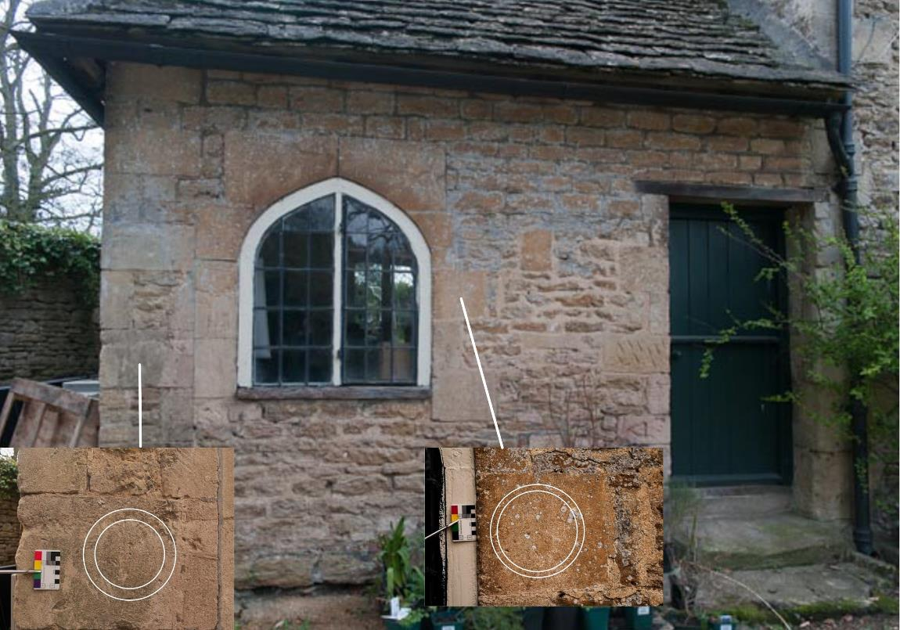
Externally there are some interesting concentric circles on the north side of the lodge building. We are unsure that these are their original location as the window construction seems incongruent to the building however if they have been moved then respect has been shown to the compass-drawn motifs.

Central Lodge Door North
Deeply incised initials on lodge doorway. Unknown origin.
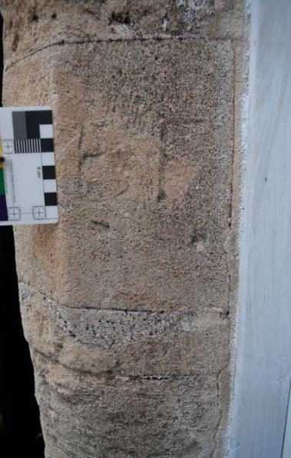
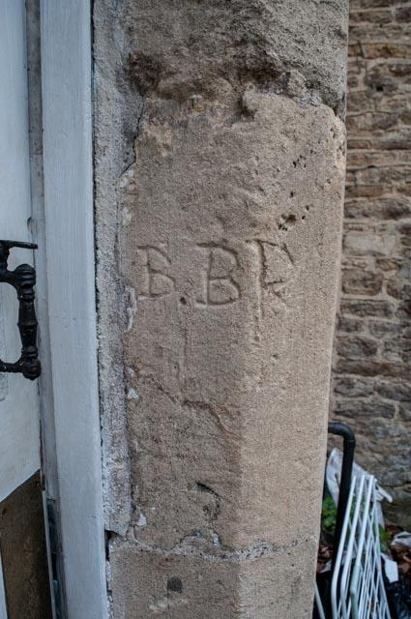
Barn South Doorway
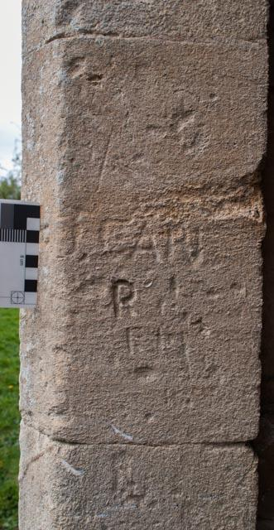
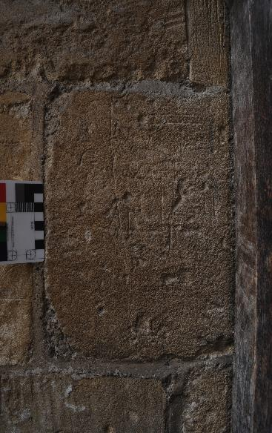
Modern graffiti “Jean” & initials. Indecipherable scratches on door jamb.

Barn Porch External North
Compass drawn arc and possible tally mark (eroded)

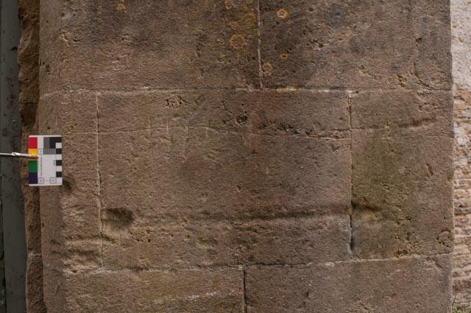

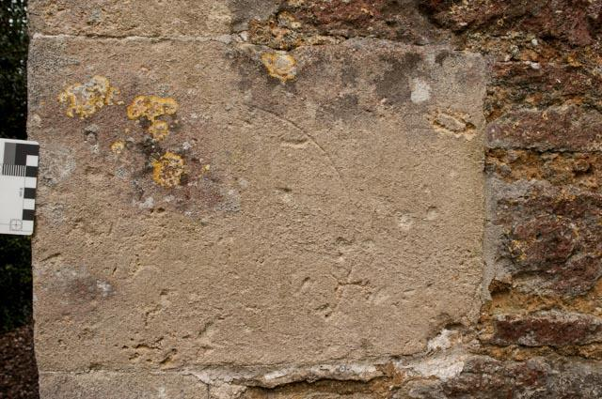

Barn interior North Window

The stairwell that leads to the new upper flooring shields a pair of apotropaic marks including this hand drawn circle. The hexafoil below is obscured by a newel post however is a detailed compass drawn piece.

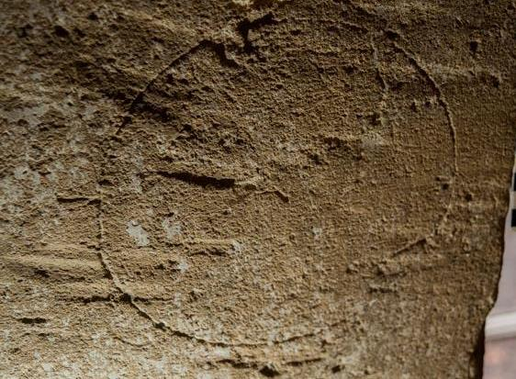
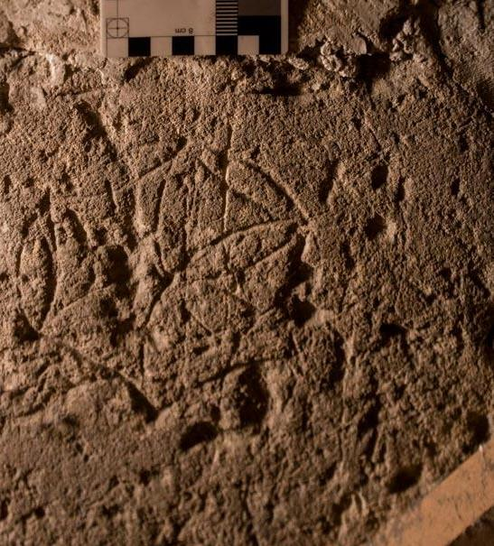

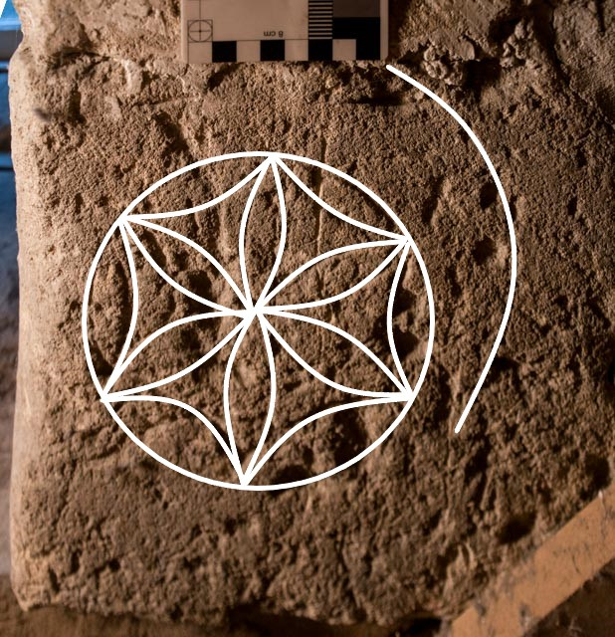

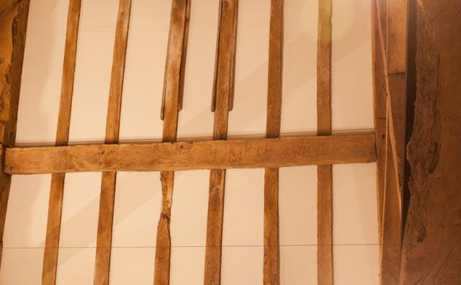
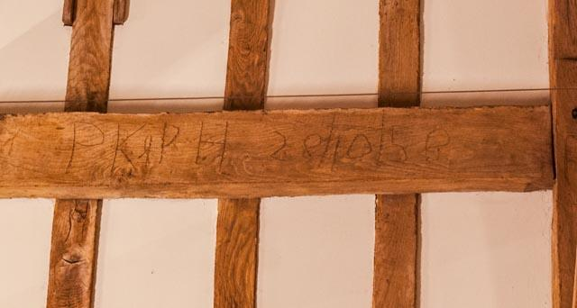
Evidence of previous work within the roof timbers reveals PK & PH 28/10/58 a subtle inclusion, easily visible from the new mezzanine flooring.
This concludes this phase of survey within the Lacock barns. It’s been a privilege and an enjoyable exercise in which both staff and the general public were engaged and enthusiastic. It would be of advantage to review the Fox Talbot barn when a major refurbishment occurs in the future.

Tony Hack

www.wiltshire-medieval-graffiti-survey.com

tl.hack@virgin.net

References

Champion, M. (2015) Medieval Graffiti, The Lost Voice of England’s Churches. London: Ebury.

Easton, T. (2016) “Apotropaic Symbols and Other Measures for Protecting Buildings against Misfortune” in Hutton, R. (ed.) Physical Evidence for Ritual Acts, Sorcery and Witchcraft in Christian Britain, Basingstoke, Palgrave Macmillan, p39-67.

Easton, T. (2016), Barns and Scribed Circles: Parallel Worlds, Society for the Protection of Ancient Buildings Magazine, Winter 2016, pp. 42-49.

Pacey, A. (2007) Medieval Architectural Drawing. Stroud: Tempus.

Pevsner, N. (1975) The Buildings of England; Wiltshire. London: Penguin.

Pritchard, V. (1967) English Medieval Graffiti. London: Cambridge University Press

