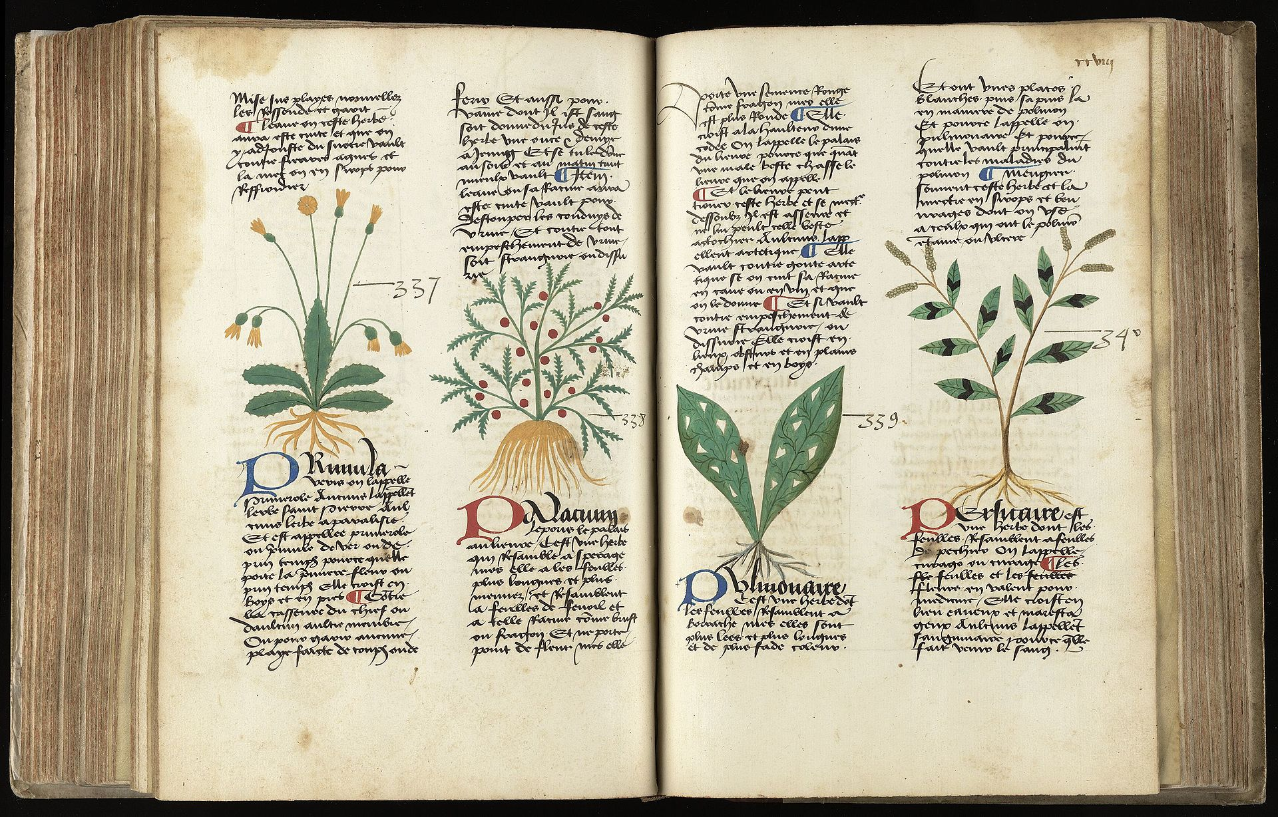

ANNA KIRKWOOD GRAHAM, M.A., J.D., Ph.D. 2021
Attorney number P70320

Educational Background:

Michigan State University College of Law, JD (cum laude) Summer 2005
- Full Merit Scholarship, 2002-2005
- Intern at Environmental, Natural Resources and Agriculture Division of Michigan Attorney General’s office, Summer and Fall, 2005.
- Research Assistant, Prof. Catherine Dwyer, on European Union business law, 2004-05
- Environmental Law Society
- In the Environmental and Natural Resources Concentration, with concentration GPA of 3.58
- Overall GPA 3.37

University of Toronto, M.A., Ph.D. (Medieval Studies), 1989
- Areas of specialization: Anglo-Latin Literature and Palaeography
- Dissertation: “The Tractatus moralis super quatuor elementa of Walter of Wimborne, O.F.M.: An Edition of Selected Portions.” Supervised by A.G. Rigg, University of Toronto
- Language requirements met: Latin, Greek, German and French
- Graduate Fellow, Centre for Reformation and Renaissance Studies, 1987-88
- University of Toronto Open Fellowship, 1983-84, 1984-85, 1985-86, 1986-87
- Connaught Fellow, 1981-82, 1982-83
- Research Assistant, Prof. Robert Sinkewicz, Greek Index Project, 1987-88
- Teaching Assistant, Basic Latin, Centre for Medieval Studies, 1986-87; Summer 1987
- Teaching Assistant, Intermediate Medieval Latin, Centre for Medieval Studies, 1985-86
- Teaching Assistant, Introduction to Medieval Latin, Centre for Medieval Studies, 1984-85

Hollins University, B.A. (Classical Studies with honors), 1981
- Graduated First in Class (Faculty Award for Academic Excellence, Summa cum Laude)
- Six letters of merit, in Chemistry, Art History, Classical Languages and German
- Phi Beta Kappa (junior election)
- Teaching Assistant, Basic German, 1980-81
- Research Assistant, Prof. Anne Laidlaw, on Roman wall-painting, in Pompeii and Rome, Summer 1980
- Research/Archival Assistant, Prof. Thomas Edwards, on the papers of labor activist Ella Reeves Bloor, 1978-79

Additional Training:
Rare Book School (Individual(courses), Columbia University and University of Virginia
- Introduction to Rare Book Librarianship, Summer 1990
- Rare Materials in Anglo-American Law, Summer 1993

Publications:

Co-author on : Jiquan Chen et al 2022 Environ. Res. Lett. 17 023001.

The De generacione et corrupcione of Henry of Avranches, Journal of Medieval Latin (2021), 219-263.

Catalogue of the Manuscripts in the Dom Edmond Obrecht Collection of Gethsemani Abbey, ed. Susan M. B. Steuer and E. Rozanne Elder (Medieval Institute Publications, 2016). Descriptions of medieval mss. by Anna Kirkwood Graham and Chrysogonus Waddell.

“St. Francis of Assisi”, in Icons of the Middle Ages, ed. Lister M. Matheson (ABC-CLIO, 2011), 323-54. As Anna Kirkwood Graham.

Martha W. Griffith: Michigan Rare Book Room, Library of Michigan Foundation, n.d. Text by Anna D. Kirkwood. Non-refereed publication.

“The Tractatus moralis super quatuor elementa of Walter of Wimborne,” Journal of Medieval Latin, Vol. 3 (1993), 64-77. As Anna D. Kirkwood.

“A Treatise on Gardening, Written by a Native of this State [Richmond, 1793],” Papers of the Bibliographical Society of America, Vol. 85:1 (March 1991), 67-71. As Anna D. Kirkwood.

Current projects:

Continuing work on Platearius, Circa instans (see below).
Coauthoring article on Population Growth as an Expression of Patriarchy, with Norman A. Graham, MSU.

Public Scholarship:

Ongoing work on abortion, ensoulment, and the law.
See https://www.academia.edu/51871662/The_Value_of_a_Womans_Life_in_the_World_Childbearing_Sustainability_and_Prosperity.
https://www.academia.edu/51868365/Book_6_a_right_like_any_other
https://www.academia.edu/51370054/Late_term_abortion_Law_and_Aristotle
https://www.academia.edu/51367213/Evangelical_protestantism_and_abortion
https://www.academia.edu/51362321/Book_2_Catholicism
https://www.academia.edu/51303344/The_value_of_a_womans_life

Translation of Matthaeus Platearius, Circa instans.
See
https://grahama9.msu.domains/

Online Activism:

I am active on Twitter, where I advocate for Climate action, women’s reproductive rights, and other liberal causes and candidates.
Anna "Plant Trees!" Kirkwood @AnnaKirkwood19

Professional Positions:

Visiting Assistant Professor, Department of French, Classics and Italian, Michigan State University, (teaching Latin and IAH) 2008 until present.

Free-lance Editor, 1997-2002.

Rare Book Curator, 1992-97, and Coordinator, Michigan Center for the Book, Library of Michigan, 1995-97.

Rare Book Librarian, Western Michigan University, 1991-92.

Archivist and Curator of Special Collections, Hollins College, 1988-91.

Instructor, Classical Studies, Hollins College, 1989.

